Table of Contents

Review 1

Linear Regression Review 1

Stochastic Gradient Descent (SGD) Regression 4

SGD Scaling 4

Epochs 5

Logistic Regression Review 6

SGDClassifier 8

A Simplified Explanation of the Gradient Descent Algorithm 9

The Loss (Cost) Function 10

Implementing Gradient Descent 12

Calculating the Derivative 13

The Learning Rate 14

Gradient Descent Summary 19

Stochastic Gradient Descent 19

Welcome back ☺

## Review

This term will actually be quite a bit different than the last one but the difference

will not be apparent today. The content in this document will seem excessive at a first glance

but I will strive to keep it manageable. I will put things into context during class so you

can get through it quickly.

A goal of this document is to provide a quick review how to apply regression and classification

routines but perfect recall is not expected. We will also introduce the Stochastic GradientDescent

to perform regression and classification just like we have done with OLS and logistic regression.

You do not need to understand the new routines at a deep level. We will examine these

algorithms in more detail later.

The reason we are spending time on gradient descent algorithms now is because they

are a foundation for other machine learning algorithms which we will introduce in the course

very shortly from now.

## Linear Regression Review

Example 1: Linear Regression

Hopefully you remember ordinary least squares, OLS, to create a best fit line. The very first example of multiple regression that we covered in COMP3948 was used to predict wine quality.

Here is the code.

|  |
| --- |
| import pandas as pd  import numpy as np  from sklearn import metrics  from sklearn.model_selection import train_test_split  import statsmodels.api as sm  PATH = "/Users/pm/Desktop/DayDocs/data/"  CSV_DATA = "winequality.csv"  dataset = pd.read_csv(PATH + CSV_DATA,  skiprows=1, # Don't include header row as part of data.  encoding = "ISO-8859-1", sep=',',  names=('fixed acidity', 'volatile acidity', 'citric acid',  'residual sugar', 'chlorides', 'free sulfur dioxide',  'total sulfur dioxide', 'density', 'pH', 'sulphates',  'alcohol', 'quality'))  # Show all columns.  pd.set_option('display.max_columns', None)  # Increase number of columns that display on one line.  pd.set_option('display.width', 1000)  print(dataset.head())  print(dataset.describe())  X = dataset[['fixed acidity', 'volatile acidity', 'citric acid', 'residual sugar',  'chlorides', 'free sulfur dioxide', 'total sulfur dioxide', 'density',  'pH', 'sulphates','alcohol']].values  # Adding an intercept *** This is required ***. Don't forget this step.  # The intercept centers the error residuals around zero  # which helps to avoid over-fitting.  X = sm.add_constant(X)  y = dataset['quality'].values  X_train, X_test, y_train, y_test = train_test_split(X, y, test_size=0.2, random_state=0)  model = sm.OLS(y_train, X_train).fit()  predictions = model.predict(X_test) # make the predictions by the model  print(model.summary())  print('Root Mean Squared Error:',  np.sqrt(metrics.mean_squared_error(y_test, predictions))) |

The result generates a root mean square error (RMSE) of **0.620**. The root mean square error represents the average deviation from the mean. Where y is the actual value and $\hat{y}$ is the predicted value:

RMSE = $\sqrt{{(y- \hat{y})}^{2}}$

Here is the model summary which shows that $R^{2}$, the coefficient of determination is **0.365**.

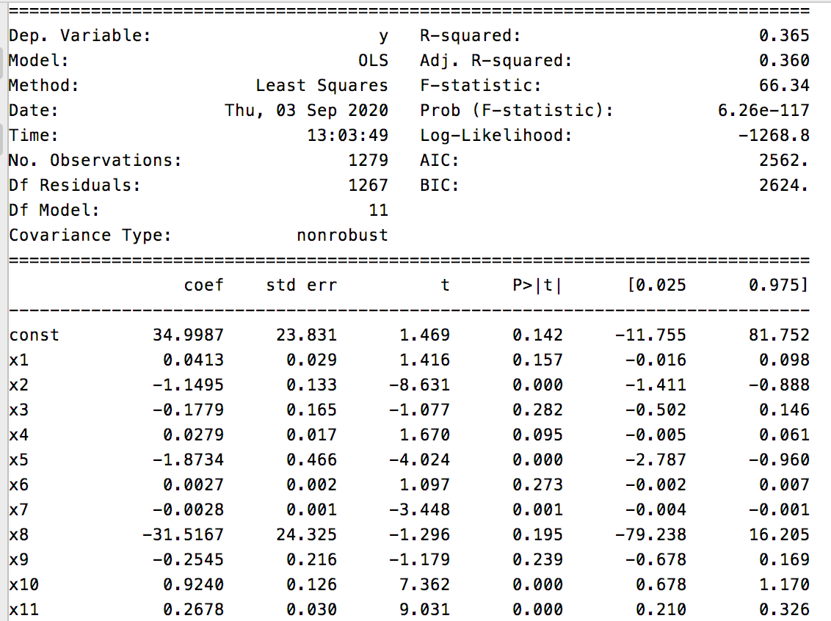

Exercise 1 (1 mark)

What does R, not $R^{2},$ represent when referring to the coefficient of determination?

|  |
| --- |
| R is the correlation coefficient. R is a measure of the closeness of association of the points in a scatter plot to a leaner regression line. $R^{2}$ is the proportion of the variance in the response variable that can explained by the predictor variables in the regression model. |

Exercise 2 (1 mark)

What are the maximum and minimum values for $R^{2}$?

|  |
| --- |
| R square values range from 0 to 1. So the min is 0 and the max is 1 |

Exercise 3 (1 mark)

What are the maximum and minimum values for R and what does each value represent?

|  |
| --- |
| The max value is 1 and the min value is -1. R is the measure of the association between two variables. The relationship between tow variables is considered strong when R is larger than 0.7. The larger R means it has the strength of the linear relationship between two quantitative variables. |

Exercise 4 (1 mark)

Are higher or lower values for the AIC / BIC preferred?

|  |
| --- |
| A lower AIC is better and lower BIC (lower penalty terms) is preferred as well. |

Exercise 5 (1 mark)

What variables shown in the model summary output are statistically insignificant? How will we treat these variables when refining our model?

|  |
| --- |
| P values (generally if the P-values <0.05 is considered statistically significant. |

Exercise 6 (2 marks)

Modify the code so only the statistically significant predictor variables are included. Show your code here:

|  |
| --- |
| import pandas as pd import numpy as np from sklearn import metrics from sklearn.model_selection import train_test_split import statsmodels.api as sm import operator  PATH = "/Users/hyerimshin/PycharmProjects/MachineLearning/datasets/" CSV_DATA = "winequality.csv"  dataset = pd.read_csv(PATH + CSV_DATA,  skiprows=1, # Don't include header row as part of data.  encoding = "ISO-8859-1", sep=',',  names=('fixed acidity', 'volatile acidity', 'citric acid',  'residual sugar', 'chlorides', 'free sulfur dioxide',  'total sulfur dioxide', 'density', 'pH', 'sulphates',  'alcohol', 'quality')) # Show all columns. pd.set_option('display.max_columns', None)  # Increase number of columns that display on one line. pd.set_option('display.width', 1000) print(dataset.head()) print(dataset.describe()) X = dataset[['fixed acidity', 'volatile acidity', 'citric acid', 'residual sugar',  'chlorides', 'free sulfur dioxide', 'total sulfur dioxide', 'density',  'pH', 'sulphates','alcohol']].values  # Adding an intercept *** This is required ***. Don't forget this step. # The intercept centers the error residuals around zero # which helps to avoid over-fitting. X = sm.add_constant(X) y = dataset['quality'].values  X_train, X_test, y_train, y_test = train_test_split(X, y, test_size=0.2, random_state=0)  model = sm.OLS(y_train, X_train).fit() predictions = model.predict(X_test) # make the predictions by the model # print(model.summary()) # print('Root Mean Squared Error:', # np.sqrt(metrics.mean_squared_error(y_test, predictions)))  print('***//// model summary output are statistically insignificant')  keep_pvals = model.pvalues[model.pvalues <= .005]  print(keep_pvals) |

What are the AIC and BIC numbers after running your revised code? How do they compare to the AIC and BIC number when more predictor variables are used?

|  |
| --- |
| Before    After    both AIC and BIC becomes lower with only using more predictor variables. |

## Stochastic Gradient Descent (SGD) Regression

Stochastic gradient descent is one of the most fundamental machine learning algorithms. We need to cover it early because it will form the basis for many other more advanced machine learning algorithms. We will not discuss it in much detail for this class but we will cover it more detail during the lab.

### SGD Scaling

Stochastic Gradient Descent is sensitive to feature scaling so it is highly recommended to scale your data. For example, scale each attribute on the input vector X to [0,1] or [-1,+1], or standardize it to have mean 0 and variance 1. Note that the same scaling must be applied to the test vector to obtain meaningful results. This task is often performed using StandardScaler.

**Note:** Remember to use the training set to fit the scaler. Also remember that only the x-values are scaled.

|  |
| --- |
| # Stochastic gradient descent models are sensitive to differences  # in scale so a StandardScaler is usually used.  from sklearn.preprocessing import StandardScaler  scaler = StandardScaler()  scaler.fit(x_trainReshaped)  X_trainScaled = scaler.transform(x_trainReshaped)  X_testScaled = scaler.transform(x_testReshaped) |

Example 2: Stochastic Gradient Descent

This code generates a regression model to predict the wine quality using stochastic gradient descent with the **SGDRegressor** class. The root mean square error from this pro

cess is varies between roughly **0.619** and **0.622** each time the program is run. The RMSE is actually very similar to the linear regression. Notice how scaling is used to tame the magnitude of the predictor variables.

To build this example, add this code onto the end of Example 1.

|  |
| --- |
| ###########################################################  print("\nStochastic Gradient Descent")  from sklearn.linear_model import SGDRegressor  from sklearn.metrics import mean_squared_error  # Stochastic gradient descent models are sensitive to differences  # in scale so a StandardScaler is usually used.  from sklearn.preprocessing import StandardScaler  scaler = StandardScaler()  scaler.fit(X_train) # Don't cheat - fit only on training data  X_trainScaled = scaler.transform(X_train)  X_testScaled = scaler.transform(X_test)  # SkLearn SGD classifier  sgd = SGDRegressor(verbose=1)  sgd.fit(X_trainScaled, y_train)  predictions = sgd.predict(X_testScaled)  print('Root Mean Squared Error:',  np.sqrt(mean_squared_error(y_test, predictions))) |

### Epochs

You will notice some differences when examining the output when building a regression model with stochastic gradient descent. SGD regressors output loss values for each epoch. **An epoch is an iteration of a machine learning algorithm which works towards minimizing a cost / loss function.**

|  |
| --- |
| -- Epoch 6  Norm: 0.41, NNZs: 11, Bias: 5.650050, T: 7674, Avg. loss: 0.215492  Total training time: 0.00 seconds.  -- Epoch 7  Norm: 0.42, NNZs: 11, Bias: 5.646630, T: 8953, Avg. loss: 0.215903  Total training time: 0.00 seconds.  -- Epoch 8  Norm: 0.42, NNZs: 11, Bias: 5.652358, T: 10232, Avg. loss: 0.215620  Total training time: 0.00 seconds.  Convergence after 8 epochs took 0.00 seconds  Root Mean Squared Error: 0.6223729015084277 |

## Logistic Regression Review

In COMP3948 we used logistic regression for classification. Remember, logistic regression uses a sigmoid function to clamp ‘y’ between 0 and 1 for all values of X.

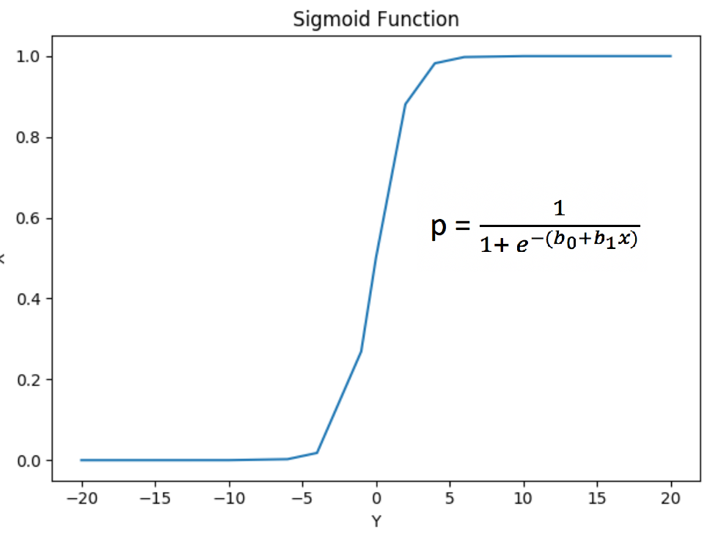

Example 3: Logistic Regression

This is actually the first logistic regression example that we covered in COMP3948. GMAT and GPA scores and work experience were used to determine if a student applicant would be admitted. A chi-square test found GMT and work experience to be statistically significant.

# GMT # GPA #Work

﻿Predictor Chi-Square Scores: [123.062 3.307 21.457]

To avoid overfitting, we dropped the GPA column. The revised model uses GMT scores and work experience to make the prediction.

Intercept:

[0.176]

[[1.546 1.711]]

The logistic regression model succeeded with 100% accuracy. Note that the results without scaling only offered 80%accuracy*.*

*If the accuracy is not great. -> what else we can do…? SMOT*

*Recall -> true target but downside (it costs me a lot of money and efforts. Persistence ( what percentage of actual targets really means for that statistics)*

Accuracy: 1.0

Confusion Matrix

Predicted 0 1

Actual

0 5 0

1 0 5

Here is the code:

|  |
| --- |
| import pandas as pd  import numpy as np  from sklearn.model_selection import train_test_split  from sklearn.linear_model import LogisticRegression  from sklearn import metrics  # Setup data.  candidates = {'gmat': [780,750,690,710,680,730,690,720,  740,690,610,690,710,680,770,610,580,650,540,590,620,  600,550,550,570,670,660,580,650,660,640,620,660,660,  680,650,670,580,590,690],  'gpa': [4,3.9,3.3,3.7,3.9,3.7,2.3,3.3,  3.3,1.7,2.7,3.7,3.7,3.3,3.3,3,2.7,3.7,2.7,2.3,  3.3,2,2.3,2.7,3,3.3,3.7,2.3,3.7,3.3,3,2.7,4,  3.3,3.3,2.3,2.7,3.3,1.7,3.7],  'work_experience': [3,4,3,5,4,6,1,4,5,  1,3,5,6,4,3,1,4,6,2,3,2,1,4,1,2,6,4,2,6,5,1,2,4,6,  5,1,2,1,4,5],  'admitted': [1,1,1,1,1,1,0,1,1,0,0,1,  1,1,1,0,0,1,0,0,0,0,0,0,0,1,1,0,1,1,0,0,1,1,1,0,0,  0,0,1]}  df = pd.DataFrame(candidates,columns= ['gmat', 'gpa',  'work_experience','admitted'])  print(df)  # Separate into x and y values.  X = df[['gmat', 'gpa','work_experience']]  y = df['admitted']  # Import the necessary libraries first  from sklearn.feature_selection import SelectKBest  from sklearn.feature_selection import chi2  # Show chi-square scores for each feature.  # There is 1-degree freedom since 1 predictor during feature evaluation.  # Generally, >=3.8 is good)  test = SelectKBest(score_func=chi2, k=3)  chiScores = test.fit(X, y) # Summarize scores  np.set_printoptions(precision=3)  print("\nPredictor Chi-Square Scores: " + str(chiScores.scores_))  # Re-assign X with significant columns only after chi-square test.  X = df[['gmat', 'work_experience']]  # Split data.  X_train,X_test,y_train,y_test = train_test_split(  X, y, test_size=0.25,random_state=0)  # Perform logistic regression.  logisticModel = LogisticRegression(fit_intercept=True, random_state = 0,  solver='liblinear')  # Stochastic gradient descent models are sensitive to differences  # in scale so a StandardScaler is usually used.  from sklearn.preprocessing import StandardScaler  scaler = StandardScaler()  scaler.fit(X_train)  X_trainScaled = scaler.transform(X_train)  X_testScaled = scaler.transform(X_test)  logisticModel.fit(X_trainScaled,y_train)  y_pred=logisticModel.predict(X_testScaled)  # Show model coefficients and intercept.  print("\nModel Coefficients: ")  print("\nIntercept: ")  print(logisticModel.intercept_)  print(logisticModel.coef_)  # Show confusion matrix and accuracy scores.  confusion_matrix = pd.crosstab(y_test, y_pred,  rownames=['Actual'],  colnames=['Predicted'])  print('\nAccuracy: ',metrics.accuracy_score(y_test, y_pred))  print("\nConfusion Matrix")  print(confusion_matrix) |

## SGDClassifier

The SGDClassifier class is an altered version of the SGDRegressor class. However, SGDClassifier is designed to make binary and multi-class predictions.

Example 4: Stochastic Gradient Descent

For your reference this code shows how you can implement the SGDClassifier class to perform the same classification as logistic regression did in Example 3. The results are not dramatic since the SGDClassifier score is also perfect just like with logistic regression. To build this example, add this code to the end of Example 3.

|  |
| --- |
| print("\nStochastic Gradient Descent")  from sklearn.linear_model import SGDClassifier  clf = SGDClassifier()  clf.fit(X_trainScaled, y_train)  y_pred = clf.predict(X_testScaled)  # Show confusion matrix and accuracy scores.  confusion_matrix = pd.crosstab(y_test, y_pred,  rownames=['Actual'],  colnames=['Predicted'])  print('\nAccuracy: ',metrics.accuracy_score(y_test, y_pred))  print("\nConfusion Matrix")  print(confusion_matrix) |

### A Simplified Explanation of the Gradient Descent Algorithm

Example 5: Gradient Descent Explained in Simple Terms

This example is based on the video by Josh Stormer at <https://youtu.be/sDv4f4s2SB8>. For this case gradient descent is used to find a best-fit linear equation to predict height based on weight.

**Height = intercept + $β∙$ weight**

To keep this explanation simple, assume the slope $β$ is known to be 0.64. To further simplify the demonstration, we will only discuss how to optimize the intercept. The equation then becomes:

**Height = intercept + $0.64∙$ weight**

To begin, the algorithm starts with a random value for the intercept of 0. Figure 1 shows a scatter plot with three samples. For this case we are trying to find the intercept of a best fit line between them.

Figure 1: Scatter of Samples

|  |  |  |
| --- | --- | --- |
|  | Weight | Height |
| 0.5  2.3  2.9 | 1.4  1.9  3.2 |

When a line with a slope of 0.64 and an intercept of 0 is drawn (refer to Figure 2), the equation for predicting weight becomes:

**Height = intercept + $β∙$ weight = 0 + $0.64∙$ weight**

**Height = 0 + $0.64∙$ 0.5 = 0.32**

Figure 2: Regression Line

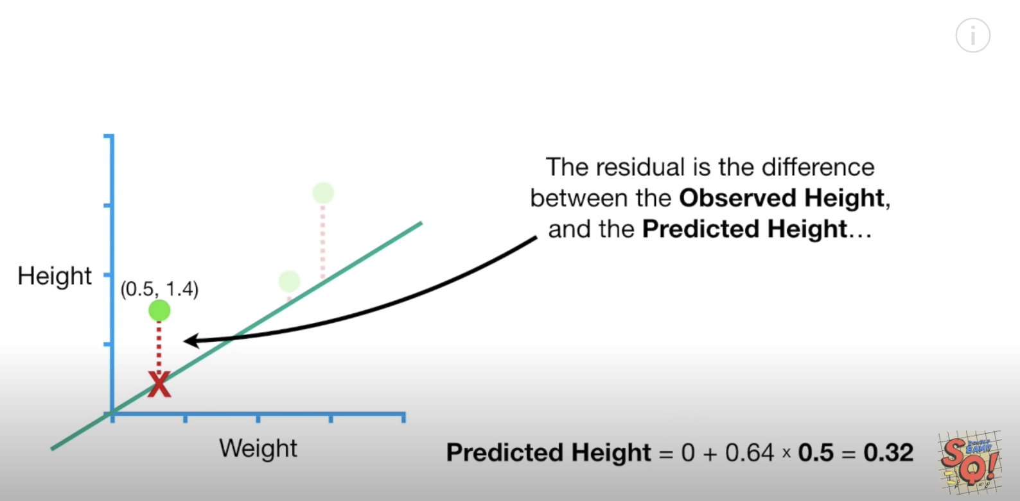

### The Loss (Cost) Function

Loss is used to measure the effectiveness of the model. Loss really is just the sum of the squared residuals. When actual height is 1.4 and our estimated height is 0.32 when the residual value is:

**1.4 – 0.32 $≈$ 1.08**

When summing the squared residuals for all three data points in our example the result is:

${(-1.08)}^{2}+{(-0.428)}^{2}+{1.344}^{2}$ = 3.155

Exercise 7 (2 marks)

Show the calculation by hand that is used to generate the residual value of -0.428 in the sum of squared residual values calculation above. To do this you will have to plug the actual weight value of 1.9 into the model equation.

|  |
| --- |
| Predicted height = 0 + 0.64*height (2.3) = 1.216  Actual weight = 1.9  So residual is 1.216 – 1.9 = -0.428 |

The red dot in Figure 3 is the sum of the squared residuals when intercept is 0. The sum of the squared residuals is the **cost function**.

Figure 3: Regression Line Versus Cost Function

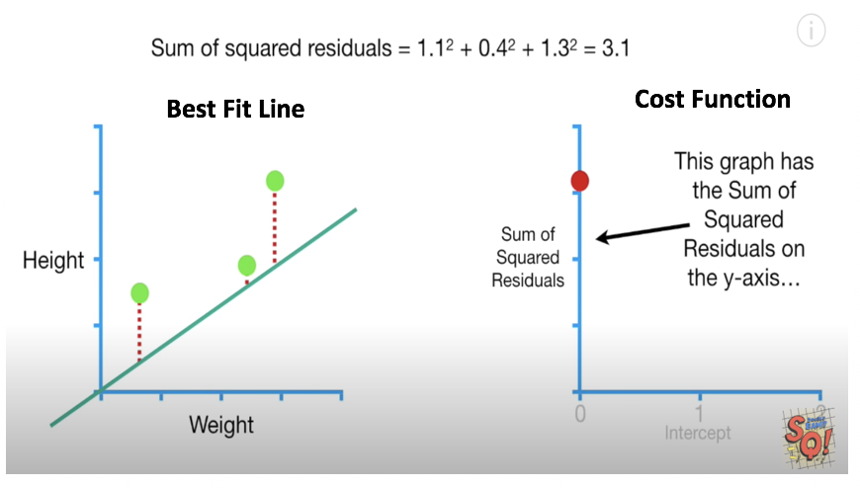

Exercise 8 (1 mark)

I know this question may seem trivial and even obvious but it is important that you understand. What does the value of the red dot in the graph in Figure 3 represent in terms of the horizontal and vertical axis?

|  |
| --- |
| Horizontal axis represents different values for the intercept and vertical axis represents sum of the squared residuals |

We can change the intercept to obtain a lower sum squared residuals. Lower squared residuals imply a more accurate regression. The red dots in the right of Figure 4 show how the error is reduced as the intercept value is increased.

Figure 4: Best Fit Versus Cost

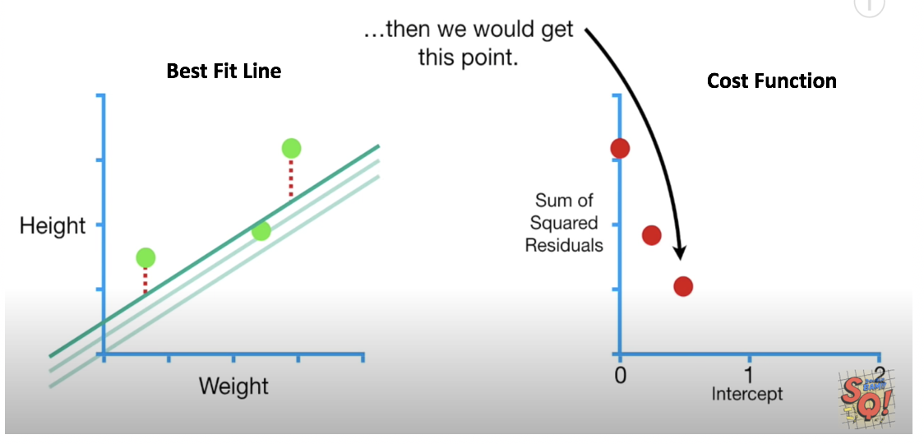

Exercise 9 (1 mark)

Which dot in Figure 4 highlights the most optimized point of the cost function.

Answer : d

1. The green dot at the very left.
2. The red dot on the left.
3. The middle red dot.
4. The red dot on the right.

Exercise 10 (1 mark)

In figure 4 for Example 5, each red dot represents the sum of the squared residuals for all samples when using a specific intercept.

T / F

The slope of the cost function approaches 0 as the regression becomes more accurate. See Figure 5.

Figure 5: Seeking the Minimal Slope of the Cost Function

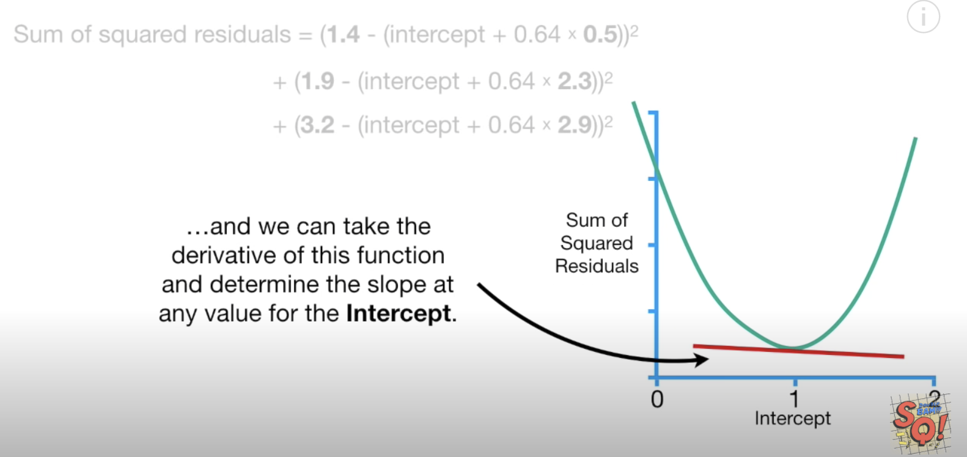

Trying to fine the lowest cost.

## Implementing Gradient Descent

We place Chad the robot at a random position in our bowl. However, Chad has only one sensor. The sensor detects the loss value at the exact position where he stands. Using this sensor, how could Chad get to the bottom? If you guessed gradient descent you guessed right. (see Figure 6).

Figure 6: Chad the Robot is. Finding His Way to the Bottom of the Bowl

|  |  |
| --- | --- |
|  |  |

Gradient descent (경사도) finds the slope of the cost function that is closest to zero. We can calculate the slope using several methods. You could calculate the change in y over the change in x. You can also take the derivative of the cost function to do the same thing. When the intercept is 0 the slope is -5.7.

Figure 7: Finding the Slope of the Cost (Loss) Function

Where 0.64 is the slope of the best fit line:

|  |  |  |
| --- | --- | --- |
|  | Weight  0.5  2.3  2.9 | Height  1.4  1.9  3.2 |

Exercise 11 (1 mark)

By examining the graph, suggest an intercept value for the example above when the cost / loss function is minimized?

|  |
| --- |
| It will be close to 1 |

## Calculating the Derivative

Figure 7 summarizes the calculates the sum of the squared residuals relative to the change in the intercept. In other words, we are calculating the derivative with respect to the intercept.

We will not cover calculus in this course but for curious minds here is how the equation for the derivative of the loss function is derived.

**intercept + $β∙$ ${weight}_{1}$ = 0 + $0.64∙$ ${weight}_{1}$**

= i + $β∙w$

Where i=intercept, h= height and $\hat{h}$ =estimated height:

Residual = $\sum{(}$ ${h-\hat{h})}^{2}$

= $\sum{h^{2}}{-2∙h∙\hat{h}+\hat{h}}^{2}$

= ${\sum{h^{2}}-2∙h∙(i+β∙w)+(i+β∙w)}^{2}$

= ${\sum{h^{2}}-2hi -2hβw+i^{2}+2iβw+β^{2}w}^{2}$

$\frac{d (residual error)}{d(intercept)}$ = 0 – 2h – 0 +2i +2 $βw$ + $0$

= -2(h – i - $βw$)

Since the intercept is a constant, the derivative of the intercept is 0. In the end we can determine that the change in the sum of squared residuals relative to the change in the intercept is -5.7 as shown in Figure 7. Therefore, the slope of the cost function when the intercept is 0 is -5.7. Here is some code to perform the same calculation:

|  |
| --- |
| weights = [0.5, 2.3, 2.9] heights = [1.4, 1.9, 3.2]  **def** getRes(weights, heights, intercept):  sum = 0  BETA = 0.64  **for** i **in** range(0, len(weights)):  sum+= -2*(heights[i] - intercept - BETA*weights[i])    print(**"Intercept: "** + str(intercept) + **" Res: "** + str(round(sum,2)) )  intercept = 0 getRes(weights, heights, intercept) |

Exercise 12 (1 mark)

What is the approximate derivative of the sum of the squared residuals when the intercept is 0.95?

1. 0
2. -1
3. 0.213
4. 0.296

Exercise 13 (1 mark)

Show a picture of the slope of the loss function when the intercept is 0.95 for this example. You can use MS Paint, a drawing tool or you can draw it on paper and embed your image in this document. Show your graph below.

|  |
| --- |
|  |

### The Learning Rate

When plotting the gradient descent cost function values in Figure 8, notice how the width between intercept estimates become closer as the slope of the cost function approaches zero.

Figure 8: Width Between Cost Function Points

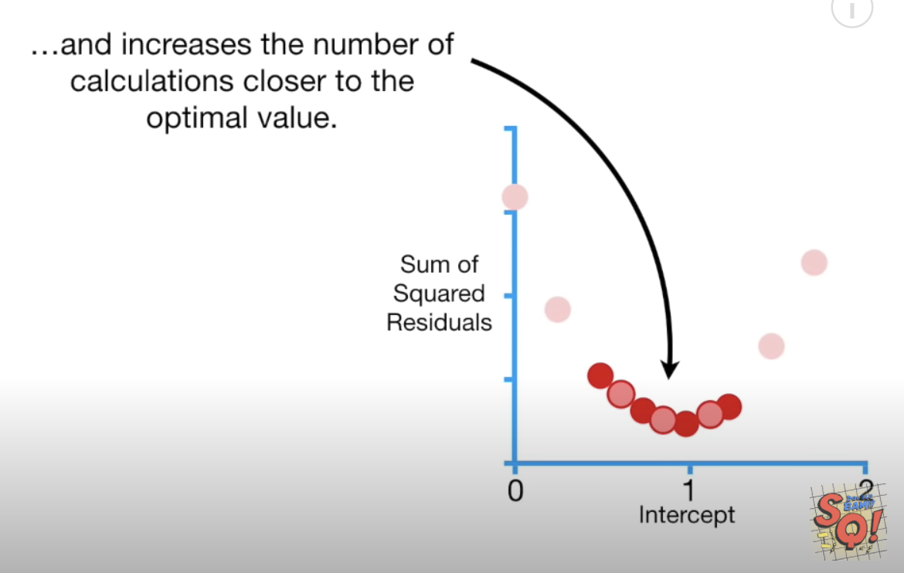

A higher learning rate can be used to speed up the descent to the minimum. However, a learning rate that is too high can cause the algorithm to overshoot the minimum and miss it. A learning rate that is too low can cause the algorithm to take too long to find the minimum. Often, manual adjustments to the learning rate are needed to find an optimal balance between speed and accuracy.

Figure 9 shows various learning rates which are applied over several iterations which are called **epochs**. The yellow and green learning rates are too fast so they missed the minimum.

Figure 9: Various Learning Rates

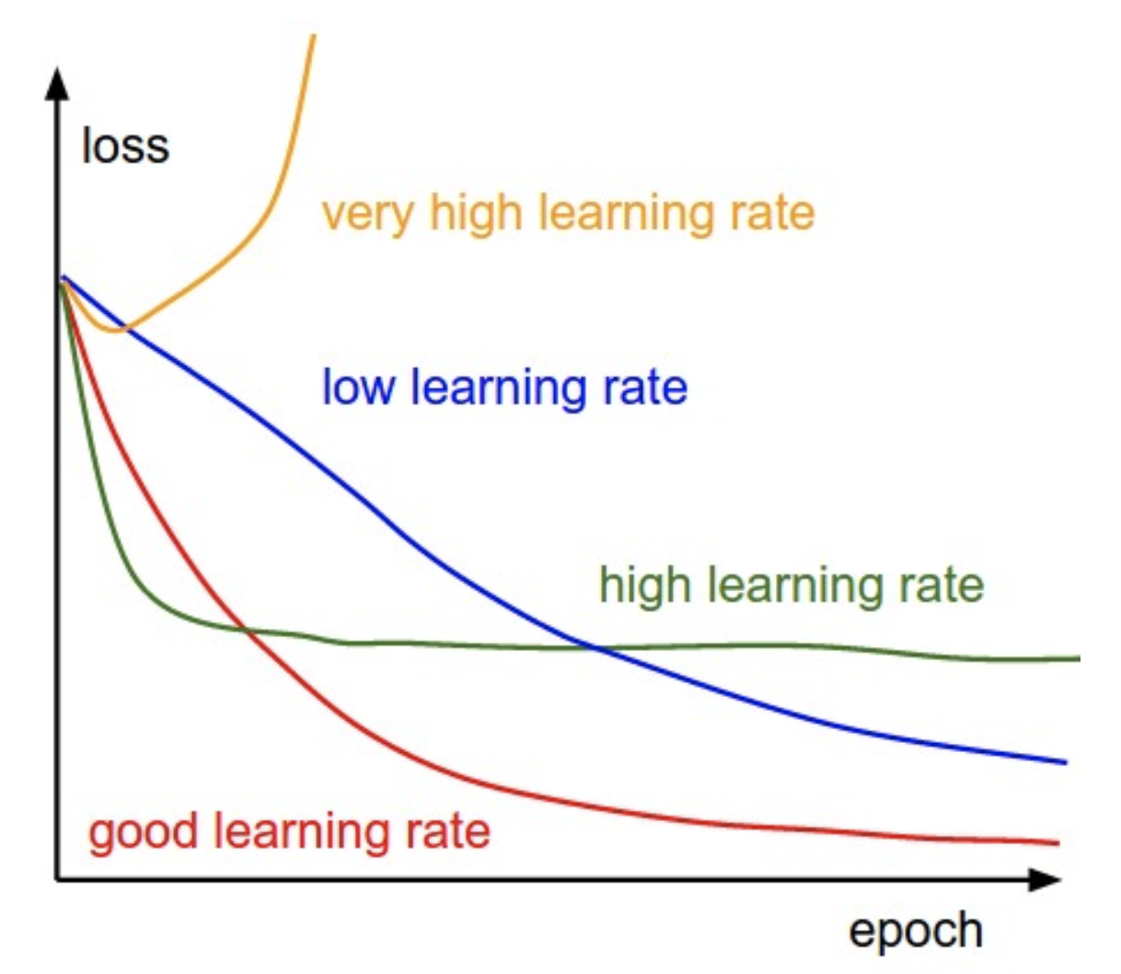

Exercise 14 (1 mark)

Which line in Figure 9 shows a learning rate that is too slow?

|  |
| --- |
| Low learning late…. Looks slow |

#### Step Size

Step size in this case refers to the amount of change in the intercept value as we search for the optimum.

To avoid over or under-shooting the minimum we need to find an appropriate step size at a rate that is suitable when far or close to the minimum. Ideally, as the slope of the loss function approaches 0 the step size becomes smaller and smaller (refer to Figure 8).

**Step size = slope $∙$ learning rate**

Remember, we showed that when the intercept is zero, the slope of the cost (loss) function is

-5.7

Figure 10: Slope of the Cost Function when the Intercept is 0.

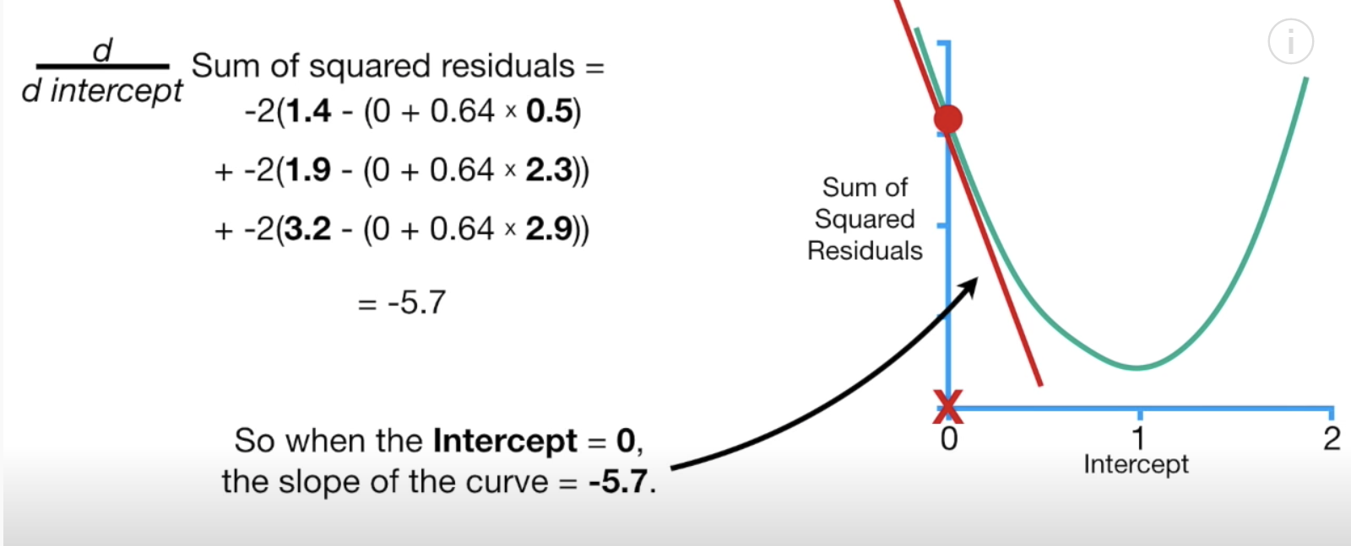

Therefore, if the **learning rate** is 0.1, the step size when the intercept is zero is:

Step size = slope $∙$ learning rate = -5.7 $∙$ 0.1 = -0.57

The new intercept becomes the old intercept - the step size:

New intercept = old intercept – step size = 0 - -0.57 = 0.57

We can represent our new intercept on our graph (see Figure 11).

Figure 11: Plotting intercepts 0 and 0.57 on the cost function graph

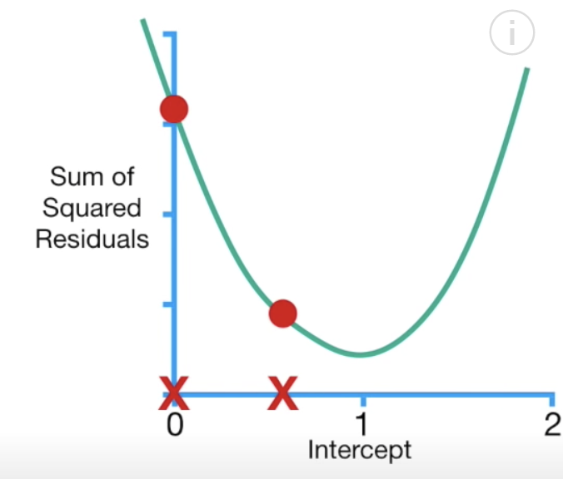

When the intercept is 0.57, notice how the sum of the squared residuals is reduced (see Figure 12).

Figure 12: Reducing the Sum of the Squared Residuals

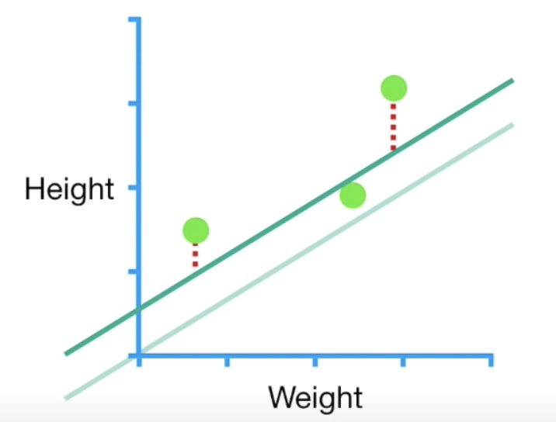

Exercise 15 (3 marks)

What is the slope of the cost function when the intercept is 0.57? Show the setup for your calculation. Refer to Figure 10. Also show the final answer.



|  |
| --- |
| Derivative of the sum of the square residuals =  -2(1.4-(0.57 + 0.64*0.5) + -2(1.9-(0.57 + 0.64*2.3) + -2(3.2-(0.57 + 0.64*2.9)  = -2.3 |

Exercise 16 (3 marks)

If the learning rate is 0.1, what is the next step size when the intercept is 0.57? What intercept is generated with the new step size? Show your calculations.

|  |
| --- |
| Step size = -2.3 * 0.1 = -0.23 so new intercept is 0.57- (-0.23) = 0.8  So calculate new Derivative of the sum of the square residuals until the step size is very close to 0 |

Example 6: Calculating the Minimum Loss When Estimating the Intercept and Slope

In Example 5 we examined how to apply gradient descent to find the best fit line by only adjusting the intercept. This example continues from Example 5. However, in this case we will consider adjustments to both the intercept and the slope of the best fit line.

Just like before we will calculate the sum of the squared residuals to determine the slope of the loss function. This time though, we will adjust both the slope and the intercept. Since we are now calculating loss function values for different slope and intercept values it helps to visualize the cost function in 3D space. To minimize the cost function, we must now find the minimum using three different axes. In other words, we need to find the bottom of the bowl shape shown in Figure 13.

Figure 13: Cost Function with Changing Slope and Intercept Values

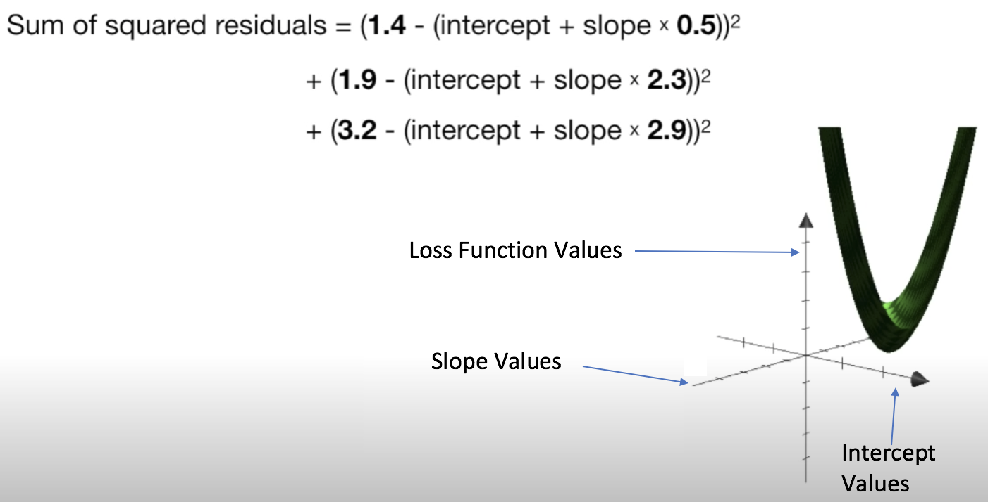

In Example 5, we were only searching for the changes in the intercept so we only took the derivative of the loss function with respect to the intercept. Now, since we are adjusting the intercept and the slope of the best fit line we must take the derivative of the loss function with respect to the intercept and the slope of the best fit line (see Figure 14).

Figure 14: Calculating the Slope of the Loss Function using Two Variables

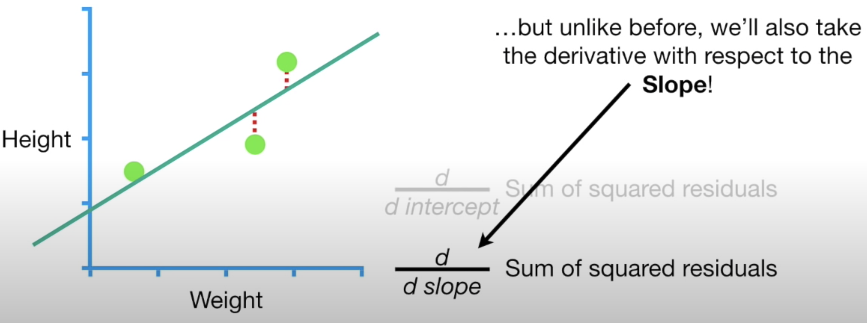

When you have two or more derivatives of the same function this is called a **gradient**. Figure 15 shows the calculations needed for determining both derivatives.

Figure 15: Derivatives with respect to the intercept and the slope

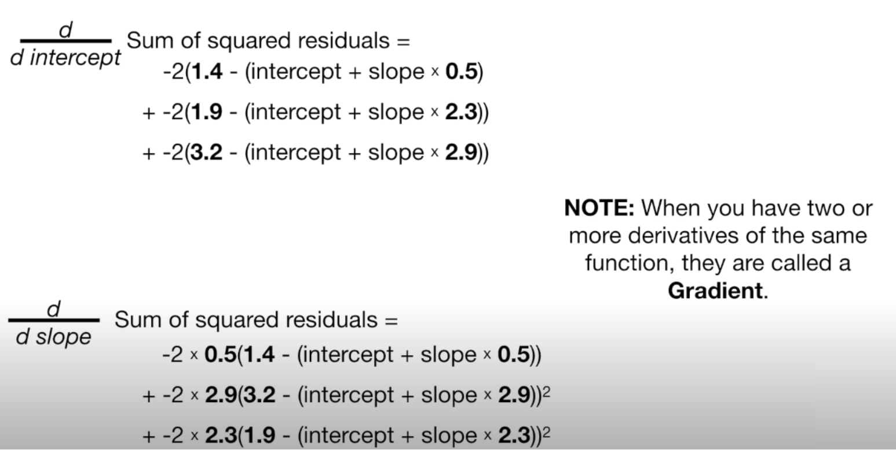

Essentially, we are using two different slopes to find minimums in two different dimensions If we were to calculate both derivatives by starting with an intercept of 0 and a slope of 1, notice how the step sizes are calculated when the learning rate is 0.1 (see Figure 16).

Figure 16: Calculating Step Size for each Dimension

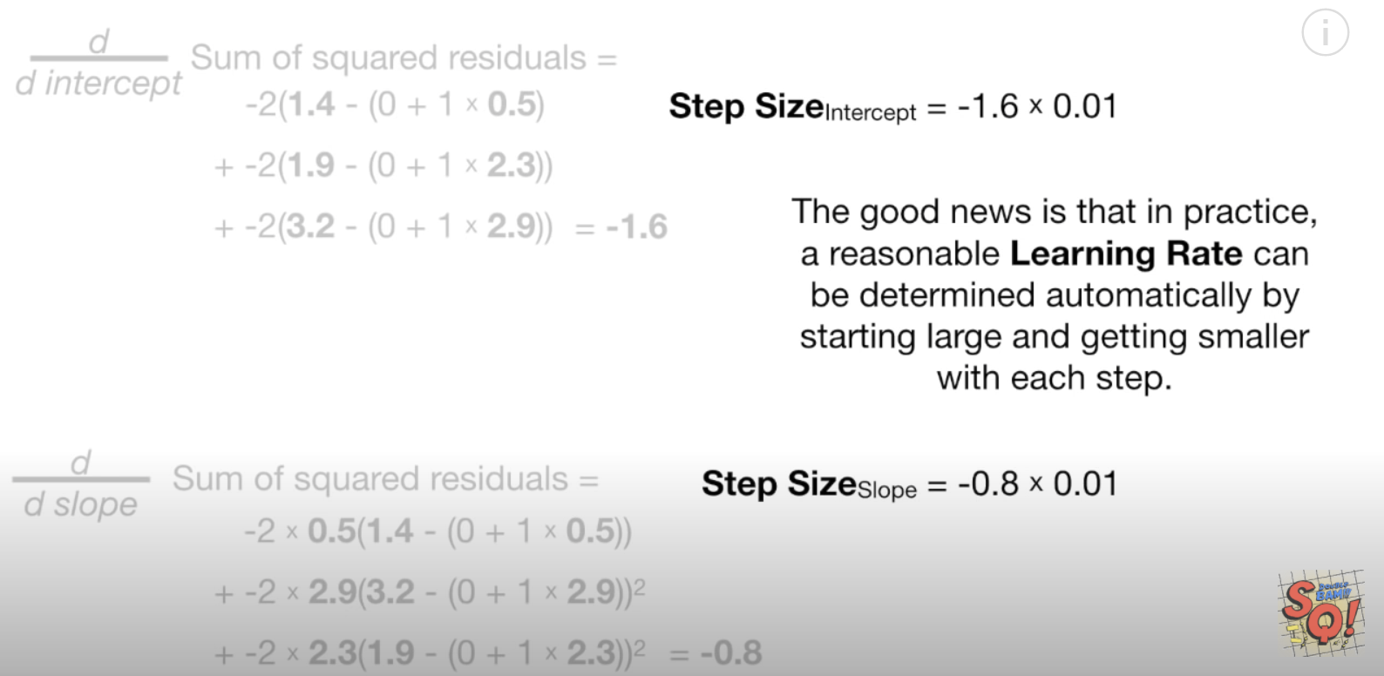

After taking several steps we arrive at the optimal slope and intercept for the best fitting line. This happens to be the same result that is generated by the least squares method (Figure 17).

Figure 17: The optimal intercept and slope from gradient descent

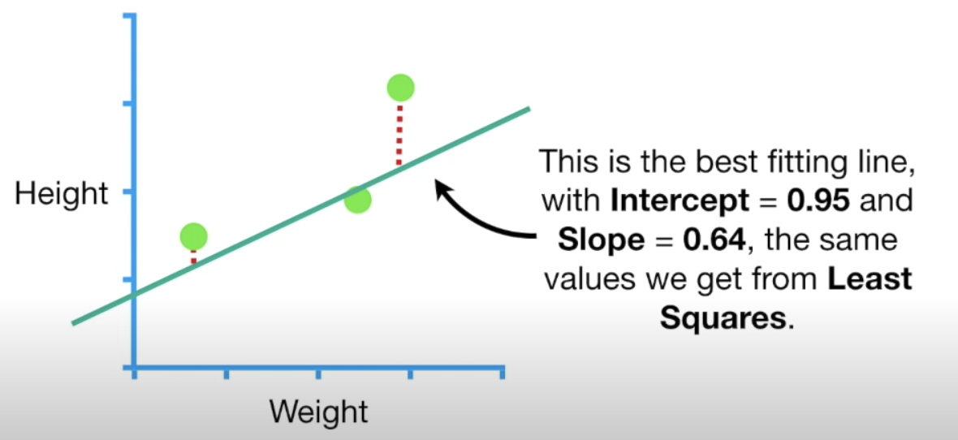

If we had more parameters than height and weight then we take only need to take more derivatives and everything else would stay the same.

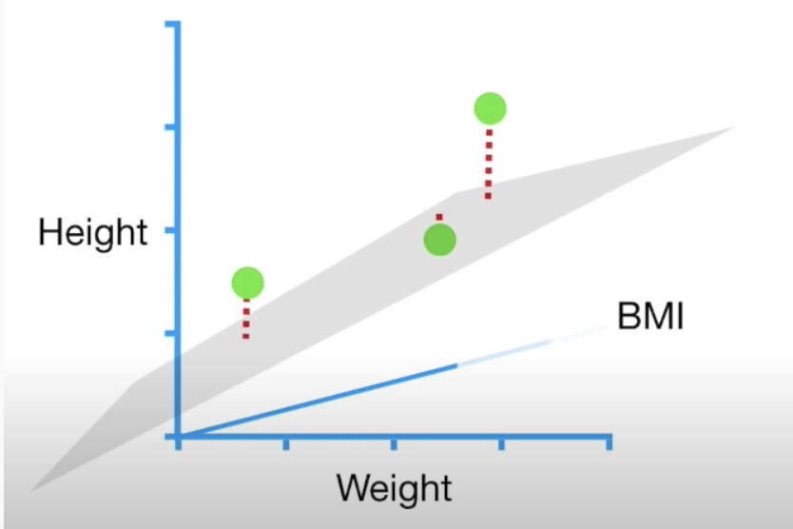

### Gradient Descent Summary

The sum of the squared residuals is just one type of loss function, there are many other types of loss functions but gradient descent works the same way. Specifically, the steps of the gradient descent algorithm are:

1. Take the derivative of the loss function for each parameter in it. In other words, take the gradient of the loss function.
2. Pick random values for the parameters.
3. Plug the parameter values into the derivatives.
4. Calculate the step sizes: (Step size = Slope x learning rate)
5. New parameter = old parameter – step size
6. Go back to step 3 and repeat until finding a minimum of 0.001 or less or until generally 1000 iterations (epochs).

## Stochastic Gradient Descent

For the three data points in Example 5 and Example 6 the calculations did not take very long. However, with millions of data records, the calculations can be very time consuming. Stochastic gradient descent works like the gradient descent algorithm. However, stochastic gradient descent takes a random subset of data to perform the calculations for the cost function.

Exercise 17 (1 mark)

In your own words, explain how stochastic gradient descent is different than gradient descent.

|  |
| --- |
| SGD is much faster because it only checking single point in loss function and its derivative, but Gradient Descent calculate almost all points’ loss and derivatives |

Exercise 18 (1 mark)

A gradient:

1. Is used for grating cheese.
2. Could be used to find the minimum of a single dimension.
3. Is the combination of two or more derivatives of the same equation in different dimensions.
4. Is the mid-point of a curvature.

**Table of Contents**

***Neural Networks Summarized by Siraj in 9 Minutes 1***

***The Learning Cycle of an Artificial Neural Network (ANN) 2***

**Hyperparameter Terminology 3**

Epoch 3

Batch Size 3

**Loss Functions 3**

1. Binary Crossentropy **'binary_crossentropy'** 3

2. Sparse Categorial Crossentropy **'sparse_categorical_crossentropy'** 3

**Activation Functions 3**

1. Sigmoid 'sigmoid' 4

2. Tanh 'tanh' 4

3. ReLU (Rectified Linear Unit) 'relu' 4

4. Leaky ReLU 4

5. Softmax 'softmax' 5

**Optimizers 5**

1. Adam 'adam' 5

2. SGD 'sgd' 5

**Kernel Initializers 5**

***Using a Grid Search Tuning the Neural Network Hyperparameters 6***

**Least Squares Regression Baseline 6**

**Neural Network Baseline 8**

**Epoch and Batch Size 10**

**Optimizer 12**

**Learning Rate and Other Optimizer Parameters 13**

**Kernel Initializer 14**

**Number of Neurons 15**

**Adding Another Layer 16**

**Final Model 17**

**Additional Tuning Tips 19**

Neural Networks Summarized by Siraj in 9 Minutes

This video summarizes the neural network structures at a lightning fast pace but the video is fun and it offers good re-enforcement for learning. You may want to revisit this video several times later in the course as you become more familiar with neural networks.

<https://www.youtube.com/watch?v=p69khggr1Jo>

The Learning Cycle of an Artificial Neural Network (ANN)

Machine learning algorithms use the term **learning** when referring to training. The diagram in Figure 1 helps to illustrate the neural network learning cycle.

1. A sample’s features are fed forward to a neuron in the input layer. Each input is then fed forward to each **neuron** in the hidden layer. Each neuron initializes a weight and a bias.
2. The dot product of each weight vector times the sample attributes is then added to each corresponding bias. This result is then sent to the activation function which usually compresses the result to a range that is roughly between 0 to 1. The output from the activation function is then sent forward to the next layer.
3. The loss is calculated at the output layer.
4. The weights and bias in the output layer are calculated.
5. The losses are then propagated backwards to the preceding layers. Weights and biases in all preceding layers are updated until reaching the first hidden layer.
6. Steps 2 through 5 are repeated. Each full pass of all samples through the network is called an **epoch**.
7. The final model weights and biases are then stored when the **learning** (training) is complete.

*Figure 1: Single Dense Layer Network Learning Cycle*

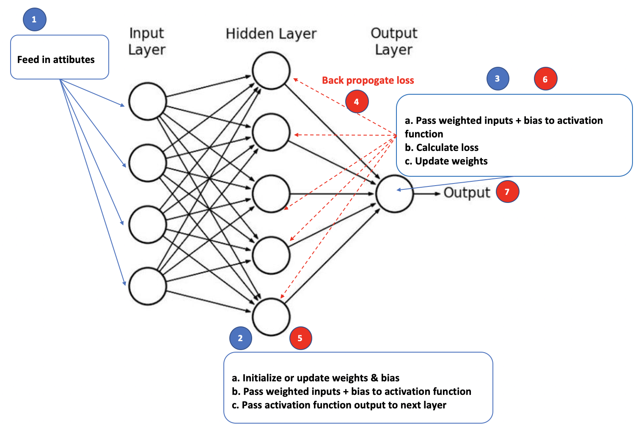

Hyperparameter Terminology

Artificial neural networks have many parameters that need to be configured. This section describes some of the basic hyperparameter terms. The process of configuring hyperparameters is called **tuning**. This section will discuss some of the initial hyperparameters that we will work adjust when tuning.

Epoch

An epoch is an iteration of all sample data through the network.

Batch Size

The batch size is the number of samples that are processed before the model is updated. Batch size can range from 1 up to the number of samples. Figure 2 compares the advantages and disadvantages of small versus full sample batch sizes.

*Figure 2: Comparing Small and Large Batch Sizes*

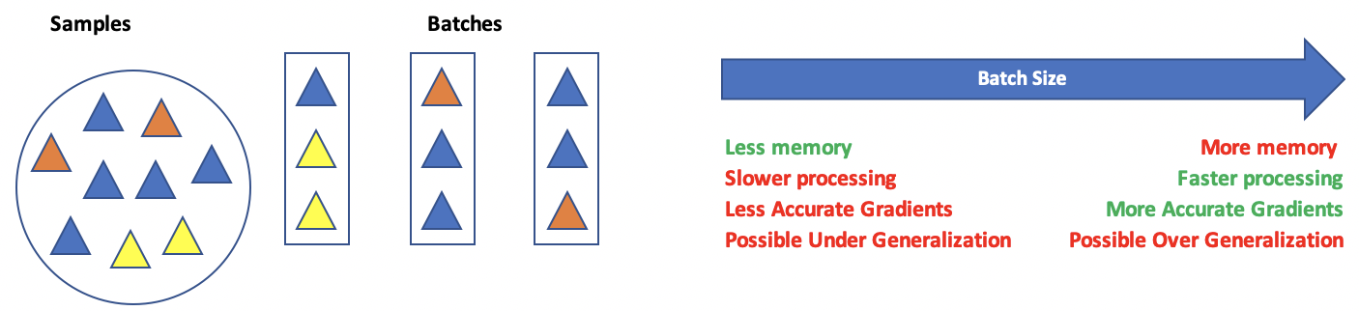

Which one is better : depends on the model.

Loss Functions

Loss functions help to measure the difference between actual and predicted results. There are many loss function algorithms. The selection relies on the type of output that is desired. For more information see <https://keras.io/api/losses/>

Here are some common loss function options:

For Classification

1. *Binary Crossentropy* **'binary_crossentropy'**

This option is used for a single output of 0 or 1.

1. *Sparse Categorial Crossentropy* **'sparse_categorical_crossentropy'**

This option is used when categories are expressed as a series of non-binary integers such as:

0, 1, 2, 3

1. *Categorical Crossentropy* **'categorical_crossentropy'**

This option is less common but is helpful when output categories are one-hot encoded:

[1,0,0]

[0,1,0]

[0,0,1]

For Regression

1. *Mean squared error.*
2. *Mean absolute error.*

<https://keras.io/api/losses/>

Activation Functions

Activation functions are mathematical equations that determine the output of a neuron. Activation functions of the hidden layer are usually different than the activation function of an output layer. Here are some common activation functions:

1. Sigmoid 'sigmoid'

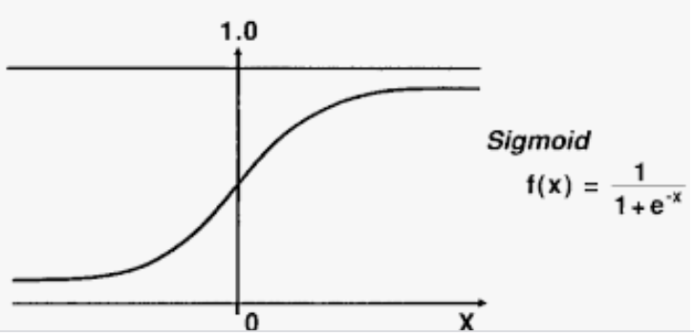

A sigmoid function transforms values to a value between 0 and 1. The sigmoid function can lead to a vanishing gradient problem in deeper networks because really large and really small values are not much different from each other. Computationally, the sigmoid is expensive.

1. Tanh 'tanh'

With a tanh function, the outputs are centered about zero. Otherwise the advantages and disadvantages are similar to the sigmoid function.

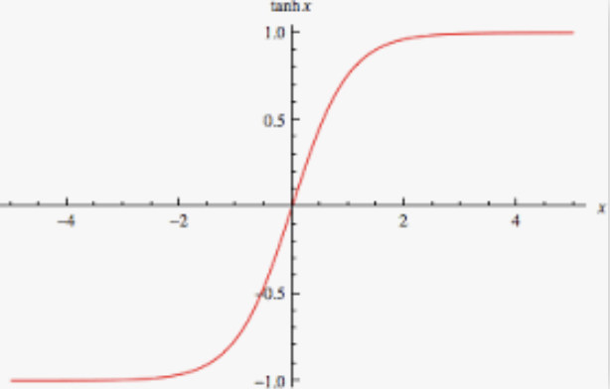

1. ReLU (Rectified Linear Unit) 'relu'

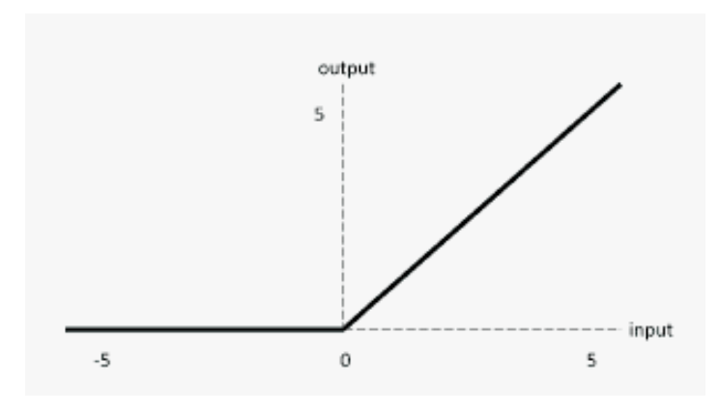

The ReLU is computationally efficient—it allows the network to converge very quickly. The ReLU is non-linear—but it looks like a linear function, ReLU has a derivative function and allows for backpropagation

**The Dying ReLU problem**—when inputs approach zero, or are negative, the gradient of the function becomes zero, the network cannot perform backpropagation and cannot learn when this happens.

1. Leaky ReLU

|  |  |
| --- | --- |
|  | import tensorflow.keras as tf  lrelu = tf.keras.layers.LeakyReLU(  alpha=0.3  )  LeakyReLU allows a small gradient when neuron not active.  f(x) = alpha * x if x < 0   f(x) = x if x >= 0 |

The Leaky ReLU (LReLU or LReL) modifies the function to allow small negative values when the input is less than zero. This prevents dying the ReLU problem—this variation of ReLU has a small positive slope in the negative area, so it enables backpropagation, even for negative input values. Results are not consistent though since the leaky ReLU does not provide consistent predictions for negative input values.

1. Softmax 'softmax'

Softmax is often used with **output neurons**. Softmax gives the probability of the input value being in a specific class. Softmax is good for classifying outputs in many categories and continuous values.

Optimizers

Optimizers adjust **weights and bias** for the regression equation and the **learning rate** to reduce the losses in the network. Common optimizers are: Adadelta, Adagrad, Adam, Adamax, Ftrl, Nadam, RMSprop, and SGD. Often, optimizers can be implemented by name but often they can be further customized with additional parameters for items such as learning rates. For example, here are custom configurations for the adam and sgd optimizers:

1. Adam 'adam'

tf.keras.optimizers.Adam(  
    learning_rate=0.001, beta_1=0.9, beta_2=0.999, epsilon=1e-07,

amsgrad=False, name='Adam', **kwargs  
)

1. SGD 'sgd'

Updates with SGD can fluctuate with significant volatility. Momentum is a time-based weighting that helps to smooth

the updates. Nesterov’s Accelerated Gradient Descent is an additional option that can sometimes eliminate volatility.

tf.keras.optimizers.SGD(  
    learning_rate=0.01, momentum=0.0, nesterov=False, name='SGD', **kwargs  
)

Kernel Initializers

Kernel initializers set the algorithm which initializes weight values in each neuron. The aim of weight initialization is to prevent neuron gradients from exploding or vanishing. In other words, neurons cannot be revived if their gradients become too large or if the gradient is 0. The network may never reach an optimum if too many neuron gradients explode or vanish. Some initializer options include 'uniform', 'lecun_uniform', 'normal', 'zero', 'glorot_normal', 'glorot_uniform', 'he_normal', 'he_uniform'.

Using a Grid Search Tuning the Neural Network Hyperparameters

A grid search is an exhaustive loop through a list of potential neural network hyperparameter combinations. The goal is to find the most effective hyperparameter combination. Grid searches can be conducted with the help of the **KerasClassifier** for classification problems or the **KerasRegressor** class for linear regression type problems.

This section is based on this post at <https://machinelearningmastery.com/grid-search-hyperparameters-deep-learning-models-pythond-keras/>

https://machinelearningmastery.com/grid-search-hyperparameters-deep-learning-models-python-keras/

The example in the post provided demonstrates an example which how the **KerasClassifier** can help to tune a neural network for classification. Example 1, however, shows how to implement the **KerasRegressor** to tune a network that is performing regression for a continuous variable.

Least Squares Regression Baseline

When tuning your network hyperparameters, I recommend that you first build a basic logistic regression model or a simple least squares regression model. This model can help to identify significant predictor variables. The model can also help to determine a reasonable level of accuracy for your network.

*Example 1: Building a Baseline Least Squares Regression Model*

This example generates prediction for housing price which is located in last column on the right.

|  |
| --- |
| 0 1 2 3 4 5 6 7 8 9 10 11 12 13  0 0.00632 18.0 2.31 0 0.538 6.575 65.2 4.0900 1 296.0 15.3 396.90 4.98 24.0  1 0.02731 0.0 7.07 0 0.469 6.421 78.9 4.9671 2 242.0 17.8 396.90 9.14 21.6  2 0.02729 0.0 7.07 0 0.469 7.185 61.1 4.9671 2 242.0 17.8 392.83 4.03 34.7  3 0.03237 0.0 2.18 0 0.458 6.998 45.8 6.0622 3 222.0 18.7 394.63 2.94 33.4  4 0.06905 0.0 2.18 0 0.458 7.147 54.2 6.0622 3 222.0 18.7 396.90 5.33 36.2 |

In this initial OLS example, coefficients 3 and 7 are insignificant. The $R^{2}$ value of 0.773 indicates a strong correlation between the price and predictor variables. The root mean-square error, RMSE, value of 5.78 provides a decent understanding of the deviation about the mean which can be used as a comparison for other models. Here is the output when running the code for this example:

|  |
| --- |
| Root Mean Squared Error: 5.7835  OLS Regression Results  ==============================================================================  Dep. Variable: y R-squared: 0.773  Model: OLS Adj. R-squared: 0.765  Method: Least Squares F-statistic: 102.2  Date: Sun, 13 Sep 2020 Prob (F-statistic): 9.64e-117  Time: 08:25:09 Log-Likelihood: -1171.5  No. Observations: 404 AIC: 2371.  Df Residuals: 390 BIC: 2427.  Df Model: 13  Covariance Type: nonrobust  ==============================================================================  coef std err t P>|t| [0.025 0.975]  ------------------------------------------------------------------------------  const 38.0917 5.522 6.898 0.000 27.234 48.949  x1 -0.1194 0.037 -3.257 0.001 -0.192 -0.047  x2 0.0448 0.014 3.102 0.002 0.016 0.073  x3 0.0055 0.063 0.087 0.931 -0.119 0.130  x4 2.3408 0.902 2.595 0.010 0.567 4.115  x5 -16.1236 4.212 -3.828 0.000 -24.404 -7.843  x6 3.7087 0.458 8.106 0.000 2.809 4.608  x7 -0.0031 0.014 -0.218 0.828 -0.031 0.025  x8 -1.3864 0.214 -6.480 0.000 -1.807 -0.966  x9 0.2442 0.070 3.481 0.001 0.106 0.382  x10 -0.0110 0.004 -2.819 0.005 -0.019 -0.003  x11 -1.0459 0.137 -7.636 0.000 -1.315 -0.777  x12 0.0081 0.003 2.749 0.006 0.002 0.014  x13 -0.4928 0.054 -9.086 0.000 -0.599 -0.386  ==============================================================================  Omnibus: 141.494 Durbin-Watson: 1.996  Prob(Omnibus): 0.000 Jarque-Bera (JB): 629.882  Skew: 1.470 Prob(JB): 1.67e-137  Kurtosis: 8.365 Cond. No. 1.55e+04  ============================================================================== |

Here is the code for generating the least squares regression:

|  |
| --- |
| import pandas as pd  import numpy as np  from sklearn import metrics  from sklearn.model_selection import train_test_split  import statsmodels.api as sm  PATH = "/Users/pm/Desktop/DayDocs/data/"  CSV_DATA = "housing.data"  df = pd.read_csv(PATH + CSV_DATA, header=None)  # Show all columns on one line.  pd.set_option('display.max_columns', None)  pd.set_option('display.width', 1000)  print(df.head())  print(df.tail())  print(df.describe())  dataset = df.values  # Split data into input (X) and output (Y) variables.  X = dataset[:,0:13]  y = dataset[:,13]  # Adding an intercept *** This is required ***. Don't forget this step.  # The intercept centers the error residuals around zero  # which helps to avoid over-fitting.  X = sm.add_constant(X)  X_train, X_test, y_train, y_test = train_test_split(X, y, test_size=0.2, random_state=0)  # Make predictions and evaluate with the RMSE.  model = sm.OLS(y_train, X_train).fit()  predictions = model.predict(X_test)  print(model.summary())  print('Root Mean Squared Error:',  np.sqrt(metrics.mean_squared_error(y_test, predictions))) |

Neural Network Baseline

The next step involves creating a simple baseline neural network. I recommend that you begin by building a 1-layer network. You may decide later to start with more layers. For now, at least understand the grid search technique before designing more complicated solutions.

*Example 2: Neural Network Baseline Housing Data*

Right now, our crude baseline neural network model does not perform as well as the linear regression model. With some tuning it is very possible that we can generate a better fitting model than OLS.

|  |  |
| --- | --- |
| **OLS RMSE from Example 1** | **RMSE from Neural Network** |
| 5.7835 | 6.5880 |

Here is the code.

**Note:** Remember to reshape your X and Y data into vertical columns.

|  |
| --- |
| import pandas as pd  import numpy as np  from sklearn import metrics  from sklearn.model_selection import train_test_split  from keras.models import Sequential  from keras.layers import Dense  from keras.wrappers.scikit_learn import KerasRegressor  from sklearn.model_selection import cross_val_score  from sklearn.model_selection import KFold  # Read the data.  PATH = "/Users/pm/Desktop/DayDocs/data/"  CSV_DATA = "housing.data"  df = pd.read_csv(PATH + CSV_DATA, header=None)  # Show all columns.  pd.set_option('display.max_columns', None)  pd.set_option('display.width', 1000)  print(df.head())  print(df.tail())  print(df.describe())  # Convert DataFrame columns to vertical columns so they can be used by the NN.  dataset = df.values  X = dataset[:, 0:13] # Columns 0 to 12  y = dataset[:, 13] # Columns 13  ROW_DIM = 0  COL_DIM = 1  x_arrayReshaped = X.reshape(X.shape[ROW_DIM], X.shape[COL_DIM])  y_arrayReshaped = y.reshape(y.shape[ROW_DIM],1)  # Split the data.  X_train, X_test, y_train, y_test = train_test_split(x_arrayReshaped,  y_arrayReshaped, test_size=0.2, random_state=0)  # Define the model.  def create_model():  model = Sequential()  model.add(Dense(13, input_dim=13, kernel_initializer='normal',  activation='relu'))  model.add(Dense(1, kernel_initializer='normal'))  model.compile(loss='mean_squared_error', optimizer='adam')  return model  # Since this is a linear regression use KerasRegressor.  estimator = KerasRegressor(build_fn=create_model, epochs=100,  batch_size=5, verbose=1)  # Use kfold analysis for a more reliable estimate.  kfold = KFold(n_splits=10)  results = cross_val_score(estimator, X_train, y_train, cv=kfold)  print("Baseline Mean (%.2f) MSE (%.2f) " % (results.mean(), results.std()))  print("Baseline RMSE: " + str(np.sqrt(results.std())))  # Build the model.  model = create_model()  history = model.fit(X_train, y_train, epochs=100,  batch_size=5, verbose=1,  validation_data=(X_test, y_test))  # Evaluate the model.  predictions = model.predict(X_test)  mse = metrics.mean_squared_error(y_test, predictions)  print("Neural network MSE: " + str(mse))  print("Neural network RMSE: " + str(np.sqrt(mse))) |

Epoch and Batch Size

Now we can start grid searching our hyperparameters ideally to minimize the RMSE the house price predictions more.

*Example 3: Epoch and Batch Tuning*

The yellow highlighted code sets up the grid search for batch_size and epochs.

|  |
| --- |
| ### Grid Building Section #######################  model = KerasRegressor(build_fn=create_model)  # define the grid search parameters  batch_size = [10, 20, 40, 60, 80, 100]  epochs = [5, 10, 50, 100]  param_grid = dict(batch_size=batch_size, epochs=epochs)  grid = GridSearchCV(estimator=model, param_grid=param_grid,  n_jobs=-1, cv=3, verbose=1)  ################################################# |

The output from the first scan suggests that 100 epochs and a batch size of 10 are optimal.

|  |
| --- |
| Best: -30.506042 using {'batch_size': 10, 'epochs': 100}  -73.378028 (15.199006) with: {'batch_size': 10, 'epochs': 5}  -59.623238 (17.230753) with: {'batch_size': 10, 'epochs': 10} |

After observing a suggested batch size of 10, I ran the code again with a finer tuned set of numbers and determined that a batch size of 9 might be more optimal. I decided to carry the batch size of 9 into the remaining examples after this observation.

Best: -27.585736 using {'batch_size': 9, 'epochs': 100}

|  |
| --- |
| import pandas as pd  from sklearn.model_selection import train_test_split  PATH = "/Users/pm/Desktop/DayDocs/data/"  CSV_DATA = "housing.data"  df = pd.read_csv(PATH + CSV_DATA, header=None)  # Show all columns.  pd.set_option('display.max_columns', None)  # Increase number of columns that display on one line.  pd.set_option('display.width', 1000)  print(df.head())  print(df.tail())  print(df.describe())  dataset = df.values  # split into input (X) and output (Y) variables  X = dataset[:,0:13]  y = dataset[:,13]  X_train, X_test, y_train, y_test = train_test_split(X,  y, test_size=0.2, random_state=0)  from keras.models import Sequential  from keras.layers import Dense  from keras.wrappers.scikit_learn import KerasRegressor  from sklearn.model_selection import GridSearchCV  # Define the model.  def create_model():  model = Sequential()  model.add(Dense(13, input_dim=13, kernel_initializer='normal',  activation='relu'))  model.add(Dense(1, kernel_initializer='normal'))  model.compile(loss='mean_squared_error', optimizer='adam')  return model  ### Grid Building Section #######################  model = KerasRegressor(build_fn=create_model)  # define the grid search parameters  batch_size = [10, 20, 40, 60, 80, 100]  epochs = [5, 10, 50, 100]  param_grid = dict(batch_size=batch_size, epochs=epochs)  grid = GridSearchCV(estimator=model, param_grid=param_grid,  n_jobs=-1, cv=3, verbose=1)  #################################################  grid_result = grid.fit(X_train, y_train)  # summarize results  print("Best: %f using %s" % (grid_result.best_score_, grid_result.best_params_))  means = grid_result.cv_results_['mean_test_score']  stds = grid_result.cv_results_['std_test_score']  params = grid_result.cv_results_['params']  for mean, stdev, param in zip(means, stds, params):  print("%f (%f) with: %r" % (mean, stdev, param)) |

*Exercise 1 (3 marks)*

Manually plug-in a batch size of 10 into the code within Example 2. Ensure that the model is tuned with 100 epochs. Show the RMSE that results after making these changes:

|  |
| --- |
|  |

What is the RMSE of the original configuration from Example 2?

|  |
| --- |
|  |

Show the section of code that you modified here.

|  |
| --- |
| # Since this is a linear regression use KerasRegressor. estimator = KerasRegressor(build_fn=create_model, epochs=100,  batch_size=10, verbose=1)  history = model.fit(X_train, y_train, epochs=10,  batch_size=10,  validation_data=(X_test, y_test)) |

*Exercise 2 (1 mark)*

What change in behaviour do you notice if the verbose=1 attribute is missing from the GridSearchCV() construction?

|  |
| --- |
| Text  Description automatically generatedText  Description automatically generated  There is no val-loss section. |

*Exercise 3 (1 mark)*

What does the cv parameter of the GridSearchCV() contructor do? (Please look this up online)

|  |
| --- |
| determines how much information is displayed. Using a value of 1 displays the time for each run. 2 indicates that the score is also displayed. 3 indicates that the fold and candidate parameter are also displayed. |

Optimizer

This section shows a strategy for grid searching the general optimizer. A more advanced version of each optimizer likely exists. It is usually possible to tweak the learning rate and other parameters that are specific to each optimizer which once an optimizer candidate is found.

*Example 4: Searching for the most efficient Optimizer*

Now that we have established a batch size of 10 and 100 epochs is a suitable estimate, we can look for an optimizer. The output suggests that the adam optimizer is best. The ‘adam’ optimizer will be used as a result for the model in all future examples.

|  |
| --- |
| Best: -30.511445 using {'optimizer': 'Adam'}  -85.811811 (15.191973) with: {'optimizer': 'SGD'}  -35.981366 (11.191688) with: {'optimizer': 'RMSprop'}  -83.595862 (30.616171) with: {'optimizer': 'Adagrad'} |

Since we are building on the best outcome from the last example, starting with Example 3, replace the create_model() code here from the previous example with this version to allow for dynamic adjustments of the optimizer function.

|  |
| --- |
| def create_model(optimizer='SGD'):  model = Sequential()  model.add(Dense(13, input_dim=13, kernel_initializer='normal',  activation='relu'))  model.add(Dense(1, kernel_initializer='normal'))  model.compile(loss='mean_squared_error', optimizer=optimizer)  return model |

Replace the *Grid Buildinig Section * from the previous example with this version.

|  |
| --- |
| ### Grid Building Section #######################  model = KerasRegressor(build_fn=create_model, epochs=100, batch_size=10, verbose=1)  # Define the grid search parameters.  optimizer = ['SGD', 'RMSprop', 'Adagrad', 'Adadelta', 'Adam', 'Adamax', 'Nadam']  param_grid = dict(optimizer=optimizer)  grid = GridSearchCV(estimator=model, param_grid=param_grid, n_jobs=-1, cv=3)  ################################################# |

*Exercise 4 (1 mark)*

Choose the best answer.

1. An optimizer sets an algorithm to initialize weights for each neuron.
2. An optimizer sets an algorithm to update weights for each neuron.
3. An optimizer sets an algorithm for activation.
4. An optimizer sets an algorithm for producing output.

Learning Rate and Other Optimizer Parameters

Most optimizers have more advanced customizable settings. Usually you can adjust the learning rate and other parameters. Documentation for several common optimizers can be found at <https://keras.io/api/optimizers/>

*Example 5: Optimizing the Learning Rate*

Since the ‘adam’ optimizer was identified as a strong performer in the previous example, we can fine tune it more by adjusting its learning rate. The ‘adam’ optimizer actually has many more parameters but we will focus on only the learning rate for this example:

|  |
| --- |
| tf.keras.optimizers.Adam(  learning_rate=0.001  ) |

The output when running the grid search for the best learning rate suggest a learning rate of 0.005 for our optimizer.

|  |
| --- |
| Best: -24.077209 using {'learningRate': 0.005}  -35.221776 (11.059594) with: {'learningRate': 0.001}  -24.077209 (7.600185) with: {'learningRate': 0.005} |

To build this example, replace the create_model() function from the previous example with this code:

|  |
| --- |
| from tensorflow.keras.optimizers import Adam #for adam optimizer  def create_model(learningRate = 0.001):  model = Sequential()  model.add(Dense(13, input_dim=13, kernel_initializer='normal',  activation='relu'))  model.add(Dense(1, kernel_initializer='normal'))  # Use Adam optimizer with the given learning rate  opt = Adam(lr=learningRate)  model.compile(loss='mse', metrics=['accuracy'], optimizer=opt)  return model |

Also, replace the “Grid Building Section” from the previous example with this version:

|  |
| --- |
| ### Grid Building Section #######################  model = KerasRegressor(build_fn=create_model, epochs=100, batch_size=10, verbose=1)  # Define the grid search parameters.  learningRates= [0.001, 0.005, 0.01, 0.015, 0.2]  param_grid = dict(learningRate=learningRates)  grid = GridSearchCV(estimator=model, param_grid=param_grid, n_jobs=-1, cv=3)  ################################################# |

*Exercise 5 (1 mark)*

How is the parameter of the create_model() function in Example 5 different than the parameter in the create_model() function of Example 4?

|  |
| --- |
| Example 5 used learning rate as the parameter because it used ama optimizer with given learning rates. So the result of adam optimizer can be multiple as the different learning rates. |

*Exercise 6 (3 marks)*

Manually plug-in a batch size of 10 into the code within Example 2. Ensure that the model is tuned with 100 epochs. Inside create_model() initialize an adam optimizer with a learning rate of 0.005. Assign this optimizer object to the optimizer parameter in create_model(). Show the RMSE that results after making these changes:

|  |
| --- |
|  |

What is the RMSE of the original configuration from Example 2?

|  |
| --- |
|  |

Show the section of code that you modified here.

|  |
| --- |
| import pandas as pd from sklearn.model_selection import train_test_split  PATH = "/Users/hyerimshin/PycharmProjects/MachineLearning/datasets/" CSV_DATA = "housing.data" df = pd.read_csv(PATH + CSV_DATA, header=None)  # Show all columns. pd.set_option('display.max_columns', None)  # Increase number of columns that display on one line. pd.set_option('display.width', 1000)  print(df.head()) print(df.tail()) print(df.describe())  dataset = df.values  # split into input (X) and output (Y) variables X = dataset[:,0:13] y = dataset[:,13]  X_train, X_test, y_train, y_test = train_test_split(X,  y, test_size=0.2, random_state=0)  from keras.models import Sequential from keras.layers import Dense from keras.wrappers.scikit_learn import KerasRegressor from sklearn.model_selection import GridSearchCV  # Define the model. def create_model():  model = Sequential()  model.add(Dense(13, input_dim=13, kernel_initializer='normal',  activation='relu'))  model.add(Dense(1, kernel_initializer='normal'))  model.compile(loss='mean_squared_error', optimizer='adam')  return model  ### Grid Building Section ####################### model = KerasRegressor(build_fn=create_model)  # define the grid search parameters batch_size = [10, 20, 40, 60, 80, 100] epochs = [5, 10, 50, 100] param_grid = dict(batch_size=batch_size, epochs=epochs) grid = GridSearchCV(estimator=model, param_grid=param_grid,  n_jobs=-1, cv=3, verbose=1) #################################################   grid_result = grid.fit(X_train, y_train)  # summarize results print("Best: %f using %s" % (grid_result.best_score_, grid_result.best_params_)) means = grid_result.cv_results_['mean_test_score'] stds = grid_result.cv_results_['std_test_score'] params = grid_result.cv_results_['params']  for mean, stdev, param in zip(means, stds, params):  print("%f (%f) with: %r" % (mean, stdev, param))   from tensorflow.keras.optimizers import Adam #for adam optimizer  def create_model(learningRate = 0.001):  model = Sequential()  model.add(Dense(13, input_dim=13, kernel_initializer='normal',  activation='relu'))  model.add(Dense(1, kernel_initializer='normal'))  # Use Adam optimizer with the given learning rate  opt = Adam(lr=learningRate)  model.compile(loss='mse', metrics=['rmse'], optimizer=opt)  return model    ### Grid Building Section ####################### model = KerasRegressor(build_fn=create_model, epochs=100, batch_size=10, verbose=1)  # Define the grid search parameters. learningRates= [0.001, 0.005, 0.01, 0.015, 0.2] param_grid = dict(learningRate=learningRates) grid = GridSearchCV(estimator=model, param_grid=param_grid, n_jobs=-1, cv=3) ################################################# |

Kernel Initializer

Kernel initializers use a distribution to optimize the initial model weights. The different algorithms for initializing weight can sometimes help to prevent vanishing and exploding gradients which destroy a neuron’s ability to back-propagate data.

*Example 6: Grid Searching the Kernel Initializer*

This section shows that some initializers perform much better than others. ‘uniform’ offers the best score and it is noticeably smaller than the ‘zero’ initializer.

|  |
| --- |
| Best: -21.859127 using {'init_mode': 'uniform'}  -21.859127 (4.547774) with: {'init_mode': 'uniform'}  -33.742336 (13.388874) with: {'init_mode': 'lecun_uniform'}  -26.358027 (9.466685) with: {'init_mode': 'normal'}  -182.339040 (28.125249) with: {'init_mode': 'zero'} |

To build this example, replace the create_model() function from the last example with this version.

|  |
| --- |
| n_features = X_train.shape[1]  # define base model  def create_model(init_mode='uniform'):  model = Sequential()  model.add(Dense(13, kernel_initializer=init_mode,  input_dim=n_features, activation='relu'))  model.add(Dense(1, kernel_initializer=init_mode))    opt = Adam(lr=0.005)  # Compile model  model.compile(loss='mse', metrics=['accuracy'], optimizer=opt)  return model |

Next, replace the “Grid Building Section” from the previous example with this version.

|  |
| --- |
| ### Grid Building Section #######################  model = KerasRegressor(build_fn=create_model, epochs=100, batch_size=10, verbose=1)  # Define the grid search parameters.  init_mode = ['uniform', 'lecun_uniform', 'normal', 'zero', 'glorot_normal',  'glorot_uniform', 'he_normal', 'he_uniform']  param_grid = dict(init_mode=init_mode)  grid = GridSearchCV(estimator=model, param_grid=param_grid, n_jobs=-1, cv=3)  ################################################# |

*Exercise 7 (3 marks)*

Manually plug-in a batch size of 10 into the code within Example 2. Ensure that the model is tuned with 100 epochs. Inside create_model() initialize an adam optimizer with a learning rate of 0.005. Assign this optimizer object to the optimizer parameter in create_model(). Set the kernel initializer to ‘uniform’. Show the RMSE that results after making these changes:

|  |
| --- |
|  |

What is the RMSE of the original configuration from Example 2?

|  |
| --- |
|  |

Show the section of code that you modified here.

|  |
| --- |
| import pandas as pd import numpy as np from sklearn import metrics from sklearn.model_selection import train_test_split, GridSearchCV from keras.models import Sequential from keras.layers import Dense from keras.wrappers.scikit_learn import KerasRegressor from sklearn.model_selection import cross_val_score from sklearn.model_selection import KFold from tensorflow.keras.optimizers import Adam  # Read the data. PATH = "/Users/hyerimshin/PycharmProjects/MachineLearning/datasets/" CSV_DATA = "housing.data" df = pd.read_csv(PATH + CSV_DATA, header=None)  # Show all columns. pd.set_option('display.max_columns', None) pd.set_option('display.width', 1000) print(df.head()) print(df.tail()) print(df.describe())  # Convert DataFrame columns to vertical columns so they can be used by the NN. dataset = df.values X = dataset[:, 0:13] # Columns 0 to 12 y = dataset[:, 13] # Columns 13 ROW_DIM = 0 COL_DIM = 1  x_arrayReshaped = X.reshape(X.shape[ROW_DIM], X.shape[COL_DIM]) y_arrayReshaped = y.reshape(y.shape[ROW_DIM],1)  # Split the data. X_train, X_test, y_train, y_test = train_test_split(x_arrayReshaped,  y_arrayReshaped, test_size=0.2, random_state=0)  # Define the model. n_features = X_train.shape[1]   # define base model def create_model(init_mode='uniform'):  model = Sequential()  model.add(Dense(13, kernel_initializer=init_mode,  input_dim=n_features, activation='relu'))  model.add(Dense(1, kernel_initializer=init_mode))   opt = Adam(lr=0.005)  # Compile model  model.compile(loss='mse', metrics=['accuracy'], optimizer=opt)  return model   # Since this is a linear regression use KerasRegressor. estimator = KerasRegressor(build_fn=create_model, epochs=100,  batch_size=10, verbose=1)  ### Grid Building Section ####################### model = KerasRegressor(build_fn=create_model, epochs=100, batch_size=10, verbose=1)  # Define the grid search parameters. init_mode = ['uniform', 'lecun_uniform', 'normal', 'zero', 'glorot_normal',  'glorot_uniform', 'he_normal', 'he_uniform'] param_grid = dict(init_mode=init_mode) grid = GridSearchCV(estimator=model, param_grid=param_grid, n_jobs=-1, cv=3) #################################################  # Use kfold analysis for a more reliable estimate. kfold = KFold(n_splits=10) results = cross_val_score(estimator, X_train, y_train, cv=kfold) print("Baseline Mean (%.2f) MSE (%.2f) " % (results.mean(), results.std())) print("Baseline RMSE: " + str(np.sqrt(results.std())))  # Build the model. model = create_model() history = model.fit(X_train, y_train, epochs=100,  batch_size=10, verbose=1,  validation_data=(X_test, y_test))  # Evaluate the model. predictions = model.predict(X_test) mse = metrics.mean_squared_error(y_test, predictions) print("Neural network MSE: " + str(mse)) print("Neural network RMSE: " + str(np.sqrt(mse))) |

Number of Neurons

Now we can examine the optimal number of neurons for the initial hidden layer.

*Example 7: Number of Neurons Tuning*

The output suggests that 25 neurons is optimal.

|  |
| --- |
| Best: -18.883469 using {'neurons': 25}  -75.784907 (57.613429) with: {'neurons': 1}  -34.282229 (3.353030) with: {'neurons': 5}  -24.196648 (4.968971) with: {'neurons': 10} |

To build this example, replace the create_model() function from the last example with this version:

|  |
| --- |
| def create_model(neurons=1):  model = Sequential()  model.add(Dense(neurons, kernel_initializer='uniform',  input_dim=n_features, activation='softplus'))  model.add(Dense(1, kernel_initializer='he_normal', activation='softplus'))  opt = Adam(lr=0.005)  model.compile(loss='mse', metrics=['accuracy'], optimizer=opt)  return model |

Next, replace the “grid building section” with this version:

|  |
| --- |
| ### Grid Building Section #######################  model = KerasRegressor(build_fn=create_model, epochs=100, batch_size=9, verbose=1)  neurons = [1, 5, 10, 15, 20, 25, 30]  param_grid = dict(neurons=neurons)  grid = GridSearchCV(estimator=model, param_grid=param_grid, n_jobs=-1, cv=3)  ################################################# |

Adding Another Layer

By now, you may realize just how many possible hyperparameter combinations exist. We could tinker with the algorithm further by adding another layer. You actually have the ability to include as many hyperparameters as you want in a grid search but a significant constraint is time so be practical about how many options that you tune at once.

**Warning:** This code takes a really really long time to run. However, the outcome suggests that a new layer could improve results. The optimal parameters are highlighted:

|  |
| --- |
| Best: -16.677304 using {'activation': 'softplus', 'initializer': 'lecun_uniform', 'numNeurons': 10}  -89.553500 (18.304827) with: {'activation': 'softmax', 'initializer': 'uniform', 'numNeurons': 10}  -89.235888 (17.908884) with: {'activation': 'softmax', 'initializer': 'uniform', 'numNeurons': 15}  -89.686081 (18.243811) with: {'activation': 'softmax', 'initializer': 'uniform', 'numNeurons': 20} |

To build this function, replace the create_model() function with this version to scan for optimal neurons, the initializer and the activation function in the new layer.

|  |
| --- |
| def create_model(numNeurons=5, initializer='uniform', activation='softplus'):  # create model  model = Sequential()  model.add(Dense(25, kernel_initializer='uniform',  input_dim=n_features, activation='softplus'))  model.add(Dense(numNeurons, kernel_initializer=initializer,  activation=activation))  model.add(Dense(1, kernel_initializer='he_normal', activation='softplus'))  opt = Adam(lr=0.005)  # Compile model  model.compile(loss='mse', metrics=['accuracy'], optimizer=opt)  return model |

Next, replace the grid building section with this version to scan feed options for activation function, number of neurons and the initializer function:

|  |
| --- |
| ### Grid Building Section #######################  # Define the parameters to try out  params = { 'activation' : ['softmax', 'softplus', 'softsign', 'relu', 'tanh',  'sigmoid', 'hard_sigmoid', 'linear'],  'numNeurons':[10, 15, 20, 25, 30, 35],  'initializer': ['uniform', 'lecun_uniform', 'normal', 'zero',  'glorot_normal', 'glorot_uniform', 'he_normal', 'he_uniform']  }  model = KerasRegressor(build_fn=create_model, epochs=100, batch_size=9, verbose=1)  grid = GridSearchCV(estimator=model, param_grid=params, n_jobs=-1, cv=3)  ################################################# |

Final Model

*Example 8: Building the Final Model*

The final model appears to be the best yet. Results will vary though since the data is randomized.

|  |  |
| --- | --- |
| Model | RMSE |
| OLS Model | 5.78 |
| Baseline Neural Network | 6.59 |
| Optimized Neural Network | 5.40 |

It is likely that further improvements can be made. Taking additional steps may be worth it depending on the payload. Perhaps additional layers could be added. Perhaps additional iterations of fine-tuning parameters could be made. To keep this manageable I will stop here with this reasonable success in hand. Here is the final network code which is based on the grid search:

|  |
| --- |
| import pandas as pd  import numpy as np  from sklearn import metrics  from sklearn.model_selection import train_test_split  PATH = "/Users/pm/Desktop/DayDocs/data/"  CSV_DATA = "housing.data"  df = pd.read_csv(PATH + CSV_DATA, header=None)  # Show all columns.  pd.set_option('display.max_columns', None)  # Increase number of columns that display on one line.  pd.set_option('display.width', 1000)  print(df.head())  print(df.tail())  print(df.describe())  dataset = df.values  # split into input (X) and output (Y) variables  X = dataset[:, 0:13]  y = dataset[:, 13]  X_train, X_test, y_train, y_test = train_test_split(X, y,  test_size=0.2, random_state=0)  from keras.models import Sequential  from keras.layers import Dense  from keras.wrappers.scikit_learn import KerasRegressor  from sklearn.model_selection import cross_val_score  from sklearn.model_selection import KFold  # define base model  from keras.optimizers import Adam #for adam optimizer  def baseline_model():  model = Sequential()  model.add(Dense(25, input_dim=13, kernel_initializer='uniform',  activation='softplus'))  model.add(Dense(10, kernel_initializer='lecun_uniform', activation='softplus'))  model.add(Dense(1, kernel_initializer='uniform'))  # Use Adam optimizer with the given learning rate  opt = Adam(lr=0.005)  model.compile(loss='mean_squared_error', optimizer=opt)  return model  # evaluate model  estimator = KerasRegressor(build_fn=baseline_model, epochs=100,  batch_size=9, verbose=1)  kfold = KFold(n_splits=10)  results = cross_val_score(estimator, X_train, y_train, cv=kfold)  print("Baseline Mean (%.2f) MSE (%.2f) " % (results.mean(), results.std()))  print("Baseline RMSE: " + str(np.sqrt(results.std())))  # So then we build the model.  model = baseline_model()  history = model.fit(X_train, y_train, epochs=100,  batch_size=9, verbose=1,  validation_data=(X_test, y_test))  predictions = model.predict(X_test)  mse = metrics.mean_squared_error(y_test, predictions)  print("Neural network MSE: " + str(mse))  print("Neural network RMSE: " + str(np.sqrt(mse))) |

Additional Tuning Tips

This section lists some helpful tips to consider when tuning hyperparameters of your neural network. Pay attention to set size.

* **k-fold Cross Validation**. You can see that the results from the examples in this post show some variance. A default cross-validation of 3 was used, but perhaps k=5 or k=10 would be more stable. Carefully choose your cross-validation configuration to ensure your results are stable.
* **Review the Whole Grid**. Do not just focus on the best result, review the whole grid of results and look for trends to support configuration decisions.
* **Parallelize**. Use all your cores if you can, neural networks are slow to train and we often want to try a lot of different parameters. Consider spinning up a lot of [AWS instances](http://machinelearningmastery.com/develop-evaluate-large-deep-learning-models-keras-amazon-web-services/).
* **Use a Sample of Your Dataset**. Because networks are slow to train, try training them on a smaller sample of your training dataset, just to get an idea of general directions of parameters rather than optimal configurations.
* **Start with Coarse Grids**. Start with coarse-grained grids and zoom into finer grained grids once you can narrow the scope.
* **Do not Transfer Results**. Results are generally problem specific. Try to avoid favorite configurations on each new problem that you see. It is unlikely that optimal results you discover on one problem will transfer to your next project. Instead look for broader trends like number of layers or relationships between parameters.
* **Reproducibility is a Problem**. Although we set the seed for the random number generator in NumPy, the results are not 100% reproducible. There is more to reproducibility when grid searching wrapped Keras models than is presented in this post.

*Example 9: Grid Search*

|  |
| --- |
| import pandas as pd  from sklearn.model_selection import train_test_split  from sklearn.linear_model import LogisticRegression  from sklearn import metrics  PATH = "/Users/pm/Desktop/DayDocs/data/"  FILE = "heart_disease.csv"  data = pd.read_csv(PATH + FILE)  x_data = data.drop("target", axis=1)  y_values = data["target"]  # Show all columns.  pd.set_option('display.max_columns', None)  pd.set_option('display.width', 1000)  print(data.head())  X_train, X_test, y_train, y_test = train_test_split(  x_data, y_values, test_size=0.3, random_state=42  )  # Stochastic gradient descent models are sensitive to differences  from sklearn.preprocessing import StandardScaler  scaler = StandardScaler()  scaler.fit(X_train)  X_trainScaled = scaler.transform(X_train)  X_testScaled = scaler.transform(X_test)  clf = LogisticRegression(max_iter=1000)  clf.fit(X_trainScaled, y_train)  lr_pred = clf.predict(X_testScaled)  print("Accuracy:{} ".format(clf.score(X_testScaled, y_test) * 100))  print("Error Rate:{} ".format((1 - clf.score(X_testScaled, y_test)) * 100))  # Show confusion matrix and accuracy scores.  confusion_matrix = pd.crosstab(y_test, lr_pred,  rownames=['Actual'],  colnames=['Predicted'])  print('\nAccuracy: ',metrics.accuracy_score(y_test, lr_pred))  print("\nConfusion Matrix")  print(confusion_matrix)  COLUMN_DIMENSION = 1  #######################################################################  # Part 2  from keras.models import Sequential  from keras.layers import Dense  from keras.wrappers.scikit_learn import KerasClassifier  from sklearn.model_selection import GridSearchCV  # shape() obtains rows (dim=0) and columns (dim=1)  n_features = X_trainScaled.shape[COLUMN_DIMENSION]  #######################################################################  # Model tuning section.  def create_model():  model = Sequential()  model.add(Dense(12, input_dim=n_features, activation='relu'))  model.add(Dense(1, activation='sigmoid'))  model.compile(loss='binary_crossentropy', optimizer='adam',  metrics=['accuracy'])  return model  model = KerasClassifier(build_fn=create_model, verbose=1)  batch_size = [10, 20, 40, 60, 80, 100, 150, 200]  epochs = [10, 50, 100]  param_grid = dict(batch_size=batch_size, epochs=epochs)  grid = GridSearchCV(estimator=model, param_grid=param_grid, n_jobs=-1, cv=3)  #######################################################################  grid_result = grid.fit(X_trainScaled, y_train)  # summarize results  print("Best: %f using %s" % (grid_result.best_score_, grid_result.best_params_))  means = grid_result.cv_results_['mean_test_score']  stds = grid_result.cv_results_['std_test_score']  params = grid_result.cv_results_['params']  for mean, stdev, param in zip(means, stds, params):  print("%f (%f) with: %r" % (mean, stdev, param)) |

*Exercise 8 (1 mark)*

What loss function is used in Example 9? Why?

|  |
| --- |
| Binary_crossentropy because calculated option (to get loss) will be able to represented by 0 or 1 |

*Exercise 9 (1 mark)*

Does Example 9 use KerasClassifier or KerasRegressor? Why?

|  |
| --- |
| KerasClassifier because it only needs to tune the a neaural network, |

Does Example 3 use KerasClassifier or KerasRegressor? Why?

|  |
| --- |
| KerasRegressor since it is used leaner regression which having a continuous variables. |

*Exercise 10 (1 mark)*

How many input dimensions are used for the input layer in Example 9?

|  |
| --- |
| 1 |

*Exercise 11 (1 mark)*

What batch and epoch size are recommended when running Example 9?

|  |
| --- |
|  |

*Exercise 12 (1 mark).*

The values for batch or epoch may be out of range. A more suitable range of epochs and batch size might be found. Can you find a total epochs and batch size pairing that offers better performance than in Exercise 11? If so, what is the improved pairing. You might run the code several times and record each answer to decide.

|  |
| --- |
|  |

*Exercise 13 (3 marks)*

Next replace the code in the model tuning section of Example 9 which is highlighted in yellow with code to tune the **optimizer**. Be sure to include the optimal batch size and number of epochs in your model which you found in Exercise 12. See <https://machinelearningmastery.com/grid-search-hyperparameters-deep-learning-models-python-keras/> for a reference. What optimizer is recommended? (You may need to run the code several times and the results may not be conclusive).

|  |
| --- |
|  |

Show your revised model tuning section code here and be sure to include your optimized parameters from previous exercises.

|  |
| --- |
| import pandas as pd from sklearn.model_selection import train_test_split from sklearn.linear_model import LogisticRegression from sklearn import metrics  PATH = "/Users/hyerimshin/PycharmProjects/MachineLearning/datasets/" FILE = "heart_disease.csv" data = pd.read_csv(PATH + FILE) x_data = data.drop("target", axis=1) y_values = data["target"]  # Show all columns. pd.set_option('display.max_columns', None) pd.set_option('display.width', 1000) print(data.head())  X_train, X_test, y_train, y_test = train_test_split(  x_data, y_values, test_size=0.3, random_state=42 )  # Stochastic gradient descent models are sensitive to differences from sklearn.preprocessing import StandardScaler scaler = StandardScaler() scaler.fit(X_train) X_trainScaled = scaler.transform(X_train) X_testScaled = scaler.transform(X_test)  clf = LogisticRegression(max_iter=1000) clf.fit(X_trainScaled, y_train) lr_pred = clf.predict(X_testScaled)  print("Accuracy:{} ".format(clf.score(X_testScaled, y_test) * 100)) print("Error Rate:{} ".format((1 - clf.score(X_testScaled, y_test)) * 100))  # Show confusion matrix and accuracy scores. confusion_matrix = pd.crosstab(y_test, lr_pred,  rownames=['Actual'],  colnames=['Predicted'])  print('\nAccuracy: ',metrics.accuracy_score(y_test, lr_pred)) print("\nConfusion Matrix") print(confusion_matrix)  COLUMN_DIMENSION = 1 ####################################################################### # Part 2 from keras.models import Sequential from keras.layers import Dense from keras.wrappers.scikit_learn import KerasClassifier from sklearn.model_selection import GridSearchCV  # shape() obtains rows (dim=0) and columns (dim=1) n_features = X_trainScaled.shape[COLUMN_DIMENSION]  ####################################################################### # Model tuning section. def create_model(optimizer):  model = Sequential()  model.add(Dense(12, input_dim=n_features, activation='relu'))  model.add(Dense(1, activation='sigmoid'))  model.compile(loss='binary_crossentropy', optimizer=optimizer,  metrics=['accuracy'])  return model optimizer = ['SGD', 'RMSprop', 'Adagrad', 'Adadelta', 'Adam', 'Adamax', 'Nadam'] model = KerasClassifier(build_fn=create_model, verbose=1) batch_size = [58] epochs = [100] param_grid = dict(optimizer=optimizer, batch_size=batch_size, epochs=epochs) grid = GridSearchCV(estimator=model, param_grid=param_grid, n_jobs=-1, cv=3) #######################################################################  grid_result = grid.fit(X_trainScaled, y_train)  # summarize results print("Best: %f using %s" % (grid_result.best_score_, grid_result.best_params_)) means = grid_result.cv_results_['mean_test_score'] stds = grid_result.cv_results_['std_test_score'] params = grid_result.cv_results_['params'] for mean, stdev, param in zip(means, stds, params):  print("%f (%f) with: %r" % (mean, stdev, param)) |

What does an optimizer do and how is it different than a kernel initializer?

|  |
| --- |
| Kernel initializers are **used to statistically initialise the weights in the model**. This will generate the weights and distribute them, it can be used as the starting weights.  Optimizers are algorithms or methods used to **change the attributes of the neural network such as weights and learning rate to reduce the losses**. Optimizers are used to solve optimization problems by minimizing the function. |

*Exercise 14 (3 marks)*

Try tuning the **learning rate**. Documentation about common optimizer parameters can be found at <https://keras.io/api/optimizers/>

What learning rate is recommended? (You may need to run the code several times and the results may not be conclusive).

|  |
| --- |
|  |

Show your revised model tuning section code here and be sure to include your optimized parameters from previous exercises.

|  |
| --- |
| import pandas as pd from sklearn.model_selection import train_test_split from sklearn.linear_model import LogisticRegression from sklearn import metrics  PATH = "/Users/hyerimshin/PycharmProjects/MachineLearning/datasets/" FILE = "heart_disease.csv" data = pd.read_csv(PATH + FILE) x_data = data.drop("target", axis=1) y_values = data["target"]  # Show all columns. pd.set_option('display.max_columns', None) pd.set_option('display.width', 1000) print(data.head())  X_train, X_test, y_train, y_test = train_test_split(  x_data, y_values, test_size=0.3, random_state=42 )  # Stochastic gradient descent models are sensitive to differences from sklearn.preprocessing import StandardScaler scaler = StandardScaler() scaler.fit(X_train) X_trainScaled = scaler.transform(X_train) X_testScaled = scaler.transform(X_test)  clf = LogisticRegression(max_iter=1000) clf.fit(X_trainScaled, y_train) lr_pred = clf.predict(X_testScaled)  print("Accuracy:{} ".format(clf.score(X_testScaled, y_test) * 100)) print("Error Rate:{} ".format((1 - clf.score(X_testScaled, y_test)) * 100))  # Show confusion matrix and accuracy scores. confusion_matrix = pd.crosstab(y_test, lr_pred,  rownames=['Actual'],  colnames=['Predicted'])  print('\nAccuracy: ',metrics.accuracy_score(y_test, lr_pred)) print("\nConfusion Matrix") print(confusion_matrix)  COLUMN_DIMENSION = 1 ####################################################################### # Part 2 from keras.models import Sequential from keras.layers import Dense from keras.wrappers.scikit_learn import KerasClassifier from sklearn.model_selection import GridSearchCV from tensorflow.keras.optimizers import RMSprop  # shape() obtains rows (dim=0) and columns (dim=1) n_features = X_trainScaled.shape[COLUMN_DIMENSION]  ####################################################################### # Model tuning section. def create_model(learningRate=0.001):  model = Sequential()  model.add(Dense(12, input_dim=n_features, activation='relu'))  model.add(Dense(1, activation='sigmoid'))  opt= RMSprop(lr=learningRate)  model.compile(loss='binary_crossentropy', optimizer=opt,  metrics=['accuracy'])  return model optimizer = ['RMSprop'] model = KerasClassifier(build_fn=create_model, epochs=100, batch_size=58, verbose=1) # batch_size = [58] # epochs = [100] learningRates= [0.001, 0.005, 0.01, 0.015, 0.2] param_grid = dict(learningRate=learningRates) grid = GridSearchCV(estimator=model, param_grid=param_grid, n_jobs=-1, cv=3) #######################################################################  grid_result = grid.fit(X_trainScaled, y_train)  # summarize results print("Best: %f using %s" % (grid_result.best_score_, grid_result.best_params_)) means = grid_result.cv_results_['mean_test_score'] stds = grid_result.cv_results_['std_test_score'] params = grid_result.cv_results_['params'] for mean, stdev, param in zip(means, stds, params):  print("%f (%f) with: %r" % (mean, stdev, param)) |

*Exercise 15 (4 marks)*

Try tuning the **kernel initializer.**

What initializer is recommended? (You may need to run the code several times and the results may not be conclusive).

|  |
| --- |
|  |

Show your revised model tuning section code here and be sure to include your optimized parameters from previous exercises.

|  |
| --- |
| import pandas as pd from sklearn.model_selection import train_test_split from sklearn.linear_model import LogisticRegression from sklearn import metrics  PATH = "/Users/hyerimshin/PycharmProjects/MachineLearning/datasets/" FILE = "heart_disease.csv" data = pd.read_csv(PATH + FILE) x_data = data.drop("target", axis=1) y_values = data["target"]  # Show all columns. pd.set_option('display.max_columns', None) pd.set_option('display.width', 1000) print(data.head())  X_train, X_test, y_train, y_test = train_test_split(  x_data, y_values, test_size=0.3, random_state=42 )  # Stochastic gradient descent models are sensitive to differences from sklearn.preprocessing import StandardScaler  scaler = StandardScaler() scaler.fit(X_train) X_trainScaled = scaler.transform(X_train) X_testScaled = scaler.transform(X_test)  clf = LogisticRegression(max_iter=1000) clf.fit(X_trainScaled, y_train) lr_pred = clf.predict(X_testScaled)  print("Accuracy:{} ".format(clf.score(X_testScaled, y_test) * 100)) print("Error Rate:{} ".format((1 - clf.score(X_testScaled, y_test)) * 100))  # Show confusion matrix and accuracy scores. confusion_matrix = pd.crosstab(y_test, lr_pred,  rownames=['Actual'],  colnames=['Predicted'])  print('\nAccuracy: ', metrics.accuracy_score(y_test, lr_pred)) print("\nConfusion Matrix") print(confusion_matrix)  COLUMN_DIMENSION = 1 ####################################################################### # Part 2 from keras.models import Sequential from keras.layers import Dense from keras.wrappers.scikit_learn import KerasClassifier from sklearn.model_selection import GridSearchCV from tensorflow.keras.optimizers import RMSprop  # shape() obtains rows (dim=0) and columns (dim=1) n_features = X_trainScaled.shape[COLUMN_DIMENSION]   ####################################################################### # Model tuning section. def create_model(learningRate=0.001, init_mode='uniform'):  model = Sequential()  model.add(Dense(12,kernel_initializer=init_mode, input_dim=n_features, activation='relu'))  model.add(Dense(1, activation='sigmoid', kernel_initializer=init_mode,))  opt = RMSprop(lr=learningRate)  model.compile(loss='binary_crossentropy', optimizer=opt,  metrics=['accuracy'])  return model   optimizer = ['RMSprop'] model = KerasClassifier(build_fn=create_model, epochs=100, batch_size=58, verbose=1) # batch_size = [58] # epochs = [100] learningRates = [0.001] init_mode = ['uniform', 'lecun_uniform', 'normal', 'zero',  'glorot_normal', 'glorot_uniform', 'he_normal', 'he_uniform']  param_grid = dict(learningRate=learningRates, init_mode=init_mode) grid = GridSearchCV(estimator=model, param_grid=param_grid, n_jobs=-1, cv=3) #######################################################################  grid_result = grid.fit(X_trainScaled, y_train)  # summarize results print("Best: %f using %s" % (grid_result.best_score_, grid_result.best_params_)) means = grid_result.cv_results_['mean_test_score'] stds = grid_result.cv_results_['std_test_score'] params = grid_result.cv_results_['params'] for mean, stdev, param in zip(means, stds, params):  print("%f (%f) with: %r" % (mean, stdev, param)) |

*Exercise 16 (3 marks)*

Try tuning the neuron **activation function.**

What activation function is recommended? (You may need to run the code several times and the results may not be conclusive).

|  |
| --- |
|  |

Show your revised model tuning section code here and be sure to include your optimized parameters from previous exercises.

|  |
| --- |
| import pandas as pd from sklearn.model_selection import train_test_split from sklearn.linear_model import LogisticRegression from sklearn import metrics  PATH = "/Users/hyerimshin/PycharmProjects/MachineLearning/datasets/" FILE = "heart_disease.csv" data = pd.read_csv(PATH + FILE) x_data = data.drop("target", axis=1) y_values = data["target"]  # Show all columns. pd.set_option('display.max_columns', None) pd.set_option('display.width', 1000) print(data.head())  X_train, X_test, y_train, y_test = train_test_split(  x_data, y_values, test_size=0.3, random_state=42 )  # Stochastic gradient descent models are sensitive to differences from sklearn.preprocessing import StandardScaler  scaler = StandardScaler() scaler.fit(X_train) X_trainScaled = scaler.transform(X_train) X_testScaled = scaler.transform(X_test)  clf = LogisticRegression(max_iter=1000) clf.fit(X_trainScaled, y_train) lr_pred = clf.predict(X_testScaled)  print("Accuracy:{} ".format(clf.score(X_testScaled, y_test) * 100)) print("Error Rate:{} ".format((1 - clf.score(X_testScaled, y_test)) * 100))  # Show confusion matrix and accuracy scores. confusion_matrix = pd.crosstab(y_test, lr_pred,  rownames=['Actual'],  colnames=['Predicted'])  print('\nAccuracy: ', metrics.accuracy_score(y_test, lr_pred)) print("\nConfusion Matrix") print(confusion_matrix)  COLUMN_DIMENSION = 1 ####################################################################### # Part 2 from keras.models import Sequential from keras.layers import Dense from keras.wrappers.scikit_learn import KerasClassifier from sklearn.model_selection import GridSearchCV from tensorflow.keras.optimizers import RMSprop  # shape() obtains rows (dim=0) and columns (dim=1) n_features = X_trainScaled.shape[COLUMN_DIMENSION]   ####################################################################### # Model tuning section. def create_model(learningRate=0.001, init_mode='uniform', activation='softplus'):  model = Sequential()  model.add(Dense(12,kernel_initializer=init_mode, input_dim=n_features, activation='relu'))  model.add(Dense(1, activation='sigmoid', kernel_initializer=init_mode,))  opt = RMSprop(lr=learningRate)  model.compile(loss='binary_crossentropy', optimizer=opt,  metrics=['accuracy'])  return model   optimizer = ['RMSprop'] model = KerasClassifier(build_fn=create_model, epochs=100, batch_size=58, verbose=1) # batch_size = [58] # epochs = [100] learningRates = [0.001] init_mode = ['uniform'] activation = ['softmax', 'softplus', 'softsign', 'relu', 'tanh',  'sigmoid', 'hard_sigmoid', 'linear'] param_grid = dict(learningRate=learningRates, init_mode=init_mode, activation=activation) grid = GridSearchCV(estimator=model, param_grid=param_grid, n_jobs=-1, cv=3) #######################################################################  grid_result = grid.fit(X_trainScaled, y_train) |

*Exercise 17 (3 marks)*

Try tuning the **number of neurons** in the hidden layer.

What activation function is recommended? (You may need to run the code several times and the results may not be conclusive).

|  |
| --- |
|  |

Show your revised model tuning section code here and be sure to include your optimized parameters from previous exercises.

|  |
| --- |
| import pandas as pd from sklearn.model_selection import train_test_split from sklearn.linear_model import LogisticRegression from sklearn import metrics  PATH = "/Users/hyerimshin/PycharmProjects/MachineLearning/datasets/" FILE = "heart_disease.csv" data = pd.read_csv(PATH + FILE) x_data = data.drop("target", axis=1) y_values = data["target"]  # Show all columns. pd.set_option('display.max_columns', None) pd.set_option('display.width', 1000) print(data.head())  X_train, X_test, y_train, y_test = train_test_split(  x_data, y_values, test_size=0.3, random_state=42 )  # Stochastic gradient descent models are sensitive to differences from sklearn.preprocessing import StandardScaler  scaler = StandardScaler() scaler.fit(X_train) X_trainScaled = scaler.transform(X_train) X_testScaled = scaler.transform(X_test)  clf = LogisticRegression(max_iter=1000) clf.fit(X_trainScaled, y_train) lr_pred = clf.predict(X_testScaled)  print("Accuracy:{} ".format(clf.score(X_testScaled, y_test) * 100)) print("Error Rate:{} ".format((1 - clf.score(X_testScaled, y_test)) * 100))  # Show confusion matrix and accuracy scores. confusion_matrix = pd.crosstab(y_test, lr_pred,  rownames=['Actual'],  colnames=['Predicted'])  print('\nAccuracy: ', metrics.accuracy_score(y_test, lr_pred)) print("\nConfusion Matrix") print(confusion_matrix)  COLUMN_DIMENSION = 1 ####################################################################### # Part 2 from keras.models import Sequential from keras.layers import Dense from keras.wrappers.scikit_learn import KerasClassifier from sklearn.model_selection import GridSearchCV from tensorflow.keras.optimizers import RMSprop  # shape() obtains rows (dim=0) and columns (dim=1) n_features = X_trainScaled.shape[COLUMN_DIMENSION]   ####################################################################### # Model tuning section. def create_model(learningRate=0.001, init_mode='uniform', activation='softplus', numNurons=1):  model = Sequential()  model.add(Dense(12, kernel_initializer=init_mode, input_dim=n_features, activation='relu'))  model.add(Dense(numNurons, activation='sigmoid', kernel_initializer=init_mode))  opt = RMSprop(lr=learningRate)  model.compile(loss='binary_crossentropy', optimizer=opt,  metrics=['accuracy'])  return model   optimizer = ['RMSprop'] model = KerasClassifier(build_fn=create_model, epochs=100, batch_size=58, verbose=1) # batch_size = [58] # epochs = [100] learningRates = [0.001] init_mode = ['uniform'] activation = ['linear'] neurons = [1, 5, 10, 15, 20, 25, 30] param_grid = dict(learningRate=learningRates, init_mode=init_mode, activation=activation, numNurons=neurons) grid = GridSearchCV(estimator=model, param_grid=param_grid, n_jobs=-1, cv=3) #######################################################################  grid_result = grid.fit(X_trainScaled, y_train)  # summarize results print("Best: %f using %s" % (grid_result.best_score_, grid_result.best_params_)) means = grid_result.cv_results_['mean_test_score'] stds = grid_result.cv_results_['std_test_score'] params = grid_result.cv_results_['params'] for mean, stdev, param in zip(means, stds, params):  print("%f (%f) with: %r" % (mean, stdev, param)) |

*Exercise 18 (5 marks)*

Show your revised model after performing the requested optimizations before this exercise. Be sure to evaluate the model with the test data. Show the entire program here:

|  |
| --- |
| import pandas as pd from sklearn.model_selection import train_test_split from sklearn.linear_model import LogisticRegression from sklearn import metrics  PATH = "/Users/hyerimshin/PycharmProjects/MachineLearning/datasets/" FILE = "heart_disease.csv" data = pd.read_csv(PATH + FILE) x_data = data.drop("target", axis=1) y_values = data["target"]  # Show all columns. pd.set_option('display.max_columns', None) pd.set_option('display.width', 1000) print(data.head())  X_train, X_test, y_train, y_test = train_test_split(  x_data, y_values, test_size=0.3, random_state=42 )  # Stochastic gradient descent models are sensitive to differences from sklearn.preprocessing import StandardScaler  scaler = StandardScaler() scaler.fit(X_train) X_trainScaled = scaler.transform(X_train) X_testScaled = scaler.transform(X_test)  clf = LogisticRegression(max_iter=1000) clf.fit(X_trainScaled, y_train) lr_pred = clf.predict(X_testScaled)  print("Accuracy:{} ".format(clf.score(X_testScaled, y_test) * 100)) print("Error Rate:{} ".format((1 - clf.score(X_testScaled, y_test)) * 100))  # Show confusion matrix and accuracy scores. confusion_matrix = pd.crosstab(y_test, lr_pred,  rownames=['Actual'],  colnames=['Predicted'])  print('\nAccuracy: ', metrics.accuracy_score(y_test, lr_pred)) print("\nConfusion Matrix") print(confusion_matrix)  COLUMN_DIMENSION = 1 ####################################################################### # Part 2 from keras.models import Sequential from keras.layers import Dense from keras.wrappers.scikit_learn import KerasClassifier from sklearn.model_selection import GridSearchCV from tensorflow.keras.optimizers import RMSprop  # shape() obtains rows (dim=0) and columns (dim=1) n_features = X_trainScaled.shape[COLUMN_DIMENSION]   ####################################################################### # Model tuning section. def create_model(learningRate=0.001, init_mode='uniform', activation='softplus', numNurons=1):  model = Sequential()  model.add(Dense(12, kernel_initializer=init_mode, input_dim=n_features, activation='relu'))  model.add(Dense(numNurons, activation='sigmoid', kernel_initializer=init_mode))  opt = RMSprop(lr=learningRate)  model.compile(loss='binary_crossentropy', optimizer=opt,  metrics=['accuracy'])  return model   optimizer = ['RMSprop'] model = KerasClassifier(build_fn=create_model, epochs=100, batch_size=58, verbose=1) # batch_size = [58] # epochs = [100] learningRates = [0.001] init_mode = ['uniform'] activation = ['linear'] neurons = [1, 5, 10, 15, 20, 25, 30] param_grid = dict(learningRate=learningRates, init_mode=init_mode, activation=activation, numNurons=neurons) grid = GridSearchCV(estimator=model, param_grid=param_grid, n_jobs=-1, cv=3) #######################################################################  grid_result = grid.fit(X_trainScaled, y_train)  # summarize results print("Best: %f using %s" % (grid_result.best_score_, grid_result.best_params_)) means = grid_result.cv_results_['mean_test_score'] stds = grid_result.cv_results_['std_test_score'] params = grid_result.cv_results_['params'] for mean, stdev, param in zip(means, stds, params):  print("%f (%f) with: %r" % (mean, stdev, param)) |

What is the accuracy rate when running the test data though the neural network?

|  |
| --- |
|  |

Does the model have a higher accuracy rate when compared to the basic logistic regression model?

|  |
| --- |
| Configu was 0.7979 and the best with different varibales was 0.8461 so it has the better accuracy! |

**Table of Contents**

***References 1***

***Hyperparameter Tuning 1***

**Regular Logistic Regression 2**

**Configuring the Optimizer 3**

Stochastic Gradient Descent (SGD) 3

**Tuning the Number of Nodes 4**

**Configuring the Number of Layers 6**

**Configuring Batch Size 9**

**Summary 11**

**Other Tips 12**

References

“Better Deep Learning’ by Dr. Jason Brownlee <https://machinelearningmastery.com/better-deep-learning/>

Hyperparameter Tuning

Hyperparameter tuning is the most challenging task in machine learning. Even for experts, hyperparameter tuning is difficult due to many reasons including:

* A complicated solution hyperplane that has many potential optima which are not necessarily the best optima in the solution space.
* Many settings to choose from that can lead to millions of tuning combinations that are not linearly related.
* Large amounts of training time needed.

This discussion presents a somewhat sequential approach to hyperparameter tuning. However, in practice you will likely find that you will need to iterate over different steps to fine tune the network. As you tune your models, sometimes you will have to settle on good-enough solutions at each step. Ideally you are able to iterate over and fine tune these configurations later to find a better solution. The use of loss and accuracy graphs should also be used where possible to visualize the success of the tuning effort. Accuracy graphs are not available for linear regression problems.

A generally recommended tuning order is:

* Performing a basic regression or classification to better understand the targets.
* Use stochastic gradient descent so you can adjust the learning rate and momentum. Pay attention to the validation loss and accuracy ratings.
* Tune the number of nodes in a single layer network. Tweak the learning rate, momentum and number of epochs if needed. Pay attention to the validation loss and accuracy ratings.
* Tune the number of layers. Tweak the learning rate, momentum and number of epochs if needed. Pay attention to the validation loss and accuracy ratings.
* Determine the optimal batch size. Tweak the learning rate, momentum and number of epochs if needed. Pay attention to the validation loss and accuracy ratings.

Regular Logistic Regression

To better understand the tuning targets before configuring a network, a basic regression to identify reasonable targets is recommended.

*Example 1: Basic Logistic Regression*

In this example we will start the series by first perform basic logistic regression with the diabetes data set. Simple logistic regression can detect diabetes with accuracy score of 80%.

|  |
| --- |
| Accuracy: 0.8070866141732284  Confusion Matrix  Predicted 0 1  Actual  0 156 16  1 33 49 |

Here is the code:

|  |
| --- |
| import pandas as pd  from sklearn.model_selection import train_test_split  PATH = "/Users/pm/Desktop/DayDocs/data/"  from sklearn.linear_model import LogisticRegression  from sklearn import metrics  import numpy as np  # load the dataset  df = pd.read_csv(PATH + 'diabetes.csv', sep=',')  # split into input (X) and output (y) variables  X = df[['Pregnancies','Glucose','BloodPressure','SkinThickness','Insulin','BMI',  'DiabetesPedigreeFunction', 'Age']]  y = df[['Outcome']]  # Split into train and test data sets.  X_train, X_test, y_train, y_test = train_test_split( X, y, test_size=0.33)  # Perform logistic regression.  logisticModel = LogisticRegression(fit_intercept=True, random_state = 0,  solver='liblinear')  logisticModel.fit(X_train,y_train)  y_pred=logisticModel.predict(X_test)  # Show model coefficients and intercept.  print("\nModel Coefficients: ")  print("\nIntercept: ")  print(logisticModel.intercept_)  print(logisticModel.coef_)  # Show confusion matrix and accuracy scores.  confusion_matrix = pd.crosstab(np.array(y_test['Outcome']), y_pred,  rownames=['Actual'],  colnames=['Predicted'])  print('\nAccuracy: ',metrics.accuracy_score(y_test, y_pred))  print("\nConfusion Matrix")  print(confusion_matrix) |

Configuring the Optimizer

Configuring the optimizer is usually done simultaneously while choosing the number of nodes in a single layer network.

Stochastic Gradient Descent (SGD)

When faced with a large set of unknown parameters, use of the stochastic gradient descent optimizer is recommended for simplicity. With SGD you can tune the learning rate for speed of learning and the momentum for smoothing. The *learning_rate* and *momentum* parameters can range between 0 and 1. You can grid search these values or you can experiment with different settings to find reasonably adequate settings.

optimizer = tf.keras.optimizers.SGD(

learning_rate=0.1, momentum=0.9, name="SGD")

High **learning rates** can lead to volatile but quick learning at the risk of overshooting the optimum. Low learning rates lead to longer training times but they offer a smoother trend for losses and accuracy. Learning rates that are too low though may never converge on a solution. It is up to you to find a decent learning rate and there is no perfect solution. You may need to adjust this setting several times as you adjust other settings.

**Momentum** is a decaying weighted average of past gradients which helps to smooth weight adjustments. Momentum can help to overcome barriers to current weight adjustments such as steep curves or flat regions. A momentum that is too high though can lead to weight changes that are not sensitive enough to current changes in the solution plane.

Tuning the Number of Nodes

In his book, “Better Deep Learning’, Dr. Jason Brownlee suggests starting the tuning session by determining the optimal number of nodes in a single layer network. A single layer network is capable of solving most learning problems if it is made wide enough. In this case, **width** refers to the number of nodes in the layer.

*Example 2: Determining the Total Nodes*

This example compares the losses and accuracy when of a single layer network that has different numbers of nodes. I actually started by testing a set of node counts totalling 3, 6 and 9. 9 nodes showed the most promise so I tried a set of larger nodes. However, the highest number of nodes in all of my trials kept offering the best results. I ended up drastically increasing the numbers of nodes until the single layer network performance plateaued at 230 nodes (see Figure 1). Note also that at this time I had to keep tweaking the learning rate and momentum of the stochastic gradient descent optimizer to find a balance between volatility and validation accuracy.

*Figure 1: Comparing Performance of a Single Layer Network with Different Numbers of Nodes*

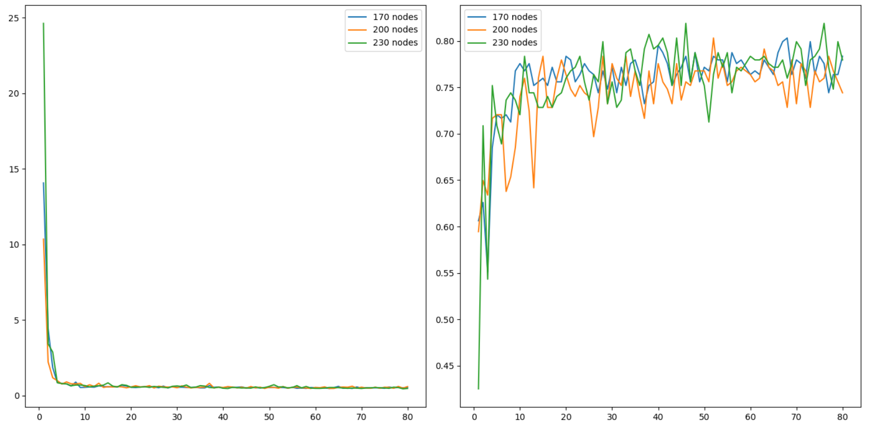

Here is the winning code so far at this point.

|  |
| --- |
| # first neural network with keras tutorial  from keras.models import Sequential  from keras.layers import Dense  import pandas as pd  from sklearn.model_selection import train_test_split  import matplotlib.pyplot as plt  PATH = "/Users/pm/Desktop/DayDocs/data/"  import tensorflow as tf  # load the dataset  df = pd.read_csv(PATH + 'diabetes.csv', sep=',')  # split into input (X) and output (y) variables  X = df[['Pregnancies','Glucose','BloodPressure','SkinThickness','Insulin','BMI',  'DiabetesPedigreeFunction', 'Age']]  y = df[['Outcome']]  # Split into train and test data sets.  X_train, X_test, y_train, y_test = train_test_split( X, y, test_size=0.33)  def buildModel(num_nodes):  # define the keras model  model = Sequential()  model.add(Dense(num_nodes, input_dim=8, activation='relu',  kernel_initializer='he_normal'))  model.add(Dense(1, activation='sigmoid'))  opitimizer = tf.keras.optimizers.SGD(  learning_rate=0.0005, momentum=0.9, name="SGD",  )  # compile the keras model  model.compile(loss='binary_crossentropy', optimizer=opitimizer,  metrics=['accuracy'])  # fit the keras model on the dataset  history = model.fit(X, y, epochs=80, batch_size=10, validation_data=(X_test,  y_test))  # evaluate the keras model  # Evaluate the model.  loss, acc = model.evaluate(X_test, y_test, verbose=0)  print('Test Accuracy: ' + str(acc) + ' Num nodes: ' + str(num_nodes))  return history  def showLoss(history, numNodes):  # Get training and test loss histories  training_loss = history.history['loss']  validation_loss = history.history['val_loss']  # Create count of the number of epochs  epoch_count = range(1, len(training_loss) + 1)  # Visualize loss history for training data.  actualLabel = str(numNodes) + " nodes"  plt.subplot(1, 2, 1)  # View loss on unseen data.  plt.plot(epoch_count, validation_loss, label=actualLabel)  plt.legend()  def showAccuracy(history, numNodes):  # Get training and test loss histories  training_loss = history.history['accuracy']  validation_loss = history.history['val_accuracy']  # Create count of the number of epochs  epoch_count = range(1, len(training_loss) + 1)  plt.subplot(1, 2, 2)  actualLabel = str(numNodes) + " nodes"  # View loss on unseen data.  plt.plot(epoch_count, validation_loss, label=actualLabel)  plt.legend()  nodeCounts = [170,200,230]  plt.subplots(nrows=1, ncols=2, figsize=(14,7))  for i in range(0, len(nodeCounts)):  history = buildModel(nodeCounts[i])  showLoss(history, nodeCounts[i])  showAccuracy(history, nodeCounts[i])  plt.show() |

Configuring the Number of Layers

Deeper networks are typically more efficient than single layer networks. An optimal number of layers should be chosen with the same number of nodes that was optimized for a single layer in Example 2. Later in Example 3, we will use this code snippet to grid search the optimal number of layers.

|  |
| --- |
| numLayers = [5,6,7,8]  plt.subplots(nrows=1, ncols=2, figsize=(14,7))  for i in range(0, len(numLayers)):  history = buildModel(numLayers[i])  showLoss(history, numLayers[i])  showAccuracy(history, numLayers[i]) |

When we refer to numbers of layers we are really referring to network **depth**. Until recently, deeper networks were often not possible due to vanishing gradients. The **relu** activation function helps to overcome the vanishing gradient problem so use it when configuring the number of layers.

*Example 3: Number Layers*

When searching for the optimal number of layers, I started with network layers of 1, 3 and 4. I kept shifting the number of layers up and eventually found that 7 layers was optimal as shown in Figure 2. As you can see in Figure 2, the losses are still declining and the accuracy is still rising. It appears that additional gains can be obtained by increasing the number of epochs so I did later.

*Figure 2: Comparing Network Depth*

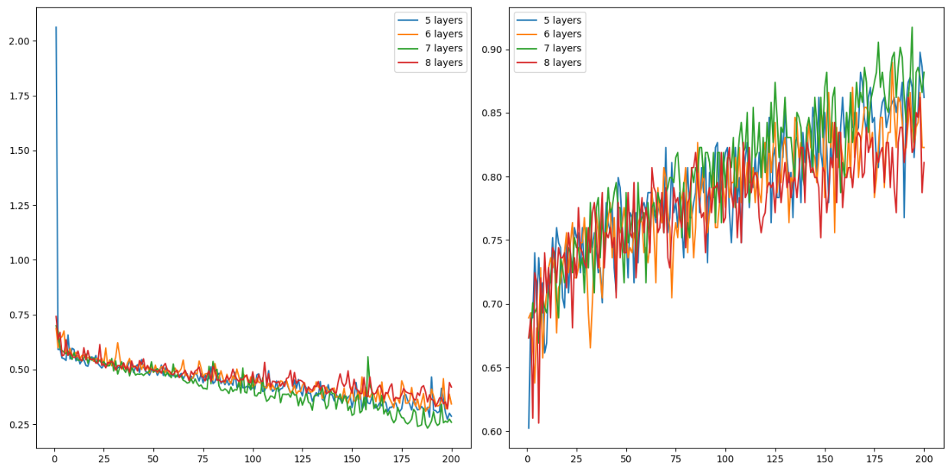

Here is the code:

|  |
| --- |
| # first neural network with keras tutorial  from keras.models import Sequential  from keras.layers import Dense  import pandas as pd  from sklearn.model_selection import train_test_split  import matplotlib.pyplot as plt  PATH = "/Users/pm/Desktop/DayDocs/data/"  import tensorflow as tf  # load the dataset  df = pd.read_csv(PATH + 'diabetes.csv', sep=',')  # split into input (X) and output (y) variables  X = df[['Pregnancies','Glucose','BloodPressure','SkinThickness','Insulin','BMI',  'DiabetesPedigreeFunction', 'Age']]  y = df[['Outcome']]  # Split into train and test data sets.  X_train, X_test, y_train, y_test = train_test_split( X, y, test_size=0.33)  def buildModel(numLayers):  # define the keras model  model = Sequential()  model.add(Dense(230, input_dim=8, activation='relu',  kernel_initializer='he_normal'))  for i in range(0, numLayers-1):  model.add(Dense(230, activation='relu',  kernel_initializer='he_normal'))  model.add(Dense(1, activation='sigmoid'))  opitimizer = tf.keras.optimizers.SGD(  learning_rate=0.0005, momentum=0.9, name="SGD",  )  # Compile the keras model.  model.compile(loss='binary_crossentropy', optimizer=opitimizer,  metrics=['accuracy'])  # Fit the keras model on the dataset.  history = model.fit(X, y, epochs=200, batch_size=10,  validation_data=(X_test, y_test))  # Evaluate the model.  loss, acc = model.evaluate(X_test, y_test, verbose=0)  print('Test Accuracy: %.3f' % acc)  return history  def showLoss(history, numNodes):  # Get training and test loss histories  training_loss = history.history['loss']  validation_loss = history.history['val_loss']  # Create count of the number of epochs  epoch_count = range(1, len(training_loss) + 1)  # Visualize loss history for training data.  actualLabel = str(numNodes) + " layers"  plt.subplot(1, 2, 1)  # View loss on unseen data.  plt.plot(epoch_count, validation_loss, label=actualLabel)  plt.legend()  def showAccuracy(history, numNodes):  # Get training and test loss histories  training_loss = history.history['accuracy']  validation_loss = history.history['val_accuracy']  # Create count of the number of epochs  epoch_count = range(1, len(training_loss) + 1)  plt.subplot(1, 2, 2)  actualLabel = str(numNodes) + " layers"  # View loss on unseen data.  plt.plot(epoch_count, validation_loss, label=actualLabel)  plt.legend()  numLayers = [5,6,7,8]  plt.subplots(nrows=1, ncols=2, figsize=(14,7))  for i in range(0, len(numLayers)):  history = buildModel(numLayers[i])  showLoss(history, numLayers[i])  showAccuracy(history, numLayers[i])  plt.show() |

Configuring Batch Size

Once a reasonable number of nodes and layers have been chosen, the next step involves configuring the batch size. Batch sizes can range between 1 and the size of the training set. You can actually set the batch size to larger than the training set but there is usually no gain from doing that.

Small batches will provide better generalization to help prevent overfitting but they will take longer to train and the results will be more volatile. A large batch size is faster but can lead to overfitting.

*Example 4: Configuring Batch Size*

This example builds on the observations that were found in Example 3. The smaller batch size of 32 did really well.

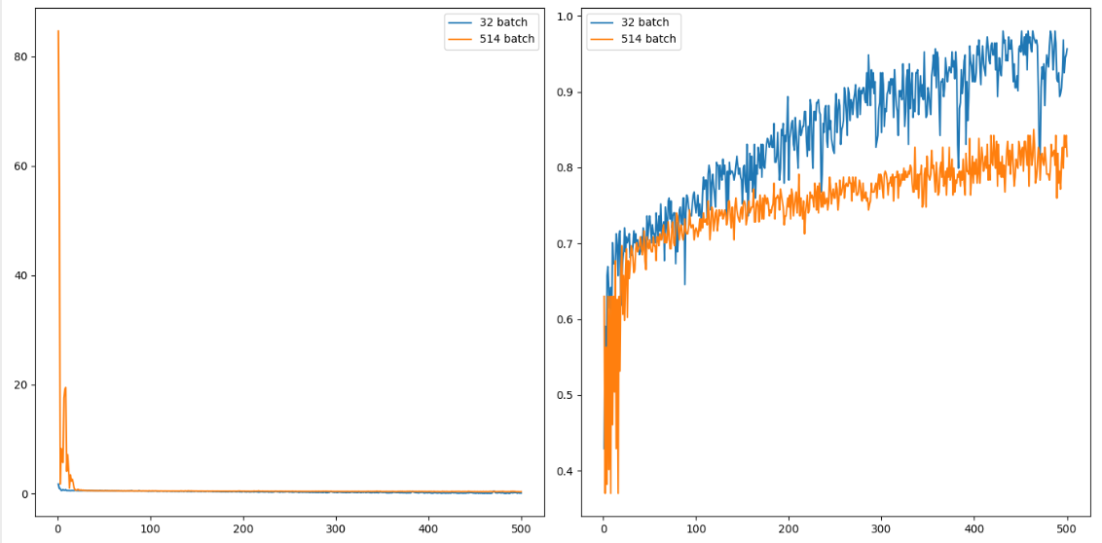

The validation accuracy reading is 0.957 for a batch size of 32 versus 0.815 for a batch size of 514. This is much better than logistic regression which had an accuracy rating of 80.7%.

Could this result be improved? Possibly more epochs and maybe even a smaller batch size would lead to an even better solution. I am happy with the 15% increase in accuracy that I received by tuning though so I will leave it there for now.

|  |
| --- |
| # first neural network with keras tutorial  from keras.models import Sequential  from keras.layers import Dense  import pandas as pd  from sklearn.model_selection import train_test_split  import matplotlib.pyplot as plt  PATH = "/Users/pm/Desktop/DayDocs/data/"  import tensorflow as tf  # load the dataset  df = pd.read_csv(PATH + 'diabetes.csv', sep=',')  # split into input (X) and output (y) variables  X = df[['Pregnancies','Glucose','BloodPressure','SkinThickness','Insulin','BMI',  'DiabetesPedigreeFunction', 'Age']]  y = df[['Outcome']]  # Split into train and test data sets.  X_train, X_test, y_train, y_test = train_test_split( X, y, test_size=0.33)  accuracy = []  def buildModel(batchSize):  NUM_LAYERS = 7  # define the keras model  model = Sequential()  model.add(Dense(230, input_dim=8, activation='relu', kernel_initializer='he_normal'))  for i in range(0, NUM_LAYERS-1):  model.add(Dense(230, activation='relu', kernel_initializer='he_normal'))  model.add(Dense(1, activation='sigmoid'))  opitimizer = tf.keras.optimizers.SGD(  learning_rate=0.0005, momentum=0.9, name="SGD",  )  # compile the keras model  model.compile(loss='binary_crossentropy', optimizer=opitimizer, metrics=['accuracy'])  # fit the keras model on the dataset  history = model.fit(X, y, epochs=500, batch_size=batchSize,  validation_data=(X_test, y_test))  # evaluate the keras model  # Evaluate the model.  loss, acc = model.evaluate(X_test, y_test, verbose=0)  print('Test Accuracy: %.3f' % acc)  accuracy.append(acc)  print(accuracy)  return history  def showLoss(history, batchSize):  # Get training and test loss histories  training_loss = history.history['loss']  validation_loss = history.history['val_loss']  # Create count of the number of epochs  epoch_count = range(1, len(training_loss) + 1)  # Visualize loss history for training data.  actualLabel = str(batchSize) + " batch"  plt.subplot(1, 2, 1)  # View loss on unseen data.  plt.plot(epoch_count, validation_loss, label=actualLabel)  plt.legend()  def showAccuracy(history, batchSize):  # Get training and test loss histories  training_loss = history.history['accuracy']  validation_loss = history.history['val_accuracy']  # Create count of the number of epochs  epoch_count = range(1, len(training_loss) + 1)  plt.subplot(1, 2, 2)  actualLabel = str(batchSize) + " batch"  # View loss on unseen data.  plt.plot(epoch_count, validation_loss, label=actualLabel)  plt.legend()  plt.subplots(nrows=1, ncols=2, figsize=(14,7))  batchSizes = [32, len(y_train)]  for i in range(0, len(batchSizes)):  history = buildModel(batchSizes[i])  showLoss(history, batchSizes[i])  showAccuracy(history, batchSizes[i])  plt.show() |

Summary

To tune your parameters:

* Perform regular linear regression or logistic regression to figure out what will happen.
* Configure the optimizer. To keep it simple, use SGD and set the learning rate and momentum. Slower learning rate can help to make it easier to identify the loss trend but takes more time. More momentum can make the learning smoother but too much momentum can make the algorithm insensitive to changes in the solution plane.
* Determine the optimal number of nodes (width) for a single layer network.
* Configure the number of layers using a **relu** activation function.
* Configure the batch size.
* Tweak the learning rate, momentum and number of epochs as needed during the entire process.
* Remember to use loss visualizations and where possible accuracy visualizations to help understand the impact of the tuning parameter values.
* Pay attention to the validation loss and accuracy ratings.

Other Tips

* Reduce the size of your data set to help speed up training until your model is more finely tuned.
* Emulate existing networks that solve similar problems.

*Exercise 1 (2 marks)*

Starting with the fluDiagnosis.csv file from the data sets folder, use the following code to perform logistic regression:

|  |
| --- |
| import pandas as pd  from sklearn.model_selection import train_test_split  PATH = "/Users/pm/Desktop/DayDocs/data/"  from sklearn.linear_model import LogisticRegression  from sklearn import metrics  import numpy as np  # load the dataset  df = pd.read_csv(PATH + 'fluDiagnosis.csv')  # split into input (X) and output (y) variables  print(df)  X = df[['A','B']]  y = df[['Diagnosed']]  # Split into train and test data sets.  X_train, X_test, y_train, y_test = train_test_split( X, y, test_size=0.33)  # Perform logistic regression.  logisticModel = LogisticRegression(fit_intercept=True, random_state = 0,  solver='liblinear')  logisticModel.fit(X_train,y_train)  y_pred=logisticModel.predict(X_test)  # Show model coefficients and intercept.  print("\nModel Coefficients: ")  print("\nIntercept: ")  print(logisticModel.intercept_)  print(logisticModel.coef_)  # Show confusion matrix and accuracy scores.  confusion_matrix = pd.crosstab(np.array(y_test['Diagnosed']), y_pred,  rownames=['Actual'],  colnames=['Predicted'])  print('\nAccuracy: ',metrics.accuracy_score(y_test, y_pred))  print("\nConfusion Matrix")  print(confusion_matrix) |

Show the accuracy rating and confusion matrix here:

|  |
| --- |
|  |

*Exercise 2 (6 marks)*

Next, use the following code to configure the optimal learning rate, momentum value and total number of nodes in a single layer network:

|  |
| --- |
| import pandas as pd  from sklearn.model_selection import train_test_split  PATH = "/Users/pm/Desktop/DayDocs/data/"  from keras.models import Sequential  from keras.layers import Dense  import matplotlib.pyplot as plt  import tensorflow as tf  # load the dataset  df = pd.read_csv(PATH + 'fluDiagnosis.csv')  # split into input (X) and output (y) variables  print(df)  X = df[['A','B']]  y = df[['Diagnosed']]  # Split into train and test data sets.  X_train, X_test, y_train, y_test = train_test_split( X, y, test_size=0.33)  def buildModel(num_nodes):  # define the keras model  model = Sequential()  model.add(Dense(num_nodes, input_dim=2, activation='relu',  kernel_initializer='he_normal'))  model.add(Dense(1, activation='sigmoid'))  opitimizer = tf.keras.optimizers.SGD(  learning_rate=0.1, momentum=0.9, name="SGD",  )  # compile the keras model  model.compile(loss='binary_crossentropy', optimizer=opitimizer,  metrics=['accuracy'])  # fit the keras model on the dataset  history = model.fit(X, y, epochs=80, batch_size=10, validation_data=(X_test,  y_test))  # evaluate the keras model  # Evaluate the model.  loss, acc = model.evaluate(X_test, y_test, verbose=0)  print('Test Accuracy: ' + str(acc) + ' Num nodes: ' + str(num_nodes))  return history  def showLoss(history, numNodes):  # Get training and test loss histories  training_loss = history.history['loss']  validation_loss = history.history['val_loss']  # Create count of the number of epochs  epoch_count = range(1, len(training_loss) + 1)  # Visualize loss history for training data.  actualLabel = str(numNodes) + " nodes"  plt.subplot(1, 2, 1)  # View loss on unseen data.  plt.plot(epoch_count, validation_loss, label=actualLabel)  plt.legend()  def showAccuracy(history, numNodes):  # Get training and test loss histories  training_loss = history.history['accuracy']  validation_loss = history.history['val_accuracy']  # Create count of the number of epochs  epoch_count = range(1, len(training_loss) + 1)  plt.subplot(1, 2, 2)  actualLabel = str(numNodes) + " nodes"  # View loss on unseen data.  plt.plot(epoch_count, validation_loss, label=actualLabel)  plt.legend()  nodeCounts = [170,200,230]  plt.subplots(nrows=1, ncols=2, figsize=(14,7))  for i in range(0, len(nodeCounts)):  history = buildModel(nodeCounts[i])  showLoss(history, nodeCounts[i])  showAccuracy(history, nodeCounts[i])  plt.show() |

After finding decent values for your learning rate, momentum and number of nodes, show a screenshot of the graphs for the loss and accuracy functions here:

|  |
| --- |
| Learning rate =0.1 momentum=0.9 numberOfNodes = 170,200,230  Test Accuracy: 0.5249999761581421 Num nodes: 230  Test Accuracy: 0.7749999761581421 Num nodes: 200  Test Accuracy: 0.800000011920929 Num nodes: 170  Learning rate =0.2 momentum=0.9 numberOfNodes = 170,200,230  Test Accuracy: 0.824999988079071 Num nodes: 230  Test Accuracy: 0.824999988079071 Num nodes: 200  Test Accuracy: 0.824999988079071 Num nodes: 170  Learning rate =0.15 momentum=0.9 numberOfNodes = 170,200,230  Test Accuracy: 0.824999988079071 Num nodes: 230  Test Accuracy: 0.8500000238418579 Num nodes: 200  Test Accuracy: 0.875 Num nodes: 170  learning_rate=0.17, momentum=0.7  0.925000011920929 Num nodes: 230  Test Accuracy: 0.925000011920929 Num nodes: 200  Test Accuracy: 0.8999999761581421 Num nodes: 170  learning_rate=0.175, momentum=0.65  Test Accuracy: 0.800000011920929 Num nodes: 230  learning_rate=0.175, momentum=0.65  Test Accuracy: 0.699999988079071 Num nodes: 230  Test Accuracy: 0.75 Num nodes: 200  Chart, histogram  Description automatically generated |

Show the optimal learning rate so far here:

|  |
| --- |
| 0.17 |

Show the optimal momentum value so far here:

|  |
| --- |
| 0.7 |

Show the optimal number of nodes in a single layer here:

|  |
| --- |
| Test Accuracy: 0.925000011920929 Num nodes: 230  Test Accuracy: 0.925000011920929 Num nodes: 200  Are the same! |

*Exercise 3 (4 marks)*

Starting with the code from Exercise 2, configure the optimal number of layers. Examine Example 3 for code hints. Show your full program which implements code to search for the optimal number of layers here. You may or may not need to adjust the learning rate, momentum and number of epochs:

|  |
| --- |
| import pandas as pd from sklearn.model_selection import train_test_split PATH = "/Users/hyerimshin/PycharmProjects/MachineLearning/datasets/" from sklearn.linear_model import LogisticRegression from sklearn import metrics import numpy as np from keras.models import Sequential from keras.layers import Dense import matplotlib matplotlib.use('TkAgg') import matplotlib.pyplot as plt import tensorflow as tf # load the dataset df = pd.read_csv(PATH + 'fluDiagnosis.csv', sep=',') # split into input (X) and output (y) variables print(df)  X = df[['A','B']] y = df[['Diagnosed']] # Split into train and test data sets. X_train, X_test, y_train, y_test = train_test_split( X, y, test_size=0.33)  def buildModel(numLayers):  # define the keras model  model = Sequential()  model.add(Dense(230, input_dim=2, activation='relu',  kernel_initializer='he_normal'))  for i in range(0, numLayers - 1):  model.add(Dense(230, activation='relu',  kernel_initializer='he_normal'))   model.add(Dense(1, activation='sigmoid'))   opitimizer = tf.keras.optimizers.SGD(  learning_rate=0.0005, momentum=0.9, name="SGD",  )   # compile the keras model  model.compile(loss='binary_crossentropy', optimizer=opitimizer,  metrics=['accuracy'])   # fit the keras model on the dataset  history = model.fit(X, y, epochs=80, batch_size=10, validation_data=(X_test,  y_test))  # evaluate the keras model   # Evaluate the model.  loss, acc = model.evaluate(X_test, y_test, verbose=0)  print('Test Accuracy: %.3f' % acc)  return history  def showLoss(history, numNodes):  # Get training and test loss histories  training_loss = history.history['loss']  validation_loss = history.history['val_loss']   # Create count of the number of epochs  epoch_count = range(1, len(training_loss) + 1)   # Visualize loss history for training data.  actualLabel = str(numNodes) + " layers"  plt.subplot(1, 2, 1)  # View loss on unseen data.  plt.plot(epoch_count, validation_loss, label=actualLabel)  plt.legend()  def showAccuracy(history, numNodes):  # Get training and test loss histories  training_loss = history.history['accuracy']  validation_loss = history.history['val_accuracy']   # Create count of the number of epochs  epoch_count = range(1, len(training_loss) + 1)  plt.subplot(1, 2, 2)   actualLabel = str(numNodes) + " layers"  # View loss on unseen data.  plt.plot(epoch_count, validation_loss, label=actualLabel)  plt.legend()  numLayers = [5,6,7,8] plt.subplots(nrows=1, ncols=2, figsize=(14,7))  for i in range(0, len(numLayers)):  history = buildModel(numLayers[i])  showLoss(history, numLayers[i])  showAccuracy(history, numLayers[i])  plt.show() |

*Exercise 4 (1 mark)*

Show the optimal number of layers here:

|  |
| --- |
| 6 layers |

*Exercise 5 (4 marks)*

Show screenshots of the accuracy and loss plots after adjusting the number of layers here:

|  |
| --- |
|  |

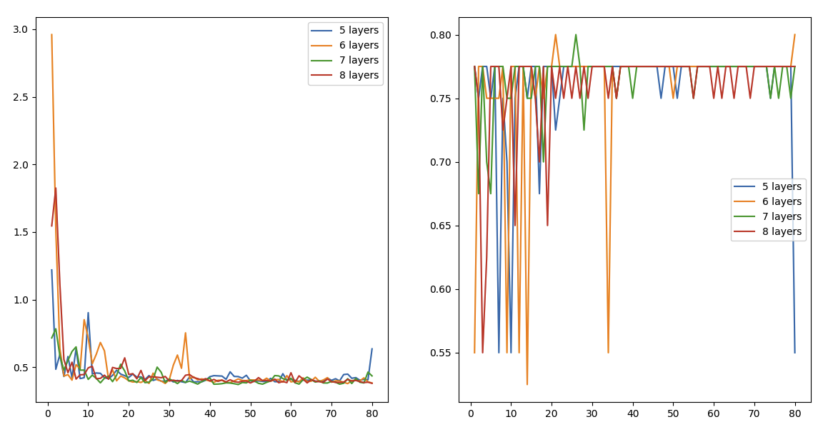

*Exercise 6 (4 marks)*

Starting with the code from Exercise 3, configure the optimal batch size. Examine Example 4 for code hints. Show your full program which implements code to search for the optimal batch size here. You may or may not need to adjust the learning rate, momentum and number of epochs:

|  |
| --- |
| import pandas as pd from sklearn.model_selection import train_test_split PATH = "/Users/hyerimshin/PycharmProjects/MachineLearning/datasets/" from sklearn.linear_model import LogisticRegression from sklearn import metrics import numpy as np from keras.models import Sequential from keras.layers import Dense import matplotlib matplotlib.use('TkAgg') import matplotlib.pyplot as plt import tensorflow as tf # load the dataset df = pd.read_csv(PATH + 'fluDiagnosis.csv', sep=',') # split into input (X) and output (y) variables print(df)  X = df[['A','B']] y = df[['Diagnosed']] # Split into train and test data sets. X_train, X_test, y_train, y_test = train_test_split( X, y, test_size=0.33)  def buildModel(batchSize):  # define the keras model  model = Sequential()  numLayers = 6  model.add(Dense(230, input_dim=2, activation='relu',  kernel_initializer='he_normal'))  for i in range(0, numLayers - 1):  model.add(Dense(230, activation='relu',  kernel_initializer='he_normal'))   model.add(Dense(1, activation='sigmoid'))   opitimizer = tf.keras.optimizers.SGD(  learning_rate=0.0005, momentum=0.9, name="SGD",  )   # compile the keras model  model.compile(loss='binary_crossentropy', optimizer=opitimizer,  metrics=['accuracy'])   # fit the keras model on the dataset  history = model.fit(X, y, epochs=80, batch_size=batchSize, validation_data=(X_test,  y_test))  # evaluate the keras model   # Evaluate the model.  loss, acc = model.evaluate(X_test, y_test, verbose=0)  print('Test Accuracy: %.3f' % acc)  return history  def showLoss(history, numNodes):  # Get training and test loss histories  training_loss = history.history['loss']  validation_loss = history.history['val_loss']   # Create count of the number of epochs  epoch_count = range(1, len(training_loss) + 1)   # Visualize loss history for training data.  actualLabel = str(numNodes) + " batch"  plt.subplot(1, 2, 1)  # View loss on unseen data.  plt.plot(epoch_count, validation_loss, label=actualLabel)  plt.legend()  def showAccuracy(history, numNodes):  # Get training and test loss histories  training_loss = history.history['accuracy']  validation_loss = history.history['val_accuracy']   # Create count of the number of epochs  epoch_count = range(1, len(training_loss) + 1)  plt.subplot(1, 2, 2)   actualLabel = str(numNodes) + " batch"  # View loss on unseen data.  plt.plot(epoch_count, validation_loss, label=actualLabel)  plt.legend()  plt.subplots(nrows=1, ncols=2, figsize=(14,7)) batchSizes = [32, len(y_train)]  for i in range(0, len(batchSizes)):  history = buildModel(batchSizes[i])  showLoss(history, batchSizes[i])  showAccuracy(history, batchSizes[i])  plt.show() |

*Exercise 7 (1 mark)*

Show the optimal batch size here:

|  |
| --- |
| 81 has the higher accuracy than 32. |

*Exercise 8 (4 marks)*

Show screenshots of the accuracy and loss plots after adjusting the batch size here:

|  |
| --- |
|  |

*Exercise 9 (1 mark)*

What type of activation function is used and why?

|  |
| --- |
| Sigmoid, because to scale y value between 0 and 1. |

*Exercise 10 (2 marks)*

Compare accuracy ratings for the original logistic regression model and your MLP network model here:

|  |
| --- |
| Original logistic regression    My MLP: |

**Table of Contents**

**References 1**

**Introduction 1**

**Classification Averaging Ensemble Preparation 1**

numpy.sum() 1

np.argmax() 2

**Eliminating Variance with Ensembles 3**

**Stacking to Improve Accuracy 7**

References

“Better Deep Learning’ by Dr. Jason Brownlee <https://machinelearningmastery.com/better-deep-learning/>

Chapter 19: Reducing Model Variance with Ensemble Learning

Chapter 20: Combine Models from Multiple Runs with Averaging Ensemble

Chapter 25: Learn to Combine Predictions with Stacked Generalization Ensemble

Introduction

Averaging ensembles calculate the prediction by averaging the predictions of multiple models. Averaging ensembles help to reduce variance.

Stacking ensembles calculate the prediction by using the outputs of multiple models as inputs. Stacking ensembles help to improve accuracy

Classification Averaging Ensemble Preparation

The classification averaging algorithms in this document will use numpy.sum() and numpy.argmax() to help find the average classification for each averaging ensemble. This section will explain how each function works.

numpy.sum()

**numpy.sum()** adds element values across arrays for each index.

*Example 1: numpy.sum()*

|  |
| --- |
| import numpy as np  # Pred1 # Pred2  testArray = np.asarray( [[[0.6, 0.4],[0.2, 0.8]], # Predictions model 1  [[0.1, 0.9],[0.8, 0.2]], # Predictions model 2  [[0.9, 0.1],[0.3, 0.7]], # Predictions model 3  [[0.7, 0.3],[0.6, 0.4]]]) # Predictions model 4  summed = np.sum(testArray, axis=0)  print("\nsummed: ")  print(summed) |

The summed output is shown below. For better readability, I have added commas and re-arranged the output so it falls on a single line.

|  |
| --- |
| [[2.3, 1.7], [1.9, 2.1]] |

Here is the math that generates summed elements for prediction 1:

0.6 0.4

0.1 0.9

0.9 0.1

+ 0.7 0.3

[2.3] [1.7]

*Exercise 1 (2 marks)*

Show the calculations needed to sum elements by index for all models for prediction 2:

|  |
| --- |
| 0.2 0.8  0.8 0.2  0.3 0.7  + 0.6 0.4  [1.9] [2.1]  [[2.3, 1.7], [1.9, 2.1]] |

np.argmax()

**np.argmax()** obtains the maximum element value for each of the sub-arrays.

*Example 2: numpy.argmax()*

This example shows how numpy.argmax() works. Here the output from Example 1 again. This time though, the largest numbers for each prediction are selected.

# Pred1 # Pred2

[[2.3, 1.7], [1.9, 2.1]]

If you at the following output to the end of the code in Example 1 and run the program again;

|  |
| --- |
| result = np.argmax(summed, axis=1)  print("Max element in array: ")  print(result) |

The output becomes:

[0 1]

*Exercise 2 (1 mark)*

What is the result of the numpy.argmax() function for the following?

# Pred1 # Pred2

[[8.3, 5.7], [8.9, 8.1]]

|  |
| --- |
| Max element in array:  [0 0] |

*Exercise 3 (1 mark)*

What is the result of the numpy.argmax() function for the following?

[[2.3, 1.7, 2.2], [1.9, 2.1, 2.4]]

|  |
| --- |
| Max element in array:  [0 2] |

We will revisit these functions later.

Eliminating Variance with Ensembles

You will have noticed during the course that many of your networks exhibit significant variance in accuracy from run-to-run. This section demonstrates how model network ensembles can help to reduce the variance of the output.

*Example 3: Model Variance (See Chapter 20 Better Deep Learning)*

This example shows the average accuracy and accuracy standard deviation for 11 separate sequential neural network classifier models.

|  |
| --- |
| Average model accuracy: 0.8111688311688312  Accuracy standard deviation: 0.017505029034279744 |

The following code is set up to build multiple sequential networks for classification. The predictions of each network are then averaged using the numpy.sum() and numpy.argmax() functions. For the initial case in Example 3, only 1 sequential network is used to make the prediction. However results are generated over 11 separate runs to observe the standard deviation between results.

Note: The output of the sequential network uses **categorical cross entropy** which causes the classification predictions to be presented in a one-hot-encoded manner.

# Two sample one-hot-encoded outputs. Each output must have only 1 of 3

# possible outcomes:

# [[1, 0, 0],

# [0, 1, 0],

Here is the code to build the network.

|  |
| --- |
| from keras.layers import Dense  from sklearn.metrics import accuracy_score  from numpy import argmax  from sklearn.datasets import make_blobs  from keras.models import Sequential  from sklearn.model_selection import train_test_split  import numpy as np  import tensorflow as tf  # fit model on dataset  def fitMModel(trainX, trainy):  # define model  model = Sequential()  model.add(Dense(15, input_dim=2, activation='relu'))  model.add(Dense(3, activation='softmax'))  model.compile(loss='categorical_crossentropy',  optimizer='adam',  metrics=['accuracy'])  # fit model  model.fit(trainX, trainy, epochs=200, verbose=0)  return model  def getData():  # generate 2d classification dataset  X, y = make_blobs(n_samples=500, centers=3, n_features=2,  cluster_std=2, random_state=2)  # split into train and test  trainX, testX, trainy, testy = train_test_split(X, y, test_size=0.7)  # Converts array to matrix of categories.  # [0, 1, 2]  # Becomes:  # [[1, 0, 0],  # [0, 1, 0],  # [0, 0, 1]]  trainy = tf.keras.utils.to_categorical(trainy)  return trainX, testX, trainy, testy  def buildAndEvaluateIndividualModels():  trainX, testX, trainy, testy = getData()  NUM_MODELS = 11  yhats = []  scores = []  models = []  print("\n**** Single model results:")  for i in range(0, NUM_MODELS):  model = fitMModel(trainX, trainy)  models.append(model)  predictions = model.predict(testX)  yhats.append(predictions)  # Converts multi-column prediction set back to single column  # so accuracy score can be calculated.  singleColumnPredictions = argmax(predictions, axis=1)  accuracy = accuracy_score(singleColumnPredictions, testy)  scores.append(accuracy)  print("Single model " + str(i) + " accuracy: " + str(accuracy))  print("Average model accuracy: " + str(np.mean(scores)))  print("Accuracy standard deviation: " + str(np.std(scores)))  return models  models = buildAndEvaluateIndividualModels() |

Now that you have seen varying results, next we will observe how an ensemble helps to stabilize the results.

*Example 4: Ensemble Predictions (See Chapter 20 Better Deep Learning)*

This example shows how results from multiple models are combined to make a more stable prediction by vote. Effectively, the code snippet below (which has already been included in Example 3) adds up votes for each prediction across all models.

Notice how the standard deviation of the ensemble voting model over 11 trials is lowered significantly compared with the ensemble model.

|  |
| --- |
| Average model accuracy: 0.8135064935064935  Accuracy standard deviation: 0.006901470262642296 |

Adding this code to the end of Example 3 will enable the building and evaluating of the ensemble.

|  |
| --- |
| # Evaluate ensemble  def buildAndEvaluateEnsemble(models):  scores = []  print("\n**** Ensemble model results: ")  for trial in range(0, 11):  # Generate new test data.  _, testX, _, testy = getData()  yhats = []  # Get predictions with pre-built models.  for model in models:  predictions = model.predict(testX)  yhats.append(predictions)  # Sum predictions for all models.  # [[0.2, 0.3, 0.5], [0.3, 0.3, 0.4]...], # Model 1 results  # [0.3, 0.3, 0.4], [0.1, 0.1, 0.8]...], # Model 2 results  # [0.2, 0.2, 0.6], [0.3, 0.3, 0.4]...], # Model 3 results  # Becomes  # [[0.7, 0.8, 1.5],[0.7, 0.7, 1.6]...] # Summed results  summed = np.sum(yhats, axis=0)  # Converts multi-column prediction set back to single column  # so accuracy score can be calculated. For example;  # [[0.7, 0.8, 1.5],[0.7, 0.7, 1.6]...]  # Becomes  # [2, 2,....]  singleColumnPredictions = argmax(summed, axis=1)  accuracy = accuracy_score(singleColumnPredictions, testy)  scores.append(accuracy)  print("Ensemble model accuracy during trial " + str(trial) +\  ": " + str(accuracy))  print("Average model accuracy: " + str(np.mean(scores)))  print("Accuracy standard deviation: " + str(np.std(scores)))  buildAndEvaluateEnsemble(models) |

*Exercise 4 (6 marks)*

Replace the getData() function in Example 4 with the following code to load and prepare data from the Iris data set.

|  |
| --- |
| from sklearn.preprocessing import LabelEncoder  import pandas as pd  def getData():  PATH = "/Users/pm/Desktop/DayDocs/data/"  df = pd.read_csv(PATH + 'iris_old.csv')  df.columns = ['Sepal L', 'Sepal W', 'Petal L', 'Petal W', 'Iris Type']  # Convert text to numeric category.  # 0 is setosa, 1 is versacolor and 2 is virginica  df['y'] = LabelEncoder().fit_transform(df['Iris Type'])  # Prepare the data.  X = df[['Sepal L', 'Sepal W', 'Petal L', 'Petal W']]  y = df['y']  ROW_DIM = 0  COL_DIM = 1  x_array = X.values  x_arrayReshaped = x_array.reshape(x_array.shape[ROW_DIM],  x_array.shape[COL_DIM])  y_array = y.values  y_arrayReshaped = y_array.reshape(y_array.shape[ROW_DIM], 1)  trainX, testX, trainy, testy = train_test_split(x_arrayReshaped,  y_arrayReshaped,  test_size=0.33)  trainy = to_categorical(trainy)  return trainX, testX, trainy, testy |

Also, adjust the fit_model() function to enable inputs with 4 features and an output value with 3 possible classifications.

|  |
| --- |
| # fit model on dataset  def fitModel(trainX, trainy):  # define model  model = Sequential()  model.add(Dense(15, input_dim=4, activation='relu'))  model.add(Dense(3, activation='softmax'))  model.compile(loss='categorical_crossentropy',  optimizer='adam',  metrics=['accuracy'])  # fit model  model.fit(trainX, trainy, epochs=200, verbose=0)  return model |

Explain how the standard deviation is affected by the ensemble of 11 models.

|  |
| --- |
| The results from the 11 models are combined to make a more stable prediction by vote. |

Show your average prediction accuracy and standard deviation for the stand-alone model and for the ensemble.

|  |
| --- |
| Stand-alone:  Average model accuracy: 0.9436363636363637  Accuracy standard deviation: 0.025324342322152932  Ensemble:  Average model accuracy: 0.9654545454545456  Accuracy standard deviation: 0.025712973861329 |

Stacking to Improve Accuracy

Stacking takes the outputs of existing models and uses them as inputs to build a new model. In this way, it is possible to dynamically generate a weighted set of inputs (see Figure 1).

*Figure 1: Stacking Model Built with Inputs from Other Models*

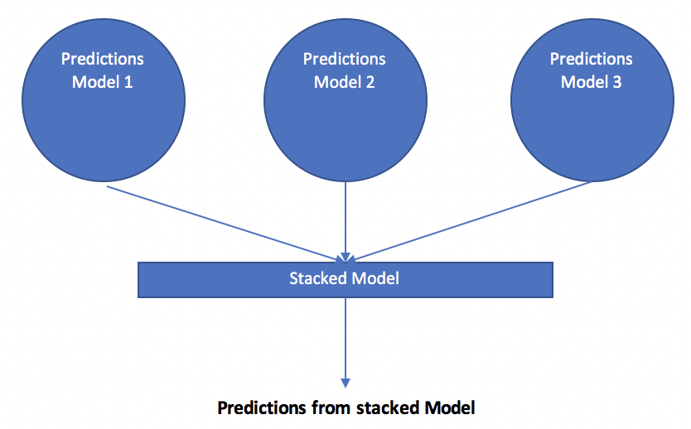

The next two examples show how to implement stacking for a neural network. These examples are discussed at:

<https://machinelearningmastery.com/stacking-ensemble-for-deep-learning-neural-networks/>

*Example 5: Creating Model for Later Use in Stacking Ensemble (See Chapter 25 Better Deep Learning)*

This first example creates 5 separate models and saves them as h5 binary files. If you run the code you will notice that it outputs the models in your project directory.

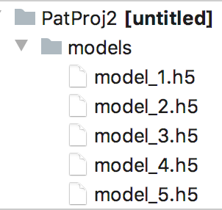

These models will be used in Example 6 for stacking.

|  |
| --- |
| from keras.models import Sequential  from keras.layers import Dense  from os import makedirs  from os import path  from sklearn.model_selection import train_test_split  from sklearn.datasets import make_blobs  from sklearn.metrics import accuracy_score  from sklearn.linear_model import LogisticRegression  from keras.models import load_model  from keras.utils import to_categorical  import pandas as pd  import numpy as np  PATH = './models/'  # fit model on dataset  def fit_model(trainX, trainy):  # define model  model = Sequential()  model.add(Dense(25, input_dim=2, activation='relu'))  model.add(Dense(3, activation='softmax'))  model.compile(loss='categorical_crossentropy',  optimizer='adam', metrics=['accuracy'])  # fit model  model.fit(trainX, trainy, epochs=500, verbose=0)  return model  def generateData():  # generate 2d classification dataset  X, y = make_blobs(n_samples=800, centers=3,  n_features=2,  cluster_std=2, random_state=2)  # split into train and test  trainX, tempX, trainy, tempy = train_test_split(X, y, test_size=0.6)  testX, valX, testy, valy = train_test_split(tempX, tempy, test_size=0.5)  return trainX, testX, valX, trainy, testy, valy  def generateModels(trainX, trainy):  # create directory for models  if(not path.exists(PATH)):  makedirs('./models')  # fit and save models  numModels = 5  print("\nFitting models with training data.")  for i in range(numModels):  # fit model  model = fit_model(trainX, trainy)  # save model  filename = PATH + 'model_' + str(i + 1) + '.h5'  model.save(filename)  print('>Saved %s' % filename)  trainX, testX, valX, trainy, testy, valy = generateData()  # one hot encode output variable  trainy = to_categorical(trainy)  generateModels(trainX, trainy)  # load models from file  def load_all_models(n_models):  all_models = list()  for i in range(n_models):  # define filename for this ensemble  filename = PATH + 'model_' + str(i + 1) + '.h5'  # load model from file  model = load_model(filename)  # add to list of models  all_models.append(model)  print('>loaded %s' % filename)  return all_models  #trainX, testX, trainy, testy = generateData()  # load all models  numModels = 5  models = load_all_models(numModels)  print('Loaded %d models' % len(models))  print("\nEvaluating single models with validation data.")  # evaluate standalone models on test dataset  # individual ANN models are built with one-hot encoded data.  for model in models:  oneHotEncodedY = to_categorical(valy)  _, acc = model.evaluate(valX, oneHotEncodedY, verbose=0)  print('Model Accuracy: %.3f' % acc) |

*Example 6: Stacking*

This example builds a meta-learner from the models that were created in Example 5. Each of the models that were built in Example 5 show the following accuracy ratings on their own.

|  |
| --- |
| Model Accuracy: 0.818  Model Accuracy: 0.773  Model Accuracy: 0.786  Model Accuracy: 0.777  Model Accuracy: 0.799 |

When predictions from the 5 models are fed as inputs to the stacking model, the stacked model shows a more favourable increase in performance:

|  |
| --- |
| Stacked Test Accuracy: 0.820 |

To build this example add this code to Example 5.

|  |
| --- |
| # Make predictions with the stacked model  def stacked_prediction(models, stackedModel, inputX):  # create dataset using ensemble  stackedX = getStackedData(models, inputX)  # make a prediction  yhat = stackedModel.predict(stackedX)  return yhat  # fit a model based on the outputs from the ensemble models  def fit_stacked_model(models, inputX, inputy):  # create dataset using ensemble  stackedX = getStackedData(models, inputX)  # fit standalone model  model = LogisticRegression()  model.fit(stackedX, inputy)  return model  # fit stacked model using the ensemble  # Stacked model build with LogisticRegression.  # y for LogisticRegression is not one-hot encoded.  print("\nFitting stacked model with test data.")  stackedModel = fit_stacked_model(models, testX, testy)  # evaluate model on test set  print("\nEvaluating stacked model with validation data.")  yhat = stacked_prediction(models, stackedModel, valX)  acc = accuracy_score(valy, yhat)  print('Stacked Test Accuracy: %.3f' % acc) |

*Exercise 5 (*6 marks)

Use the following code to generate five models with the Iris data set.

|  |
| --- |
| from sklearn.preprocessing import LabelEncoder  def generateData():  PATH = "/Users/pm/Desktop/DayDocs/data/"  df = pd.read_csv(PATH + 'iris_old.csv')  df.columns = ['Sepal L', 'Sepal W', 'Petal L', 'Petal W', 'Iris Type']  # Convert text to numeric category.  # 0 is setosa, 1 is versacolor and 2 is virginica  df['y'] = LabelEncoder().fit_transform(df['Iris Type'])  # Prepare the data.  X = df[['Sepal L', 'Sepal W', 'Petal L', 'Petal W']]  y = df['y']  # split into train and test  trainX, tempX, trainy, tempy = train_test_split(X, y, test_size=0.6)  testX, valX, testy, valy = train_test_split(tempX, tempy, test_size=0.5)  return trainX, testX, valX, trainy, testy, valy |

Run the code. What adjustment is needed in fit_model()?

|  |
| --- |
| input_dim should have a value of 4 instead of 2 |

Explain the difference in performance between the stacked model and the individual models.

|  |
| --- |
| Evaluating single models with validation data.  Model Accuracy: 0.956  Model Accuracy: 0.956  Model Accuracy: 0.956  Model Accuracy: 0.978  Model Accuracy: 0.956  Evaluating stacked model with validation data.  Stacked Test Accuracy: 0.978  The stacked model has a higher accuracy score compared to the individual models because it uses the outputs of existing models and uses them as inputs to build a new model. |

*Exercise 6 (5 marks)*

Show a screenshot of the debugger while it shows the dataframe contents. Be sure to show the rows and columns of the stackXdf dataframe at the end of getStackedData() to get this mark.



Show your screenshot here:

|  |
| --- |
|  |

*Exercise 7 (4 marks)*

Use the terms *ensemble*, *stacked model* to fill in the blanks.

1. A *ensemble* helps to reduce variance.
2. A *stacked model* helps to improve accuracy.
3. A *stacked model* builds a model by using the outputs of other models.
4. A *ensemble* builds a model by averaging the outputs of multiple models.

**Table of Contents**

***Other Machine Learning Algorithms for Regression and Classification 1***

**Least Squares Regression 1**

**Gradient Descent 2**

**Ridge Regression 4**

**Lasso Regression 6**

**Elastic Net Regression 7**

**Equation Comparison 9**

**Support Vector Machines 10**

**Summary 14**

Other Machine Learning Algorithms for Regression and Classification

<https://www.analyticsvidhya.com/blog/2017/06/a-comprehensive-guide-for-linear-ridge-and-lasso-regression/>

At the start of the course we discussed gradient descent as a way to perform linear and classification regressions. Today we will examine machine learning techniques for performing linear and classification regression without building neural networks. Why bother? Sometimes these techniques can offer better results.

**Note:** Josh Stormer’s videos refers to $λ$ as the parameter which sets the strength of L1 and L2 penalties. (We will talk about the L1 and L2 penalties shortly). However, sklearn uses $∝$ since sklearn already refers to $λ$ as the learning rate. These notes will also use $∝$ to refer to the strength of the L1 and L2 penalties. The conflicting references to the penalty strength are confusing so I will try my best to make it as clear as I can.

Least Squares Regression

The examples in this section examine different ways to perform linear regression with the wine quality data set. When examining several different algorithms to perform linear regression starting with a simple OLS model is a great place to start to identify significant predictor variables and a baseline target.

*Example 1: Ordinary Least Squares Regression*

This example shows how to perform ordinary least squares regression. The code is actually the same code that we used when we first covered multiple regression in COMP3948. Insignificant variables have been removed from the training data. The root mean square error after building the model with OLS is: 0.6259157889490549. This RMSE score will be our benchmark for other models. Here is the code;

|  |
| --- |
| import pandas as pd  from sklearn.model_selection import train_test_split  from sklearn import metrics  import statsmodels.api as sm  import numpy as np  PATH = "/Users/pm/Desktop/DayDocs/data/"  CSV_DATA = "winequality.csv"  dataset = pd.read_csv(PATH + CSV_DATA,  skiprows=1, # Don't include header row as part of data.  encoding = "ISO-8859-1", sep=',',  names=('fixed acidity', 'volatile acidity', 'citric acid',  'residual sugar', 'chlorides', 'free sulfur dioxide',  'total sulfur dioxide', 'density', 'pH', 'sulphates',  'alcohol', 'quality'))  X = dataset[['volatile acidity', 'chlorides', 'total sulfur dioxide', 'sulphates',  'alcohol']]  # Adding an intercept *** This is requried ***. Don't forget this step.  # The intercept centers the error residuals around zero  # which helps to avoid over-fitting.  X_withConst = sm.add_constant(X)  y = dataset['quality'].values  X_train, X_test, y_train, y_test = train_test_split(X_withConst, y,  test_size=0.2, random_state=0)  def performLinearRegression(X_train, X_test, y_train, y_test):  model = sm.OLS(y_train, X_train).fit()  predictions = model.predict(X_test) # make the predictions by the model  print(model.summary())  print('Root Mean Squared Error:',  np.sqrt(metrics.mean_squared_error(y_test, predictions)))  return predictions  predictions = performLinearRegression(X_train, X_test, y_train, y_test) |

Gradient Descent

On the first day of COMP3948 we also discussed stochastic gradient descent. In case you need a review, you may want to watch Josh Stormer’s video where he explains how gradient descent works at <https://youtu.be/sDv4f4s2SB8>.

Gradient descent finds the minimum of the loss function which in turn identifies the best fit line. The example in the video uses an ordinary least squares regression. The loss function uses the equation ${(actual-predicted)}^{2}$ to quantify the deviation between expected and actual values.

Gradient descent involves taking the derivative of the loss function to find the lowest point of the function’s curve. Derivatives with respect to different predictor variables are called gradients.

Given that we are only making adjustments for different intercepts, Figure 1 shows how the gradient descent algorithm could calculate the slope of the loss function when the intercept is 0. The slope of -5.7 is not optimal but it is a start. Ideally, we want to find a slope that is as close to zero as possible somewhere around where the intercept equals 1.

*Figure 1: Following Gradients to the Minimum*



*Example 2: Stochastic Gradient Descent*

This example shows how to build a predictive model using stochastic gradient descent.

To build this example, add this code to the end of Example 1.

The root mean squared error from SGD is 0.68442053944026. The RMSE in this case is higher than the RMSE value of 0.6259157889490549 that was generated with the ordinary least-squares regression. Based on this finding we can say OLS performed better. The SGD model may have performed worse because it is using randomly selected data from the training set.

|  |
| --- |
| from sklearn.linear_model import SGDRegressor  def performSGD(X_train, X_test, y_train, y_test, scalerY):  sgd = SGDRegressor(verbose=1)  sgd.fit(X_train, y_train)  print("\n***SGD=")  predictions = sgd.predict(X_test)  #print(predictions)  y_test_unscaled = scalerY.inverse_transform(y_test)  predictions_unscaled = scalerY.inverse_transform(predictions.reshape(-1, 1) )  #print(predictions_unscaled)  print('Root Mean Squared Error:',  np.sqrt(metrics.mean_squared_error(y_test_unscaled,  predictions_unscaled)))  from sklearn.preprocessing import MinMaxScaler  scalerX = MinMaxScaler()  scalerX.fit(X)  x2Scaled = scalerX.transform(X)  scalerY = MinMaxScaler()  reshapedY = y.reshape(-1,1)  scalerY.fit(reshapedY)  yScaled = scalerY.transform(reshapedY)  X_train, X_test, y_train, y_test = train_test_split(x2Scaled, yScaled,  test_size=0.2, random_state=0)  performSGD(X_train, X_test, y_train, y_test, scalerY) |

Ridge Regression

On the first day of COMP4948 we also discussed ridge regression. Josh Stormer’s video explains ridge regression nicely in detail in case you would like to review it

<https://www.youtube.com/watch?v=Q81RR3yKn30>

As Josh explains, the original ordinary least squares best-fit line in Figure 2 is a perfect fit for the training data. The model equation in this case is:

intercept + slope $∙x_{i}$

*Figure 2: Fitting a best-fit line to training data without a penalty*

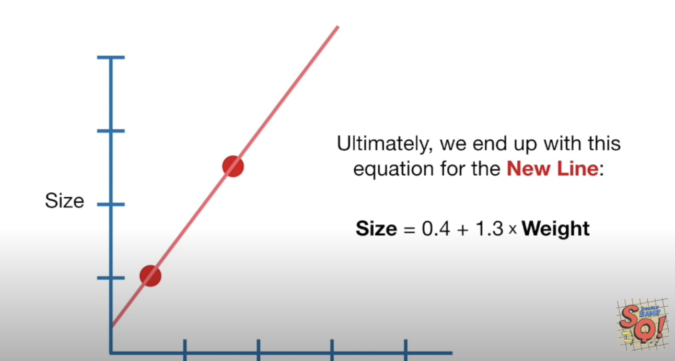

However, if we were given new data which is represented by the green dots in Figure 3, it is obvious that the original model does not fit the new data well.

*Figure 3: Poor fit with new data*

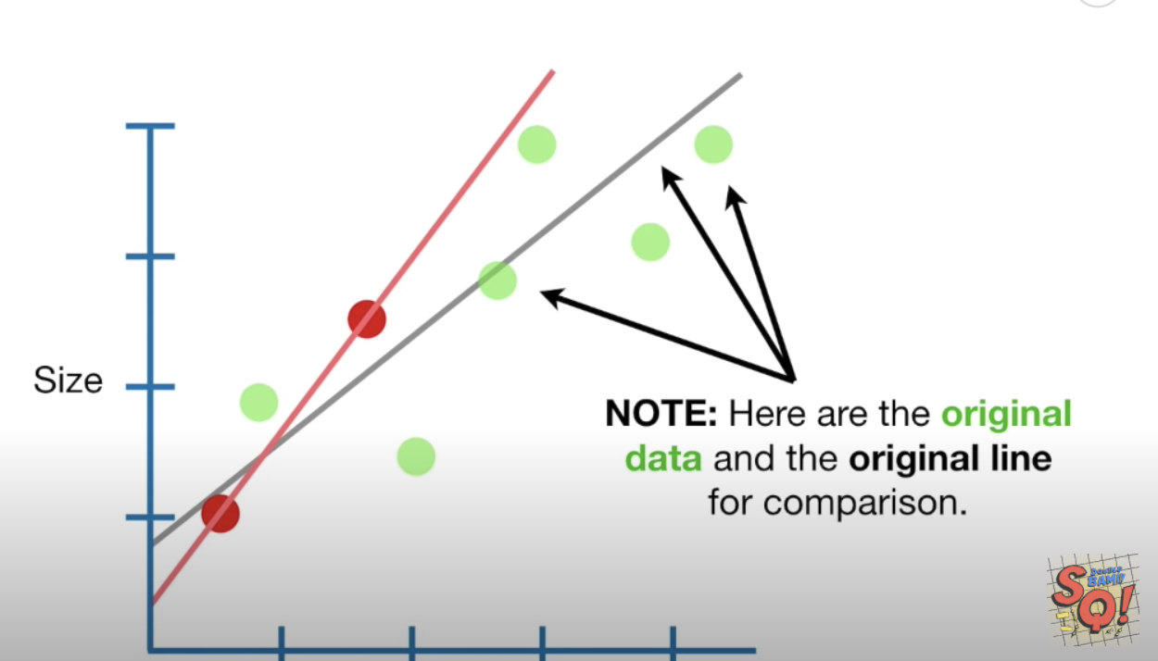

Ridge regression adds an **L2** penalty of $∝∙{slope}^{2}$ to the best fit line equation. $∝$

determines how strong the penalty is. The new model equation becomes;

intercept + slope $∙x_{i}$ + $∝∙{slope}^{2}$

Ridge regression then includes the penalty when calculating gradients to minimize the loss function. The loss function in this case is;

$Loss= {(Actual-predicted)}^{2}$ = ${(Actual-( intercept+slope∙x_{i}+ ∝∙{slope}^{2} ))}^{2}$

When the minimum point of the loss function is found, it is used to identify the best fit line.

*Example 3: Ridge Regression*

This example uses ridge regression to model the best fit line. To build this example add this code to the end of Example 1. When alpha=0.17, the RMSE of 0 0.623445 for ridge regression is slightly better than 0.6259157889490531 for ordinary least squares regression.

The coefficients in this case become:

Intercept: 3.349750965754926

'volatile acidity', 'chlorides', 'total sulfur dioxide', 'sulphates', 'alcohol'

[-1.09042919 -1.5465499 -0.00208941 0.79016659 0.24841788]

To build this program, add this code to the end of Example 1.

|  |
| --- |
| from sklearn.linear_model import Ridge  def ridge_regression(X_train, X_test, y_train, y_test, alpha):  # Fit the model  ridgereg = Ridge(alpha=alpha, normalize=True)  ridgereg.fit(X_train, y_train)  y_pred = ridgereg.predict(X_test)  # predictions = scalerY.inverse_transform(y_pred.reshape(-1,1))  print("\n***Ridge Regression Coefficients ** alpha=" + str(alpha))  print(ridgereg.intercept_)  print(ridgereg.coef_)  print('Root Mean Squared Error:',  np.sqrt(metrics.mean_squared_error(y_test, y_pred)))  X_train, X_test, y_train, y_test = train_test_split(X, y,  test_size=0.2, random_state=0)  alphaValues = [0, 0.16, 0.17, 0.18]  for i in range(0, len(alphaValues)):  ridge_regression(X_train, X_test, y_train, y_test,  alphaValues[i]) |

*Exercise 1 (1 mark)*

What is the RMSE value of ridge regression when alpha = 0?

|  |
| --- |
| ***Ridge Regression Coefficients ** alpha=0  3.0105263238850775  [-1.21046416 -1.7655295 -0.00217522 0.89491841 0.28268935]  Root Mean Squared Error: 0.625915788949053 |

*Exercise 2 (1 mark)*

How does the RMSE from OLS compare with the RMSE of ridge regression when alpha = 0?

|  |
| --- |
| OLS:  Root Mean Squared Error: 0.6259157889490544  Ridge Regression when alpha = 0:  Root Mean Squared Error: 0.625915788949053  The RMSE for the two are equal. |

*Exercise 3 (1 mark)*

In addition to giving the same result as OLS, when alpha equals 0 ridge regression also provides a result that is identical to which other algorithm?

|  |
| --- |
| When alpha equals 0 ridge regression has an intercept (3.0105263238850775) which is equal to the constant in the OLS model. |

Lasso Regression

A problem with ridge regression is that it cannot fully eliminate any of insignificant predictor variables unless we remove them manually. Lasso regression addresses this problem by adding an **L1 penalty** of $∝∙\left|slope\right|$ so insignificant predictor variables vanish.

intercept + slope $∙x_{i}$ + $∝∙|slope|$

To understand lasso regression in detail, see Josh Stormer’s videos at

<https://www.youtube.com/watch?v=NGf0voTMlcs> (Lasso regression)

<https://www.youtube.com/watch?v=Xm2C_gTAl8c> (Comparing lasso and ridge regression)

*Example 4: Lasso*

To implement lasso regression, add the code below on to the end of any of the prior examples. Lasso does very poorly. For this case, lasso set all predictor coefficients to zero so the intercept of 5.6466 is the only predictive feature in the entire model. It turns out that 5.6465 is approximately the average wine quality rating.

|  |
| --- |
| ***Lasso Regression Coefficients ** alpha=0.5  5.64659890539484  [-0. -0. -0. 0. 0.]  Root Mean Squared Error: 0.7584549718351333  ***Lasso Regression Coefficients ** alpha=1  5.64659890539484  [-0. -0. -0. 0. 0.]  Root Mean Squared Error: 0.7584549718351333 |

Here is the code:

|  |
| --- |
| from sklearn.linear_model import Lasso  def performLassorRegression(X_train, X_test, y_train, y_test, alpha):  lassoreg = Lasso(alpha=alpha, normalize=True, max_iter=1e5)  lassoreg.fit(X_train, y_train)  y_pred = lassoreg.predict(X_test)  print("\n***Lasso Regression Coefficients ** alpha=" + str(alpha))  print(lassoreg.intercept_)  print(lassoreg.coef_)  print('Root Mean Squared Error:',  np.sqrt(metrics.mean_squared_error(y_test, y_pred)))  alphaValues = [0, 0.1, 0.5, 1]  for i in range(0, len(alphaValues)):  performLassorRegression(X_train, X_test, y_train, y_test,  alphaValues[i]) |

Lasso did poorly in this case but we will see shortly how it can make a difference as part of the elastic net algorithm.

Elastic Net Regression

Elastic Net is useful when there are many predictor variables and we do not know which ones are actually significant for making a prediction. Elastic Net regression combines the L1 penalty from lasso regression and the L2 penalty from ridge regression.

For a reference consider reading:

<https://machinelearningmastery.com/elastic-net-regression-in-python/>

You might watch Josh Stormer’s video on elastic net for a better understanding at;

<https://www.youtube.com/watch?v=1dKRdX9bfIo>

The equation for generating the best fit line with elastic net regression is;

intercept + slope $∙x_{i}$ + $∝∙\left|slope\right| +(1-∝)∙{slope}^{2}$

As mentioned at the start of this document, the conflicting variable references for the strength of L1 and L2 penalties is confusing. The sklearn package also provides an additional l1_ratio parameter for their ElasticNet regressor to set the strength level of the L1 penalty. This extra parameter makes the terminology even more confusing so rather than overthinking it – I recommend just grid searching for the *alpha* and *l1_ratio* parameters to find the best results.

*Example 5: ElasticNet Regression*

This example demonstrates how to implement elastic net regression. When running the code, given all potential predictor variables, elastic net chose to only implement the L2 penalty. We know this because the l1ratio is set to 0 where the RMSE is at its lowest value of 0.61973. It is possible though that the model is overfit. A way to test this further would involve cross fold validation.

***ElasticNet Regression Coefficients ** alpha=0.01 l1ratio=0

2.9628181790919284

[ 0.0248009 -0.90311047 -0.00991496 0.00671778 -0.26896603 0.00376948

-0.00286842 -0.00340709 -0.18190618 0.55111427 0.31511091]

Root Mean Squared Error: 0.619732479961025

If we are concerned about overfitting, we can assign more strength to the L1 penalty for lasso regression. When an L1 penalty is used you will notice that some of the insignificant predictor variables are eliminated. The RMSE values from the elastic net regression with the L1 and L2 penalties still out-perform all OLS, SGD, ridge and lasso models.

***ElasticNet Regression Coefficients ** alpha=0.01 l1ratio=0.25

2.5743182663196325

[ 0.03011923 -0.9144444 -0. 0.00502741 -0.05385138 0.00359964

-0.00275648 -0. -0.06977843 0.50768012 0.31363392]

Root Mean Squared Error: 0.6214618411645152

***ElasticNet Regression Coefficients ** alpha=0.01 l1ratio=0.5

2.357912146791541

[ 0.03387944 -0.92442306 0. 0.00376742 -0. 0.00348747

-0.00267609 -0. -0. 0.47166676 0.31168149]

Root Mean Squared Error: 0.6225075422100831

Here is the code that implements elastic net regression:

|  |
| --- |
| from sklearn.linear_model import ElasticNet  bestRMSE = 100000.03  def performElasticNetRegression(X_train, X_test, y_train, y_test, alpha, l1ratio, bestRMSE,  bestAlpha, bestL1Ratio):  model = ElasticNet(alpha=alpha, l1_ratio=l1ratio)  # fit model  model.fit(X_train, y_train)  y_pred = model.predict(X_test)  print("\n***ElasticNet Regression Coefficients ** alpha=" + str(alpha)  + " l1ratio=" + str(l1ratio))  rmse = np.sqrt(metrics.mean_squared_error(y_test, y_pred))  print(model.intercept_)  print(model.coef_)  try:  if(rmse < bestRMSE):  bestRMSE = rmse  bestAlpha = alpha  bestL1Ratio = l1ratio  print('Root Mean Squared Error:', rmse)  except:  print("rmse =" + str(rmse))  return bestRMSE, bestAlpha, bestL1Ratio  X_elastic = dataset[['fixed acidity', 'volatile acidity', 'citric acid',  'residual sugar', 'chlorides', 'free sulfur dioxide',  'total sulfur dioxide', 'density', 'pH', 'sulphates',  'alcohol']]  X_train, X_test, y_train, y_test = train_test_split(X_elastic, y,  test_size=0.2, random_state=0)  alphaValues = [0, 0.00001, 0.0001, 0.001, 0.01, 0.18]  l1ratioValues = [0, 0.25, 0.5, 0.75, 1]  bestAlpha = 0  bestL1Ratio = 0  for i in range(0, len(alphaValues)):  for j in range(0, len(l1ratioValues)):  bestRMSE, bestAlpha, bestL1Ratio = performElasticNetRegression(  X_train, X_test, y_train, y_test,  alphaValues[i], l1ratioValues[j], bestRMSE,  bestAlpha, bestL1Ratio)  print("Best RMSE " + str(bestRMSE) + " Best alpha: " + str(bestAlpha)  + " " + "Best l1 ratio: " + str(bestL1Ratio)) |

Equation Comparison

With all of the methods discussed we are using gradients to find the minimum loss with the minimum least squared error equation. To implement each of the machine learning algorithms, we search for the minimum loss by calculating the gradient of the loss function.

$\frac{d(least squares)}{dx}$ = $\frac{d {(actual-prediction)}^{2}}{dx}$

The prediction equation changes with the algorithm. The prediction equation includes an L2 penalty with ridge regression. The prediction equation includes an L1 penalty for lasso regression. The prediction equation includes both L1 and L2 penalties for elastic net regression.

*Table 1: Regression Comparison*

|  |  |  |
| --- | --- | --- |
|  | Prediction equation as |  |
| Gradient Descent | intercept+slope $∙x_{i}$ | Simple |
| Stochastic Gradient Descent | intercept+slope $∙x_{i}$ (Training set is randomly selected) | Simple |
| Ridge Regression | intercept+slope $∙x_{i}$ + $∝∙{slope}^{2}$ | Tends to do better when most variables are relevant. |
| Lasso Regression | intercept+slope + | Gets rid of useless variables. |
| Elastic Net Regression  (Is a hybrid of ridge and lasso) | intercept+slope++ | Good for many variables when don’t know which ones are relevant. |

Support Vector Machines

Support vector machines offer another way to apply machine learning for conducting linear regression and classification. Once again Josh Stormer has an excellent video to explain how support vector machines work.

<https://www.youtube.com/watch?v=efR1C6CvhmE>

Support vector machines (SVMs) are supervised algorithms for both classification and regression. Generally, an SVM algorithm tries to find the widest margin between classes to distinguish one from the other.

Josh Stormer presents an example of an SVM for classifying mice as either not obese or obese. Figure 4 illustrates how we can set a threshold to separate non-obese mice from obese mice.

*Figure 4: Classifying Non-Obese Mice (Left) with Obese Mice (Right)*

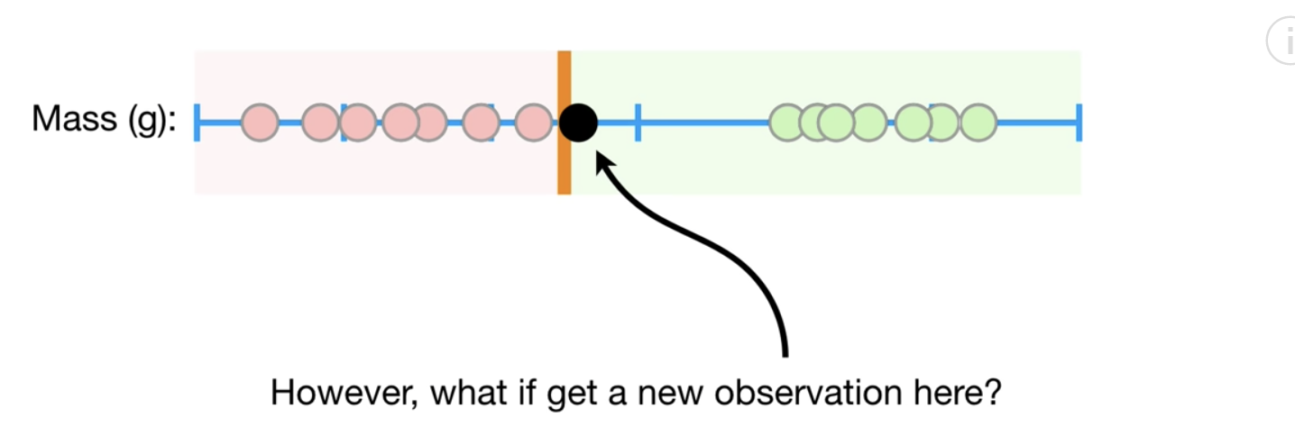

In order to optimize most predictions, we may place set threshold that allows some samples to be misclassified. Obviously, there is a trade-off but the benefit of high accuracy may be worth the occasional misclassification.

*Figure 5: Allowing for Mis-classification*

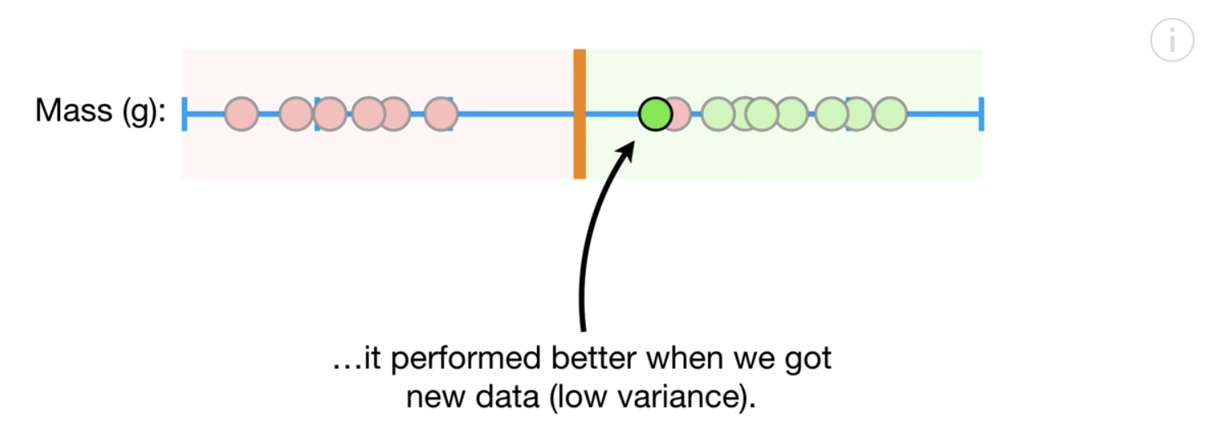

Josh presents another scenario in Figure 6 for vaccine dosage. The samples on the left do not receive enough of the vaccine to be cured. The samples on the right receive too much of the dosage to be cured. The samples in the middle receive the right amount of the dosage. A threshold in the same dimension does not help with classification.

*Figure 6: Vaccine Dosage*



Support vector classifiers allow us to create lines or planes in higher dimensions to enable better separation between classes (refer to Figure 7).

*Figure 7: Enabling Classification with Higher Dimensions*

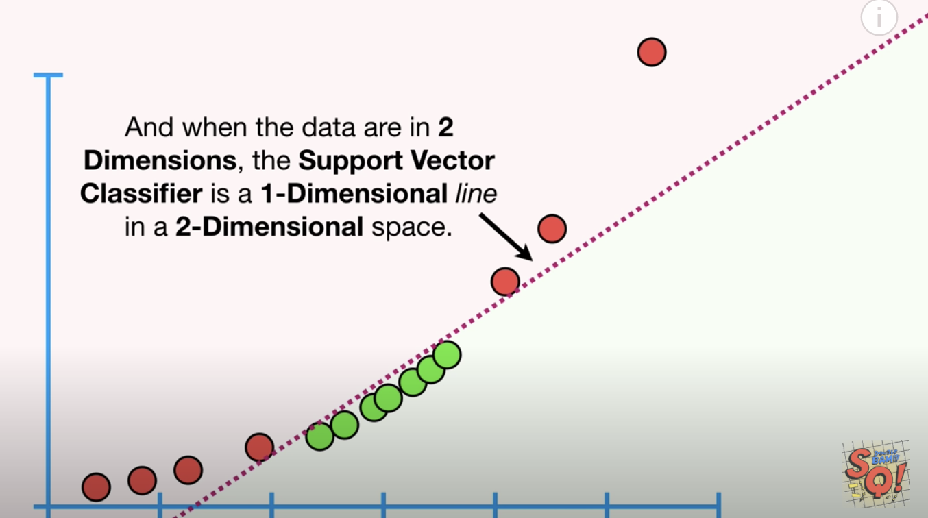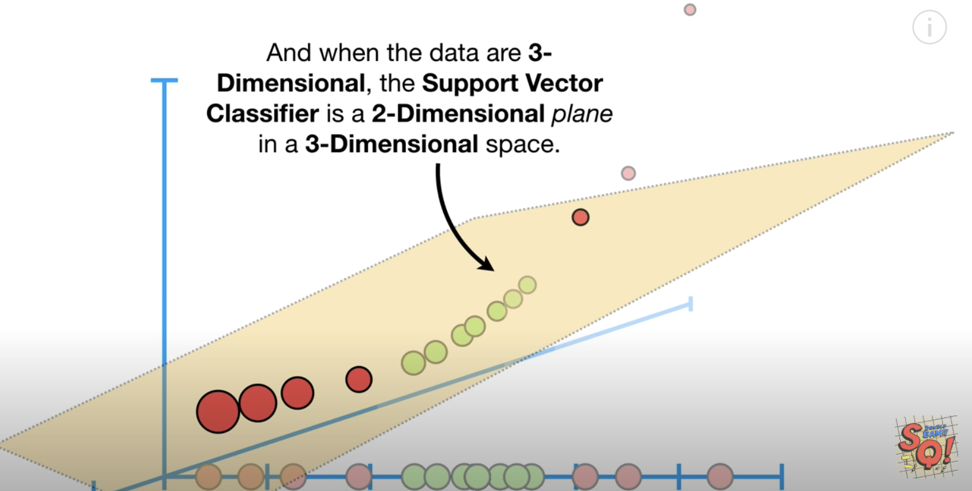

We could Kernel could be sigmoid, linear, rbf (gaussian), poly with degree.

clf = svm.SVC(kernel='linear')

clf = svm.SVC(kernel='rbf')

clf = svm.SVC(kernel='sigmoid')

svclassifier = SVC(kernel='poly', degree=8)

*Example 6: Basic Logistic Regression*

In this example we will start the series by first perform basic logistic regression with the diabetes data set. Simple logistic regression can detect diabetes with accuracy score of 80%.

|  |
| --- |
| Accuracy: 0.8070866141732284  Confusion Matrix  Predicted 0 1  Actual  0 156 16  1 33 49 |

Here is the code:

|  |
| --- |
| import pandas as pd  from sklearn.model_selection import train_test_split  PATH = "/Users/pm/Desktop/DayDocs/data/"  from sklearn.linear_model import LogisticRegression  from sklearn import metrics  import numpy as np  # load the dataset  df = pd.read_csv(PATH + 'diabetes.csv', sep=',')  # split into input (X) and output (y) variables  X = df[['Pregnancies','Glucose','BloodPressure','SkinThickness','Insulin','BMI',  'DiabetesPedigreeFunction', 'Age']]  y = df[['Outcome']]  # Split into train and test data sets.  X_train, X_test, y_train, y_test = train_test_split( X, y, test_size=0.33)  # Perform logistic regression.  logisticModel = LogisticRegression(fit_intercept=True, random_state = 0,  solver='liblinear')  logisticModel.fit(X_train,y_train)  y_pred=logisticModel.predict(X_test)  # Show model coefficients and intercept.  print("\nModel Coefficients: ")  print("\nIntercept: ")  print(logisticModel.intercept_)  print(logisticModel.coef_)  # Show confusion matrix and accuracy scores.  confusion_matrix = pd.crosstab(np.array(y_test['Outcome']), y_pred,  rownames=['Actual'],  colnames=['Predicted'])  print('\nAccuracy: ',metrics.accuracy_score(y_test, y_pred))  print("\nConfusion Matrix")  print(confusion_matrix) |

*Example 7: Support Vector Machines with a Linear Kernel*

This example implements an SVM model with a linear kernel setting. The original logistic regression equation generates reasonable accuracy.

Accuracy: 0.7716535433070866

Confusion Matrix

Predicted 0 1

Actual

0 145 26

1 32 51

The linear kernel appears to be slightly better in this case. Running the code multiple times though obtains varying results.

Accuracy: 0.7755905511811023

To build this example, add this code to the end of Example 6.

|  |
| --- |
| # Import svm package  from sklearn import svm  # Create a svm Classifier using one of the following options:  # linear, polynomial, and radial  clf = svm.SVC(kernel='linear')  # Train the model using the training set.  clf.fit(X_train, y_train)  # Evaluate the model.  y_pred = clf.predict(X_test)  from sklearn import metrics  print("Accuracy:",metrics.accuracy_score(y_test, y_pred)) |

*Exercise 4 (1 mark)*

Try running the code in Example 7 with the ‘rbf’ option. How do the results compare with logistic regression?

|  |
| --- |
| Logistic Regression:  Accuracy: 0.7204724409448819  Svm with ‘rbf kernel:  Accuracy: 0.7283464566929134  Accuracy of the ‘rbf’ option with svm is slightly higher compared to using logistic regression. |

*Exercise 5 (1 mark)*

Try running the code in Example 7 with the ‘sigmoid’ option. How do the results compare with logistic regression?

|  |
| --- |
| Logistic Regression:  Accuracy: 0.7480314960629921  Svm with ‘sigmoid’ kernel:  Accuracy: 0.7283464566929134  The logistic regression accuracy is significantly higher than the ‘sigmoid’ option with svm. |

*Example 8: Fitting an SVM classifier with a polynomial kernel*

This example shows how to implement the SVM classifier with a polynomial kernel setting. The routine grid searches for the optimal polynomial order:

Accuracy: 0.6181102362204725 Num degrees: 0

Accuracy: 0.7401574803149606 Num degrees: 1

Accuracy: 0.7440944881889764 Num degrees: 2

Accuracy: 0.7440944881889764 Num degrees: 3

Accuracy: 0.7401574803149606 Num degrees: 4

Accuracy: 0.7322834645669292 Num degrees: 5

In this case, the results are quite volatile so the polynomial kernel may not offer the best fit. To build this example, add this code to the end of Example 6.

|  |
| --- |
| # Suppress the data convergence warning.  import warnings  from sklearn.exceptions import DataConversionWarning  warnings.filterwarnings(action='ignore', category=DataConversionWarning)  from sklearn import svm  def buildSVMmodel(degree):  # Create a svm Classifier using one of the following options:  # linear, polynomial, and radial  clf = svm.SVC(kernel='poly', degree=degree)  # Train the model using the training set.  clf.fit(X_train, y_train)  # Evaluate the model.  y_pred = clf.predict(X_test)  from sklearn import metrics  accuracy = metrics.accuracy_score(y_test, y_pred)  print("Accuracy: " + str(accuracy) + " Num degrees: " + str(degree))  degrees = [0, 1,2,3,4,5]  for i in range(0, len(degrees)):  buildSVMmodel(degrees[i]) |

Summary

The content that has been covered in this document shows several other ways to perform linear regression and classification regression. In addition to OLS and logistic regression, we have added gradient descent, ridge regression, lasso regression, elastic net regression and support vector machines to our tool kit. To know which algorithm performs best always cross validate and compare. In the words of Dr. Donald Wedding, line the models up and let them have a street brawl.

*Exercise 6 (2 marks)*

Run the following code and show the model summary and RMSE. Indicate if any of the predictor variables are insignificant in a 5% confidence interval. It is fine if the intercept is not significant.

|  |
| --- |
| import pandas as pd  from sklearn.model_selection import train_test_split  from sklearn import metrics  import statsmodels.api as sm  import numpy as np  PATH = "/Users/pm/Desktop/DayDocs/data/"  CSV_DATA = "petrol_consumption.csv"  dataset = pd.read_csv(PATH + CSV_DATA)  # Petrol_Consumption  X = dataset[['Petrol_tax','Average_income', 'Population_Driver_licence(%)']]  # Adding an intercept *** This is requried ***. Don't forget this step.  # The intercept centers the error residuals around zero  # which helps to avoid over-fitting.  X_withConst = sm.add_constant(X)  y = dataset['Petrol_Consumption'].values  X_train, X_test, y_train, y_test = train_test_split(X_withConst, y,  test_size=0.2, random_state=0)  def performLinearRegression(X_train, X_test, y_train, y_test):  model = sm.OLS(y_train, X_train).fit()  predictions = model.predict(X_test) # make the predictions by the model  print(model.summary())  print('Root Mean Squared Error:',  np.sqrt(metrics.mean_squared_error(y_test, predictions)))  return predictions  predictions = performLinearRegression(X_train, X_test, y_train, y_test) |

Show the model summary here:

|  |
| --- |
|  |

Show the RMSE here:

|  |
| --- |
| Root Mean Squared Error: 62.8802344122691 |

Are any predictor variables insignificant? If so which ones are insignificant?

|  |
| --- |
| None of the predictor variables are insignificant as they are all p<=0.05. |

*Exercise 7 (2 marks)*

Build a linear regression model for petrol consumption using stochastic gradient descent. Big hint: add in the code from Example 2. How does the RMSE from SGD compare with the RMSE when using OLS? Explain why this may have happened.

|  |
| --- |
| OLS: Root Mean Squared Error: 62.8802344122691  ***SGD=  Root Mean Squared Error: 81.25035630956046  The SGD RMSE is higher than the OLS RMSE. This may be a result of SGD using randomly selected data from the training set. |
|  |

*Exercise 8 (3 marks)*

Start with the code for OLS again from Example 2. Add in the code to perform **ridge** regression. This is easy. Please see the example code for ridge regression. Make sure none of the SGD or scaling code exists in this file so you can get a clear view of how ridge regression compares with OLS. Also, remove the parameter random_state=0 to prevent seeding so you can have truly random data. Grid search optimal values for alpha. Compare RMSE’s for your OLS and ridge regression models here:

|  |
| --- |
| OLS:  Root Mean Squared Error: 38.66882929750994  ***Ridge Regression Coefficients ** alpha=0.18  316.0551839040345  [ 0.00000000e+00 -2.81779704e+01 -5.21829022e-02 1.21970077e+03]  Root Mean Squared Error: 36.251070081163334  The ridge regressions have a slightly lower RMSE compared to OLS. |

*Exercise 9 (3 marks)*

Start with the code for OLS again from Example 2. Add in the code to perform **lasso** regression. This is easy. Please see the example code for lasso regression. Make sure none of the SGD or scaling code exists in this file so you can get a clear view of how ridge regression compares with OLS. Also, remove the parameter random_state=0 to prevent seeding so you can have truly random data. Grid search optimal values for alpha. Compare RMSE’s for your OLS and your best performing lasso regression models here:

|  |
| --- |
| OLS:  Root Mean Squared Error: 59.224810221306214  ***Lasso Regression Coefficients ** alpha=1  240.9130299699235  [ 0.00000000e+00 -1.70525973e+01 -7.28397770e-02 1.36526227e+03]  Root Mean Squared Error: 56.55025032930167  Lasso regression has a slightly lower RMSE compared to OLS. |

*Exercise 10 (6 marks)*

Start with the code for OLS again from Example 2. Add in the following code to perform **elastic net** regression:

|  |
| --- |
| from sklearn.linear_model import ElasticNet  bestRMSE = 100000.03  def performElasticNetRegression(X_train, X_test, y_train, y_test, alpha, l1ratio, bestRMSE,  bestAlpha, bestL1Ratio):  model = ElasticNet(alpha=alpha, l1_ratio=l1ratio)  # fit model  model.fit(X_train, y_train)  y_pred = model.predict(X_test)  print("\n***ElasticNet Regression Coefficients ** alpha=" + str(alpha)  + " l1ratio=" + str(l1ratio))  rmse = np.sqrt(metrics.mean_squared_error(y_test, y_pred))  print(model.intercept_)  print(model.coef_)  try:  if(rmse < bestRMSE):  bestRMSE = rmse  bestAlpha = alpha  bestL1Ratio = l1ratio  print('Root Mean Squared Error:', rmse)  except:  print("rmse =" + str(rmse))  return bestRMSE, bestAlpha, bestL1Ratio  alphaValues = [0, 0.00001, 0.0001, 0.001, 0.01, 0.18]  l1ratioValues = [0, 0.25, 0.5, 0.75, 1]  bestAlpha = 0  bestL1Ratio = 0  for i in range(0, len(alphaValues)):  for j in range(0, len(l1ratioValues)):  bestRMSE, bestAlpha, bestL1Ratio = performElasticNetRegression(  X_train, X_test, y_train, y_test,  alphaValues[i], l1ratioValues[j], bestRMSE,  bestAlpha, bestL1Ratio)  print("Best RMSE " + str(bestRMSE) + " Best alpha: " + str(bestAlpha)  + " " + "Best l1 ratio: " + str(bestL1Ratio)) |

Make sure none of the SGD or scaling code exists in this file so you can get a clear view of how elastic net regression compares with OLS. Also, remove the parameter random_state=0 to prevent seeding so you can have truly random data. Grid search optimal values for alpha and the l1_ratio.

Compare RMSE’s for your OLS and your best performing elastic net regression model here:

|  |
| --- |
| OLS  Root Mean Squared Error: 93.10047083149566  ElasticNet Regression  Root Mean Squared Error: 93.10047083149294  OLS and elastic net regression produces very similar RMSEs. |

Show a screenshot of your best elastic net model settings here:

|  |
| --- |
| Best elastic net model setting are a result of alpha=0, changing l1ratio doesn’t further lower the RMSE. |

What are the model coefficients of your best model? What does this imply?

|  |
| --- |
| [ 0.00000000e+00 -2.97724742e+01 -6.11797230e-02 1.15417418e+03]  The first coefficient with a value of 0 shows that it is insigifnicant. |

*Exercise 11 (5 marks)*

Create a table. Show RMSE values, alpha values and where applicable l1_ratio values for your best OLS, ridge, lasso and elastic net models. Show your table here:

|  |  |  |  |  |  |  |  |  |  |  |  |  |  |  |  |  |  |  |  |  |
| --- | --- | --- | --- | --- | --- | --- | --- | --- | --- | --- | --- | --- | --- | --- | --- | --- | --- | --- | --- | --- |
| |  |  |  |  | | --- | --- | --- | --- | |  | alpha | l1_ratio | RMSE | | OLS | - | - | 56.716410270986934 | | Ridge | 0.18 | - | 60.62664201594916 | | Lasso | 1 | - | 56.71641027095869 | | Elastic Net Model | 0 | 0 | 56.716410270958704 | |

*Exercise 12 (2 marks)*

Match the following terms with a definition. Use each term only once to generate the optimal matches.

Gradient descent, Elastic net regression, Lasso regression, Ridge Regression, Support Vector Machines

1. _Elastic Net Regression__

Is good for data sets with many attributes and significant predictor variables are unknown.

1. _ Lasso Regression____

Is good for eliminating insignificant predictor variables.

1. ____ Ridge Regression__

Adds a penalty to eliminate bias.

1. _Support Vector Machines__

Uses higher dimensions for better separation between classes.

*Exercise 13 (3 marks)*

Indicate if each of the following statements is either true or false.

False Lasso regression adds an L1 penalty so insignificant variable coefficients effectively

vanish.

True Ridge regression uses an L2 penalty to help minimize the loss function.

False Support vector machines combine L1 and L2 penalties.

True Elastic net regression combines L1 and L2 penalties.

True The L1 penalty is $∝∙|slope|$

False The L1 penalty is $∝∙{slope}^{2}$

**Table of Contents**

**Trees Are Not Strong on their Own 1**

**Random Forests 1**

Advantage of Random Forests 2

Disadvantage of Random Forests 2

**Building a Simple Random Forest Model 2**

**Displaying Feature Importance 5**

**Random Forest Hyperparameter Tuning 8**

**Random forests have several hyperparameters: 8**

Trees Are Not Strong on their Own

Last week we looked at decision trees for regression. On their own they are not great. They may work well with training data but they are not good with new samples.

Random Forests

Random forests combine hundreds of trees. These trees are built and initialized slightly differently. Once the random forest is built, the test data is given to each tree in the forest. Each tree makes a prediction. Each prediction counts as a vote for the collective outcome. Random forests can be used for classification and linear regressions.



Once again Josh Stormer provides a great video on now to build a random forest. I recommend watching it:

<https://www.youtube.com/watch?v=J4Wdy0Wc_xQ>

To create a forest:

* Each tree is created with a bootstrapped data set. “Bootstrapped” means the tree is built using sampling with replacement.
* Each decision tree is built with a random subset of variables at each step.
* Hundreds of trees are built.

To evaluate the forest, test data is given to the forest and the trees vote on the prediction.

Advantage of Random Forests

Random forests include the following:

* They are often highly accurate.
* They help to avoid overfitting.
* They enable helpful scoring of important features so the least important features can be dropped during training.

Disadvantage of Random Forests

The downside of random forests includes:

* Slowness.
* Difficult interpretability.

Building a Simple Random Forest Model

The code that builds a random forest is similar to many other models that we have used. In the snippet below, a random forest with 1000 trees is created. We will fine tune these parameters later.

|  |
| --- |
| # Import the model we are using  from sklearn.ensemble import RandomForestRegressor  # Instantiate model with 1000 decision trees  rf = RandomForestRegressor(n_estimators = 1000, random_state = 42)  # Train the model on training data  rf.fit(train_features, train_labels)  # Use the forest's predict method on the test data  predictions = rf.predict(test_features) |

*Example 1: Random Forests*

This example implements a random forest to predict the weather. It is based on the code that is presented at <https://towardsdatascience.com/random-forest-in-python-24d0893d51c0>

Here is a quick view of the data set:

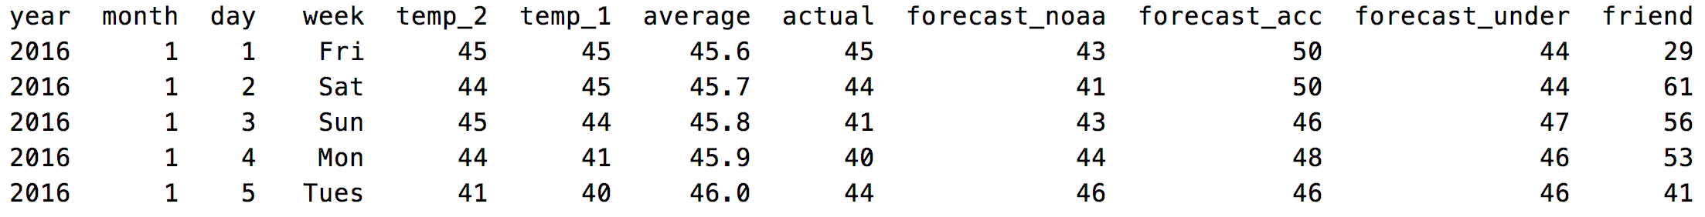

When preparing the data, one-hot encoding is used to create dummy variables for the days of the week:

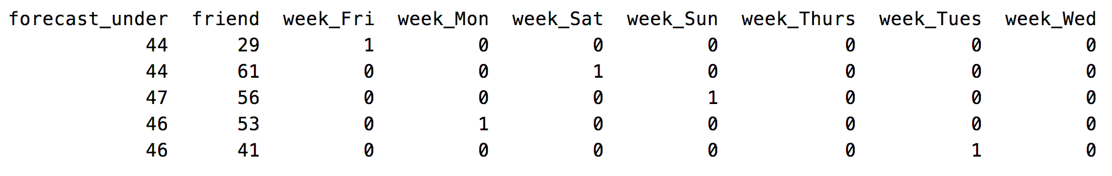

The random forest produces a reasonably accurate model. The example provided implements the mean absolute error which is used to calculate an accuracy rating.

Mean Absolute Error = $\frac{1}{n}\sum{|y-\hat{y}|}$

# Calculate the absolute errors

errors = abs(predictions - test_labels)

# Calculate mean absolute percentage error (MAPE)

mape = 100 * (errors / test_labels)

# Calculate and display accuracy

accuracy = 100 - np.mean(mape)

The root mean square error has also been included with the results as another valid measure of model success.

|  |
| --- |
| Mean Absolute Error: 3.87 degrees.  Accuracy: 93.93 %.  RMSE: 5.101657512937373 |

Here is the full program:

|  |
| --- |
| # Pandas is used for data manipulation  import pandas as pd  from sklearn.metrics import mean_squared_error  # Read in data and display first 5 rows  features = pd.read_csv('/Users/pm/Desktop/DayDocs/data/temperatures.csv')  # Show all columns.  pd.set_option('display.max_columns', None)  pd.set_option('display.width', 1000)  print(features)  # One-hot encode the data using pandas get_dummies  features = pd.get_dummies(features)  # Display the first 5 rows of the last 12 columns.  print(features.head(5))  # Use numpy to convert to arrays  import numpy as np  # Labels are the values we want to predict  labels = np.array(features['actual'])  # Remove the labels from the features  # axis 1 refers to the columns  features= features.drop('actual', axis = 1)  # Saving feature names for later use  feature_list = list(features.columns)  # Convert to numpy array  features = np.array(features)  # Using Skicit-learn to split data into training and testing sets  from sklearn.model_selection import train_test_split  # Split the data into training and testing sets  train_features, test_features, train_labels, test_labels =\  train_test_split(features, labels, test_size = 0.25, random_state = 42)  # Import the model we are using  from sklearn.ensemble import RandomForestRegressor  # Instantiate model with 1000 decision trees  rf = RandomForestRegressor(n_estimators = 1000, random_state = 42)  # Train the model on training data  rf.fit(train_features, train_labels)  # Use the forest's predict method on the test data  predictions = rf.predict(test_features)  # Calculate the absolute errors  errors = abs(predictions - test_labels)  # Print out the mean absolute error (mae)  print('Mean Absolute Error:', round(np.mean(errors), 2), 'degrees.')  # Calculate mean absolute percentage error (MAPE)  mape = 100 * (errors / test_labels)  # Calculate and display accuracy  accuracy = 100 - np.mean(mape)  print('Accuracy:', round(accuracy, 2), '%.')  # Print out the mean square error.  mse = mean_squared_error(test_labels, predictions)  print('RMSE:', np.sqrt(mse)) |

Displaying Feature Importance

A neat feature of random forests is its ability to provide a ranking of feature importance for making predictions.

*Example 2: Show the Importance’s*

This example demonstrates how to rank feature importance for the random forest. The output is:

|  |
| --- |
| Variable: temp_1 Importance: 0.66  Variable: average Importance: 0.15  Variable: forecast_noaa Importance: 0.05  Variable: forecast_acc Importance: 0.03  Variable: day Importance: 0.02  Variable: temp_2 Importance: 0.02  Variable: forecast_under Importance: 0.02  Variable: friend Importance: 0.02  Variable: month Importance: 0.01  Variable: year Importance: 0.0  Variable: week_Fri Importance: 0.0  Variable: week_Mon Importance: 0.0  Variable: week_Sat Importance: 0.0  Variable: week_Sun Importance: 0.0  Variable: week_Thurs Importance: 0.0  Variable: week_Tues Importance: 0.0  Variable: week_Wed Importance: 0.0 |

To implement this solution, add the following code to the end of Example 1.

|  |
| --- |
| # Get numerical feature importances  importances = list(rf.feature_importances_)  # Present features and importance scores.  def showFeatureImportances(importances, feature_list):  dfImportance = pd.DataFrame()  for i in range(0, len(importances)):  dfImportance = dfImportance.append({"importance":importances[i],  "feature":feature_list[i] },  ignore_index = True)  dfImportance = dfImportance.sort_values(by=['importance'],  ascending=False)  print(dfImportance)  showFeatureImportances(importances, feature_list) |

*Example 3: Building Forest with Important Features Only*

This example builds a random forest with the important features which includes only the *temp1* variable and the *average* variable. The following scores are surprisingly competitive with the results from Example 2 which use many more features.

|  |
| --- |
| Mean Absolute Error: 3.92 degrees.  Accuracy: 93.76 %.  RMSE: 5.167988371104833 |

To build this solution, add this code to the end of Example 2:

|  |
| --- |
| # New random forest with only the two most important variables  rf_most_important = RandomForestRegressor(n_estimators= 1000, random_state=42)  # Extract the two most important features  important_indices = [feature_list.index('temp_1'), feature_list.index('average')]  train_important = train_features[:, important_indices]  test_important = test_features[:, important_indices]  # Train the random forest  rf_most_important.fit(train_important, train_labels)  # Make predictions and determine the error  predictions = rf_most_important.predict(test_important)  errors = abs(predictions - test_labels)  # Display the performance metrics  print('Mean Absolute Error:', round(np.mean(errors), 2), 'degrees.')  mape = np.mean(100 * (errors / test_labels))  accuracy = 100 - mape  print('Accuracy:', round(accuracy, 2), '%.') |

*Exercise 1 (4 marks)*

Given the following code for the Iris data set, add the additional code needed to find the top three features for a random forest where. Hint: (See Example 3)

feature_list = ['sepal length', 'sepal width', 'petal length', 'petal width']

Here is code to help you get started:

|  |
| --- |
| #Import scikit-learn dataset library  from sklearn import datasets  #Load dataset  iris = datasets.load_iris()  # Creating a DataFrame of given iris dataset.  import pandas as pd  data=pd.DataFrame({  'sepal length':iris.data[:,0],  'sepal width':iris.data[:,1],  'petal length':iris.data[:,2],  'petal width':iris.data[:,3],  'species':iris.target  })  iris['target_names']  print(data.head())  # Import train_test_split function  from sklearn.model_selection import train_test_split  X=data[['sepal length', 'sepal width', 'petal length', 'petal width']] # Features  y=data['species'] # Labels  # Split dataset into training set and test set  X_train, X_test, y_train, y_test = train_test_split(X, y, test_size=0.3)  #Import Random Forest Model  from sklearn.ensemble import RandomForestClassifier  #Create a Gaussian Classifier  rf=RandomForestClassifier(n_estimators=100)  #Train the model using the training sets y_pred=rf.predict(X_test)  rf.fit(X_train,y_train)  y_pred=rf.predict(X_test)  #Import scikit-learn metrics module for accuracy calculation  from sklearn import metrics  # Model Accuracy, how often is the classifier correct?  print("Accuracy:", metrics.accuracy_score(y_test, y_pred))  # Predict species for a single flower.  # sepal length = 3, sepal width = 5  # petal length = 4, petal width = 2  prediction = rf.predict([[3, 5, 4, 2]])  # 'setosa', 'versicolor', 'virginica'  print(prediction) |

Add in code to generate the top performing feature list. Show the listing that is displayed when running your revised program here:

|  |
| --- |
| #Import scikit-learn dataset library from sklearn import datasets import pandas as pd from sklearn.metrics import mean_squared_error   #Load dataset iris = datasets.load_iris()  # Creating a DataFrame of given iris dataset. import pandas as pd data=pd.DataFrame({  'sepal length':iris.data[:,0],  'sepal width':iris.data[:,1],  'petal length':iris.data[:,2],  'petal width':iris.data[:,3],  'species':iris.target }) iris['target_names'] print(data.head())  # Import train_test_split function from sklearn.model_selection import train_test_split X=data[['sepal length', 'sepal width', 'petal length', 'petal width']] # Features y=data['species'] # Labels  # Split dataset into training set and test set X_train, X_test, y_train, y_test = train_test_split(X, y, test_size=0.3)  #Import Random Forest Model from sklearn.ensemble import RandomForestClassifier  #Create a Gaussian Classifier rf=RandomForestClassifier(n_estimators=100)  #Train the model using the training sets y_pred=rf.predict(X_test) rf.fit(X_train,y_train)  y_pred=rf.predict(X_test)  #Import scikit-learn metrics module for accuracy calculation from sklearn import metrics # Model Accuracy, how often is the classifier correct? print("Accuracy:", metrics.accuracy_score(y_test, y_pred))  # Predict species for a single flower. # sepal length = 3, sepal width = 5 # petal length = 4, petal width = 2 prediction = rf.predict([[3, 5, 4, 2]]) # 'setosa', 'versicolor', 'virginica' print(prediction)    # Show all columns. pd.set_option('display.max_columns', None) pd.set_option('display.width', 1000)   # One-hot encode the data using pandas get_dummies # features = pd.get_dummies(features) features = pd.get_dummies(data) print(features)  # Display the first 5 rows of the last 12 columns. print(features.head(5))  # Use numpy to convert to arrays import numpy as np  # Labels are the values we want to predict labels = np.array(features['species'])  # Remove the labels from the features # axis 1 refers to the columns features= features.drop('species', axis = 1)  # Saving feature names for later use feature_list = list(features.columns)  # Convert to numpy array features = np.array(features)  # Using Skicit-learn to split data into training and testing sets from sklearn.model_selection import train_test_split  # Split the data into training and testing sets train_features, test_features, train_labels, test_labels =\  train_test_split(features, labels, test_size = 0.25, random_state = 42)  # Import the model we are using from sklearn.ensemble import RandomForestRegressor  # Instantiate model with 1000 decision trees rf = RandomForestRegressor(n_estimators = 1000, random_state = 42)  # Train the model on training data rf.fit(train_features, train_labels)  # Use the forest's predict method on the test data predictions = rf.predict(test_features)  # Calculate the absolute errors errors = abs(predictions - test_labels)  # Print out the mean absolute error (mae) print('Mean Absolute Error:', round(np.mean(errors), 2), 'degrees.')  # Calculate mean absolute percentage error (MAPE) mape = 100 * (errors / test_labels)  # Calculate and display accuracy accuracy = 100 - np.mean(mape)  print('Accuracy:', round(accuracy, 2), '%.')  # Print out the mean square error. mse = mean_squared_error(test_labels, predictions) print('RMSE:', np.sqrt(mse))  # Get numerical feature importances importances = list(rf.feature_importances_)  # Present features and importance scores. def showFeatureImportances(importances, feature_list):  dfImportance = pd.DataFrame()  df_list =[ ]  for i in range(0, len(importances)):  new_row = {"importance": importances[i], "feature": feature_list[i]}  df_list.append({"importance": importances[i], "feature": feature_list[i]})  print(new_row)  # dfImportance = pd.concat((dfImportance, df_new_row))  # print(df_list)  df_list = pd.DataFrame(df_list)  dfImportance = pd.concat(df_list, ignore_index=True)    # dfImportance = pd.DataFrame().concat({"importance":importances[i],  # "feature":feature_list[i] },  # ignore_index = True)   dfImportance = dfImportance.sort_values(by=['importance'],  ascending=False)  print(dfImportance)  print("#######importnace###########") showFeatureImportances(importances, feature_list)  # New random forest with only the two most important variables rf_most_important = RandomForestRegressor(n_estimators= 1000, random_state=42)  # Extract the two most important features important_indices = [feature_list.index('petal length'), feature_list.index('petal width')] train_important = train_features[:, important_indices] test_important = test_features[:, important_indices]  # Train the random forest rf_most_important.fit(train_important, train_labels)  # Make predictions and determine the error predictions = rf_most_important.predict(test_important) errors = abs(predictions - test_labels)  # Display the performance metrics print('Mean Absolute Error:', round(np.mean(errors), 2), 'degrees.') mape = np.mean(100 * (errors / test_labels)) accuracy = 100 - mape print('Accuracy:', round(accuracy, 2), '%.') |

*Exercise 2 (3 marks)*

Rebuild the random forest with Iris data set using only the top performing features. Show the accuracy score. Compare the accuracy of the Iris data set before and after the removal of the lowest performing feature.

|  |
| --- |
|  |

Random Forest Hyperparameter Tuning

Random forests have several hyperparameters:

* n_estimators = number of trees in the forest.
* max_features = max number of features considered for splitting a node. Settings include:
  + int, then consider max_features features at each split.
  + float, then max_features is a fraction and int(max_features * n_features) features are considered at each split.
  + “auto”, then max_features=sqrt(n_features).
  + “sqrt”, then max_features=sqrt(n_features) (same as “auto”).
  + “log2”, then max_features=log2(n_features).
  + None, then max_features=n_features.
* max_depth = max number of levels in each decision tree.
* min_samples_split = min number of data points placed in a node before the node is split.
* min_samples_leaf = min number of data points allowed in a leaf node.
* bootstrap = method for sampling data points (with or without replacement).

It is possible to use both RandomizedSearchCV() and GridSearchCV() to help find optimal parameters.

*Example 4: Searching for the Optimal RandomForest Hyperparmaters*

This example shows how to search for an optimal set of parameters with RandomizedSearchCV() for the temperatures.csv data set. When running the program with the weather set the output is:

{'n_estimators': 1600, 'min_samples_split': 10, 'min_samples_leaf': 2, 'max_features': 'auto', 'max_depth': None, 'bootstrap': True}

To build this example, add this code to the end of Example 1.

|  |
| --- |
| from sklearn.model_selection import RandomizedSearchCV  # Number of trees in random forest  n_estimators = [int(x) for x in np.linspace(start = 200, stop = 2000, num = 10)]  # Number of features to consider at every split  max_features = ['auto', 'sqrt']  # Maximum number of levels in tree  max_depth = [int(x) for x in np.linspace(10, 110, num = 11)]  max_depth.append(None)  # Minimum number of samples required to split a node  min_samples_split = [2, 5, 10]  # Minimum number of samples required at each leaf node  min_samples_leaf = [1, 2, 4]  # Method of selecting samples for training each tree  bootstrap = [True, False]  # Create the random grid  random_grid = {'n_estimators': n_estimators,  'max_features': max_features,  'max_depth': max_depth,  'min_samples_split': min_samples_split,  'min_samples_leaf': min_samples_leaf,  'bootstrap': bootstrap}  {'bootstrap': [True, False],  'max_depth': [10, 20, 30, 40, 50, 60, 70, 80, 90, 100, None],  'max_features': ['auto', 'sqrt'],  'min_samples_leaf': [1, 2, 4],  'min_samples_split': [2, 5, 10],  'n_estimators': [200, 400, 600, 800, 1000, 1200, 1400, 1600, 1800, 2000]}  print(random_grid)  # Use the random grid to search for best hyperparameters  # First create the base model to tune  rf = RandomForestRegressor()  # Random search of parameters, using 3 fold cross validation,  # search across 100 different combinations, and use all available cores  rf_random = RandomizedSearchCV(estimator = rf, param_distributions = random_grid, n_iter = 100, cv = 3, verbose=2, random_state=42, n_jobs = -1)  # Fit the random search model  rf_random.fit(train_features, train_labels)  print("Best parrameters")  print(rf_random.best_params_) |

*Exercise 3 (4 marks)*

Using the randomized search parameter values that are listed before the code in Example 4, take the code from Example 1 and assign these parameter values when declaring the RandomForestRegressor() object. Show the new MAE and RMSE measures here after making the changes:

|  |
| --- |
|  |

Compare these scores with the results that are obtained initially in Example 1:

|  |
| --- |
| Before  Text  Description automatically generated  After using Randomized searching parameter values, MAE is decreased, accuracy is increased and RMSE is decreased so the result are optimal |

*Exercise 4 (3 marks)*

The following code performs logistic regression using Logistic Regression.

|  |
| --- |
| from sklearn import datasets  iris = datasets.load_iris()  # Creating a DataFrame of given iris dataset.  import pandas as pd  data=pd.DataFrame({  'sepal length':iris.data[:,0],  'sepal width':iris.data[:,1],  'petal length':iris.data[:,2],  'petal width':iris.data[:,3],  'species':iris.target  })  iris['target_names']  print(data.head())  # Import train_test_split function  from sklearn.model_selection import train_test_split  X=data[['sepal length', 'sepal width', 'petal length', 'petal width']] # Features  y=data['species'] # Labels  # Split dataset into training set and test set  X_train, X_test, y_train, y_test = train_test_split(X, y, test_size=0.3)  from sklearn.preprocessing import StandardScaler  sc_x = StandardScaler()  X_train_scaled = sc_x.fit_transform(X_train)  X_test_scaled = sc_x.transform(X_test)  from sklearn import metrics  from sklearn.ensemble import RandomForestClassifier  from sklearn.linear_model import LogisticRegression  def buildModelAndPredict(clf, X_train_scaled, X_test_scaled, y_train, y_test, title):  print("\n**** " + title)  #Train the model using the training sets y_pred=rf.predict(X_test)  clf_fit = clf.fit(X_train_scaled,y_train)  y_pred = clf_fit.predict(X_test_scaled)  print("Accuracy:", metrics.accuracy_score(y_test, y_pred))  # For explanation see:  # https://towardsdatascience.com/multi-class-metrics-made-simple-part-i-precision-and-recall-9250280bddc2  print(metrics.classification_report(y_test, y_pred, digits=3))  # Predict species for a single flower.  # sepal length = 3, sepal width = 5  # petal length = 4, petal width = 2  prediction = clf_fit.predict([[3, 5, 4, 2]])  # 'setosa', 'versicolor', 'virginica'  print(prediction)  lr = LogisticRegression(fit_intercept=True, solver='liblinear')  buildModelAndPredict(lr, X_train_scaled, X_test_scaled, y_train, y_test, "Logistic Regression") |

Modify the code to initialize a RandomForest classifier using 200 estimators and max_features of 3. Show a comparison of the precision, recall and F1 scores here for both logistic regression and random forests.

|  |
| --- |
|  |

**Table of Contents**

**Boosting 1**

**Data Preparation 6**

qcut() 6

map() 6

**Bagging 8**

Bagged Classifier 8

Bagged Regressors 11

**Grid Searching 12**

**Stacked Models 15**

Stacking Regression 15

Stacking Classification 18

Boosting

Boosting is an ensemble technique which can often improve model performance. With boosting, models are added to an ensemble sequentially instead of all at once. At each iteration, a new model is created and the new base-learner model is trained while using the errors of the previous learners. Josh Stormer provides an excellent overview of how boosting (with AdaBoost) is implemented at:

<https://www.youtube.com/watch?v=LsK-xG1cLYA&t=1020s>

|  |  |
| --- | --- |
| With AdaBoost, the trees usually only include a root node and two leaves. These short trees are called stumps. Stumps on their own though are not great for classifications. |  |

|  |  |
| --- | --- |
| A stump generally uses one variable to make decisions. |  |

|  |  |
| --- | --- |
| With AdaBoost some stumps are weighted more in the classification. |  |

|  |  |
| --- | --- |
| Errors that are made by the first stump influence how the second stump is made and so on…. |  |

|  |  |
| --- | --- |
|  | For the heart disease prediction example, when the first stump is created, all samples are given the same weight.  Sample Weight = = |

|  |  |
| --- | --- |
| Patient weight turns out to be the best variable to perform the first prediction for heart disease. Only the prediction at the very right is incorrect. It is no coincidence that Gini index is also the lowest compared to all over predictor variables. This stump becomes the first stump in our forest. |  |

|  |  |
| --- | --- |
| The patient who is incorrectly classified by the stump actually has heart disease but the stump shown above says they do not. The total error for the stump is therefore $\frac{1}{8}$. The total error always ranges between 0 for a good stump and 1 for a bad stump. |  |

The amount of say that a stump has in the prediction is:

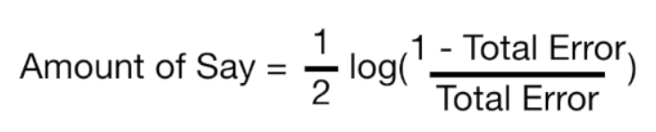

When total error is small, the amount of say for the sample is large. When the total error is large the amount of say is small. When the total error is 1/8 the amount of say is 0.97.

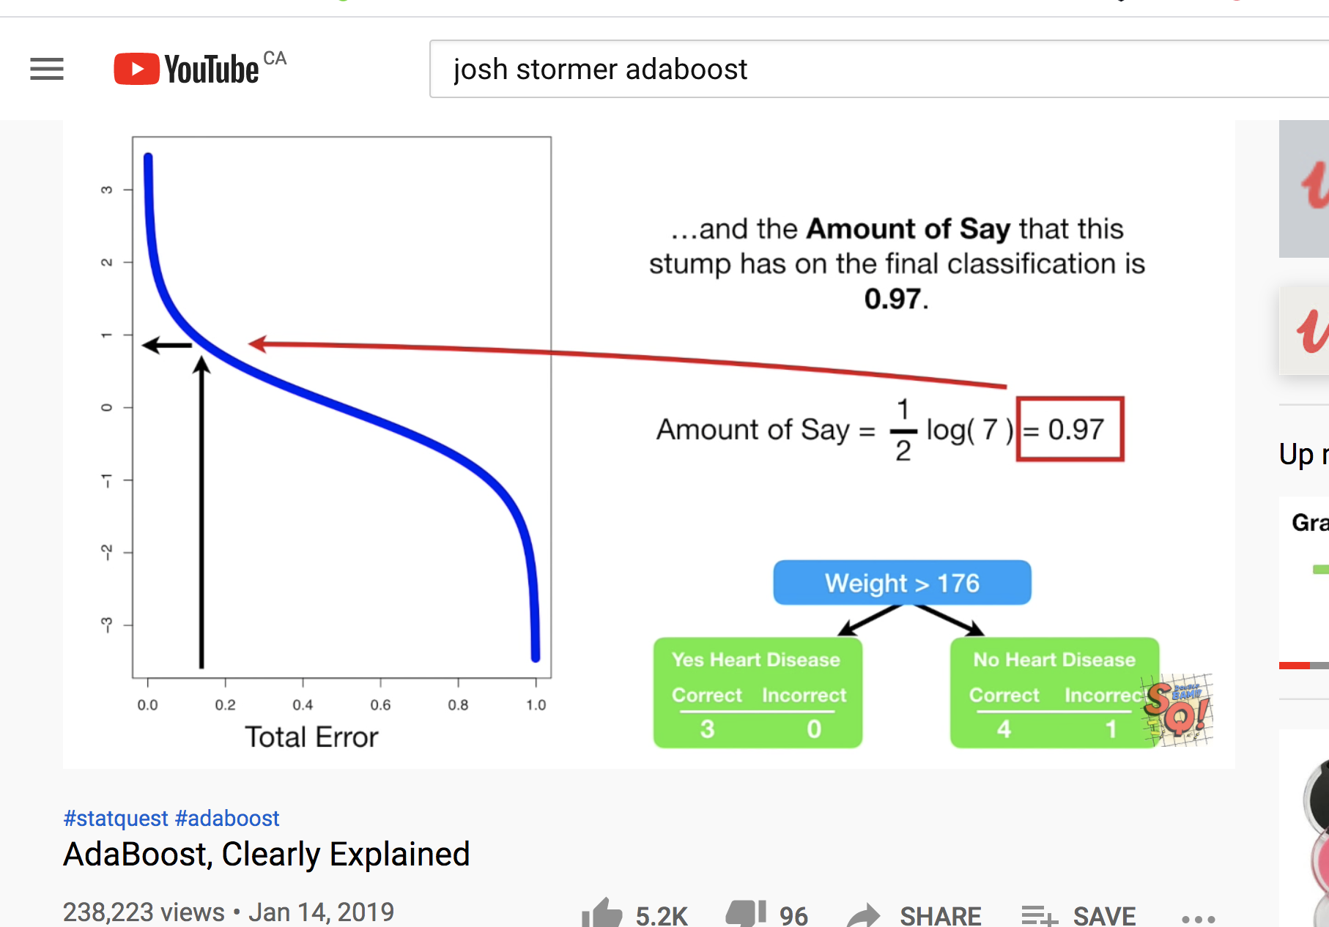

*Exercise 1 (4 marks)*

The patient weight is definitely the correct classifier for the first stump. However, if we had chosen chest pain to be the classifier in the first stump 3 classifications would have been incorrect.

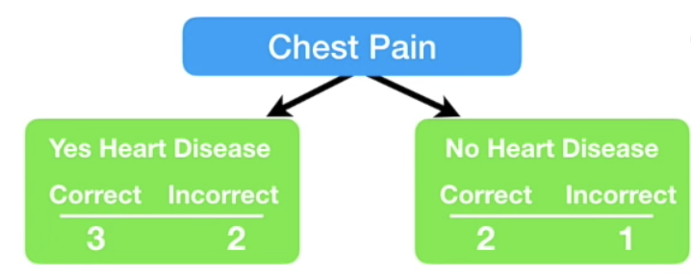

Calculate the amount of say that this stump would have had. Show your calculations here:

|  |
| --- |
| Amount of say =1/2 log(1-3/8) / 3/8 |

|  |  |
| --- | --- |
| Continuing on with our example, since the first stump incorrectly classified the heart disease status for the person on the right, we need to adjust the sample weight. |  |
|  |  |

The **incorrectly classified** sample weight becomes:

New sample weight = sample weight $∙$ $e^{amount of say}$ = $\frac{1}{8}∙e^{0.97}$ = 0.33

The **correctly classified** sample weights on the other hand must be decreased.

New sample weight = sample weight $∙$ $e^{-amount of say}$ = $\frac{1}{8}∙e^{-0.97}$ = 0.05

|  |  |
| --- | --- |
| These are the weights after at the very right. |  |

Next, we need to normalize the weights so they sum up to 1.

$\frac{Sample Weight}{Sum of all sample weights}$ = $\frac{0.05}{0.05+0.05+0.05+0.33+0.05+0.05+0.05+0.05}$ = 0.0736

$\frac{Sample Weight}{Sum of all sample weights}$ = $\frac{0.33}{0.05+0.05+0.05+0.33+0.05+0.05+0.05+0.05}$ = 0.4853

|  |  |
| --- | --- |
| Next, we throw out the old weights and use the new weights to build our new sample set. To generate the new sample, we take random picks between 0 and 1. If the pick falls between 0 and 0.07 we choose sample 1. If we pick 0.1 we choose sample 2. If we pick between 0.22 and 0.71 we choose sample 4 and so on. |  |

|  |  |
| --- | --- |
| Note that we are likely to choose sample 4 several times as outlined at the right but this is okay since selection is with replacement. |  |

We continue these steps to build more stumps. To make a prediction we sum the ‘amounts of say’ for each stump. The largest sum represents the prediction.

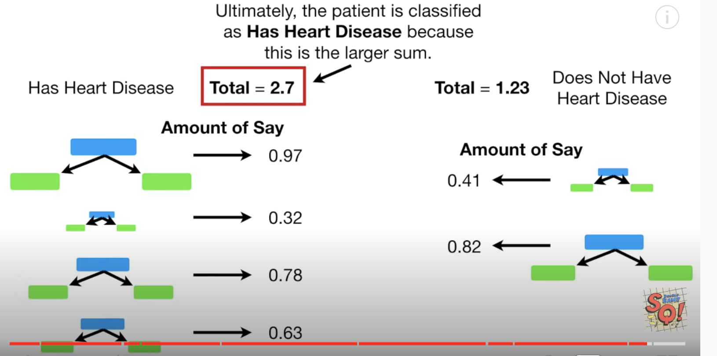

*Example 1: Boosting*

Thankfully the boosting classifiers hide all of the detail for us. We can just use them in our code. Add this code onto the end of Example 2.

|  |
| --- |
| from sklearn.model_selection import cross_val_score  from mlxtend.classifier import EnsembleVoteClassifier  from xgboost import XGBClassifier, plot_importance  from sklearn.ensemble import AdaBoostClassifier, GradientBoostingClassifier  ada_boost = AdaBoostClassifier()  grad_boost = GradientBoostingClassifier()  xgb_boost = XGBClassifier()  boost_array = [ada_boost, grad_boost, xgb_boost]  eclf = EnsembleVoteClassifier(clfs=[ada_boost, grad_boost,  xgb_boost], voting='hard')  labels = ['Ada Boost', 'Grad Boost', 'XG Boost', 'Ensemble']  for clf, label in zip([ada_boost, grad_boost, xgb_boost, eclf], labels):  scores = cross_val_score(clf, X, y, cv=10, scoring='accuracy')  print("Mean: {0:.3f}, std: (+/-) {1:.3f} [{2}]".format(scores.mean(),  scores.std(), label)) |

The output is:

|  |
| --- |
| Name: price, Length: 546, dtype: int8  Mean: 0.641, std: (+/-) 0.082 [Ada Boost]  Mean: 0.630, std: (+/-) 0.103 [Grad Boost]  Mean: 0.635, std: (+/-) 0.099 [XG Boost]  Mean: 0.626, std: (+/-) 0.091 [Ensemble] |

*Exercise 2 (4 marks)*

Compare the different boosting algorithm performances for the Iris data set. Use the code at the start of Exercise 6 to load and prepare the Iris data set. Show your working program here:

|  |
| --- |
| from sklearn.model_selection import cross_val_score from mlxtend.classifier import EnsembleVoteClassifier from xgboost import XGBClassifier, plot_importance from sklearn.ensemble import AdaBoostClassifier, GradientBoostingClassifier  import pandas as pd from sklearn.preprocessing import LabelEncoder   PATH = "/Users/hyerimshin/PycharmProjects/MachineLearning/datasets/" df = pd.read_csv(PATH + 'iris_old.csv') df.columns = ['Sepal L', 'Sepal W', 'Petal L', 'Petal W', 'Iris Type']  # Convert text to numeric category. # 0 is setosa, 1 is versacolor and 2 is virginica df['y'] = LabelEncoder().fit_transform(df['Iris Type'])  # Prepare the data. X = df[['Sepal L', 'Sepal W', 'Petal L', 'Petal W']] print(type(df)) y = df['y'] print(type(y))  ada_boost = AdaBoostClassifier() grad_boost = GradientBoostingClassifier() xgb_boost = XGBClassifier() boost_array = [ada_boost, grad_boost, xgb_boost] eclf = EnsembleVoteClassifier(clfs=[ada_boost, grad_boost,  xgb_boost], voting='hard') labels = ['Ada Boost', 'Grad Boost', 'XG Boost', 'Ensemble']  for clf, label in zip([ada_boost, grad_boost, xgb_boost, eclf], labels):  scores = cross_val_score(clf, X, y, cv=10, scoring='accuracy')  print("Mean: {0:.3f}, std: (+/-) {1:.3f} [{2}]".format(scores.mean(),  scores.std(), label)) |

Show the output from your code:

|  |
| --- |
| <class 'pandas.core.series.Series'>  Mean: 0.953, std: (+/-) 0.052 [Ada Boost]  Mean: 0.960, std: (+/-) 0.044 [Grad Boost]  Mean: 0.960, std: (+/-) 0.033 [XG Boost]  Mean: 0.960, std: (+/-) 0.044 [Ensemble] |

Explain which boosting algorithm performed best and why you made that selection.

|  |
| --- |
| from sklearn.model_selection import cross_val_score from mlxtend.classifier import EnsembleVoteClassifier from xgboost import XGBClassifier, plot_importance from sklearn.ensemble import AdaBoostClassifier, GradientBoostingClassifier  import pandas as pd from sklearn.preprocessing import LabelEncoder  PATH = "/Users/hyerimshin/PycharmProjects/MachineLearning/datasets/" df = pd.read_csv(PATH + 'loan_default.csv') print(df.head())  # Prepare the data. X = df.copy() del X['default'] y = df[['default']]   ada_boost = AdaBoostClassifier() grad_boost = GradientBoostingClassifier() xgb_boost = XGBClassifier() boost_array = [ada_boost, grad_boost, xgb_boost] eclf = EnsembleVoteClassifier(clfs=[ada_boost, grad_boost,  xgb_boost], voting='hard') labels = ['Ada Boost', 'Grad Boost', 'XG Boost', 'Ensemble']  for clf, label in zip([ada_boost, grad_boost, xgb_boost, eclf], labels):  scores = cross_val_score(clf, X, y, cv=10, scoring='accuracy')  print("Mean: {0:.3f}, std: (+/-) {1:.3f} [{2}]".format(scores.mean(),  scores.std(), label)) |

*Exercise 3 (2 marks)*

Indicate if the following statement is true or false. Boosting for classification attempts to improve learning by assigning extra learning focus towards samples that are initially incorrectly classified.

True or False

Data Preparation

This section discusses two additional functions which will be used to help with data preparation.

qcut()

qcut() converts continuous data into evenly distributed categories. This line of code shows how qcut() converts continuous price values into one of three price categories.

df['price'] = pd.qcut(df['price'], 3, labels=[0, 1, 2]).cat.codes

map()

map() translates text encodings to specific numeric labels.

df[columns[i]] = df[columns[i]].map({'yes': 1, 'no': 0})

*Example 2: Data Preparation*

This example prepares data for modelling. The prepared data will be used in Example 3. Initially, the data looks like the following:

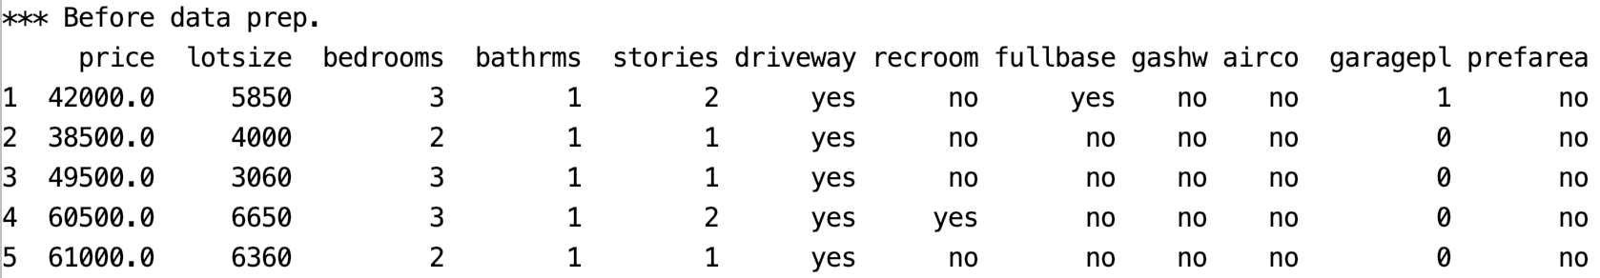

After using the map() function to convert the ‘no’ and ‘yes’ values to 0 and 1, the X feature set becomes:

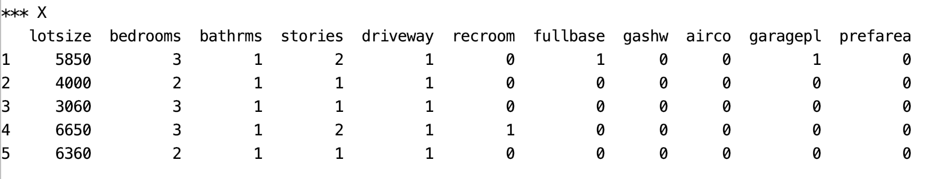

After using the qcut() function to convert prices into categories, the price target becomes:

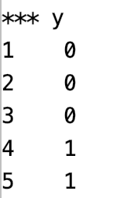

Here is the program that loads and prepares the housing price data for categorical price prediction:

|  |
| --- |
| from pydataset import data  import pandas as pd  # Get the housing data  df = data('Housing')  # Show all columns.  pd.set_option('display.max_columns', None)  pd.set_option('display.width', 1000)  print("\n*** Before data prep.")  print(df.head(5))  # Convert continues price variable into evenly distributed categories.  df['price'] = pd.qcut(df['price'], 3, labels=[0,1,2]).cat.codes  # Show new price variable cateogories.  print("\nNewly categorized target (price) values")  print(df['price'].value_counts())  def convertToBinaryValues(df, columns):  for i in range(0, len(columns)):  df[columns[i]] = df[columns[i]].map({'yes': 1, 'no': 0})  return df  df = convertToBinaryValues(df, ['driveway', 'recroom', \  'fullbase', 'gashw', 'airco', 'prefarea'])  # Split into two sets  y = df['price']  X = df.drop('price', 1)  # Show prepared data.  print("\n*** X")  print(X.head(5))  print("\n*** y")  print(y.head(5)) |

The output from this data set will be used a little later in bagging and stacking examples.

Bagging

Bagging involves averaging the predictions from the weak learners to generate a more stable result with less variance. ‘Bagging’ is a term that is derived from the terms “bootstrapping” and “aggregating”. Bootstrapping involves sampling with replacement. Weak learners of the same type are built with the bootstrapped data.

Bagged Classifier

We have looked at bagging with random forests. We can perform bagging with other model types as well.

*Example 3: Bagging*

Next in this example, several stand-alone and bagged classifiers are compared. These classifiers include:

* RandomForestClassifier()
* ExtraTreesClassifier()
* KNeighborsClassifier()
* SVC()
* RidgeClassifier()

Bagging often offers a slight improvement in accuracy with generally less variance in most cases. Overall the Bagged RandomForest classifier appears to have the best accuracy, precision and recall (see Table 1).

*Table 1: Comparing Stand-Alone and Bagged Classifiers*

|  |  |
| --- | --- |
| *** RandomForestClassifier ***  Accuracy: 0.6158536585365854  Precision: 0.6236235578117348  Recall: 0.6158536585365854  F1: 0.6162779662773046  *** Bagged: RandomForestClassifier ***  Accuracy: 0.6951219512195121  Precision: 0.6989793281926248  Recall: 0.6951219512195121  F1: 0.6962455650810152 | *** ExtraTreesClassifier ***  Accuracy: 0.6219512195121951  Precision: 0.6246320390556507  Recall: 0.6219512195121951  F1: 0.6195969265924138  *** Bagged: ExtraTreesClassifier ***  Accuracy: 0.6463414634146342  Precision: 0.652869134573478  Recall: 0.6463414634146342  F1: 0.6476985461972846 |

To build this example, add this code to the code in Example 2:

|  |
| --- |
| from sklearn.ensemble import BaggingClassifier, \  ExtraTreesClassifier, RandomForestClassifier  from sklearn.neighbors import KNeighborsClassifier  from sklearn.linear_model import RidgeClassifier  from sklearn.svm import SVC  # Create classifiers  rf = RandomForestClassifier()  et = ExtraTreesClassifier()  knn = KNeighborsClassifier()  svc = SVC()  rg = RidgeClassifier()  # Build array of classifiers.  classifierArray = [rf, et, knn, svc, rg]  def showStats(classifier, scores):  print(classifier + ": ", end="")  strMean = str(round(scores.mean(),2))  strStd = str(round(scores.std(),2))  print("Mean: " + strMean + " ", end="")  print("Std: " + strStd)  from sklearn import metrics  from sklearn.model_selection import train_test_split  X_train, X_test, y_train, y_test = train_test_split(X, y, test_size=0.30)  def evaluateModel(model, X_test, y_test, title):  print("\n*** " + title + " ***")  predictions = model.predict(X_test)  accuracy = metrics.accuracy_score(y_test, predictions)  recall = metrics.recall_score(y_test, predictions, average='weighted')  precision = metrics.precision_score(y_test, predictions, average='weighted')  f1 = metrics.f1_score(y_test, predictions, average='weighted')  print("Accuracy: " + str(accuracy))  print("Precision: " + str(precision))  print("Recall: " + str(recall))  print("F1: " + str(f1))  # Search for the best classifier.  for clf in classifierArray:  modelType = clf.__class__.__name__  # Create and evaluate stand-alone model.  clfModel = clf.fit(X_train, y_train)  evaluateModel(clfModel, X_test, y_test, modelType)  # max_features means the maximum number of features to draw from X.  # max_samples sets the percentage of available data used for fitting.  bagging_clf = BaggingClassifier(clf, max_samples=0.4, max_features=11,  n_estimators=10)  baggedModel = bagging_clf.fit(X_train, y_train)  evaluateModel(baggedModel, X_test, y_test, "Bagged: " + modelType) |

*Exercise 4 (2 marks)*

Compared to when max_features is 11, what happens if you set max_features to 3. Do the results improve? Please explain.

|  |  |  |  |  |
| --- | --- | --- | --- | --- |
| Max feature is the maximum number of features to draw from X. So it affects the accuracy. ncreasing max_features generally **improves the performance of the model** as at each node now we have a higher number of options to be considered. But in this case, less max features gives us the better accuracy.     |  |  | | --- | --- | | Max feature:11 | Max features 3 | | *** RandomForestClassifier ***  Accuracy: 0.6646341463414634  Precision: 0.6586214344116876  Recall: 0.6646341463414634  F1: 0.6602221542891117  *** Bagged: RandomForestClassifier ***  Accuracy: 0.7195121951219512  Precision: 0.7247920810461614  Recall: 0.7195121951219512  F1: 0.7216538451954594  *** ExtraTreesClassifier ***  Accuracy: 0.5792682926829268  Precision: 0.5820845651638334  Recall: 0.5792682926829268  F1: 0.5790242387752242  *** Bagged: ExtraTreesClassifier ***  Accuracy: 0.6219512195121951  Precision: 0.6264452011403231  Recall: 0.6219512195121951  F1: 0.6222015859576289  *** KNeighborsClassifier ***  Accuracy: 0.5304878048780488  Precision: 0.522309682187731  Recall: 0.5304878048780488  F1: 0.5187947005081566  *** Bagged: KNeighborsClassifier ***  Accuracy: 0.5792682926829268  Precision: 0.5706937595834574  Recall: 0.5792682926829268  F1: 0.5387280058942692  Accuracy: 0.5548780487804879  Precision: 0.35872841874486167  Recall: 0.5548780487804879  F1: 0.43566021867115234  *** Bagged: SVC ***  Accuracy: 0.5670731707317073  Precision: 0.5450649554843655  Recall: 0.5670731707317073  F1: 0.4738506160846508  *** RidgeClassifier ***  Accuracy: 0.6341463414634146  Precision: 0.6090298266576815  Recall: 0.6341463414634146  F1: 0.6042214439639596  *** Bagged: RidgeClassifier ***  Accuracy: 0.6402439024390244  Precision: 0.6214153019031068  Recall: 0.6402439024390244  F1: 0.6166463486683785 | *** RandomForestClassifier ***  Accuracy: 0.6158536585365854  Precision: 0.6258153047632171  Recall: 0.6158536585365854  F1: 0.6200407288821922  *** Bagged: RandomForestClassifier ***  Accuracy: 0.6402439024390244  Precision: 0.61699495272484  Recall: 0.6402439024390244  F1: 0.6222316544048293  *** ExtraTreesClassifier ***  Accuracy: 0.5853658536585366  Precision: 0.6016770562246566  Recall: 0.5853658536585366  F1: 0.5915147539536698  *** Bagged: ExtraTreesClassifier ***  Accuracy: 0.5548780487804879  Precision: 0.5704224789126113  Recall: 0.5548780487804879  F1: 0.5592839957944085  *** KNeighborsClassifier ***  Accuracy: 0.5  Precision: 0.5192534599465938  Recall: 0.5  F1: 0.5012413791792084  *** Bagged: KNeighborsClassifier ***  Accuracy: 0.6524390243902439  Precision: 0.6432926829268293  Recall: 0.6524390243902439  F1: 0.6451857797721513  *** SVC ***  Accuracy: 0.5182926829268293  Precision: 0.4721780414340287  Recall: 0.5182926829268293  F1: 0.46612774545317814  *** Bagged: SVC ***  Accuracy: 0.5853658536585366  Precision: 0.5905526391653861  Recall: 0.5853658536585366  F1: 0.5573852403575824  *** RidgeClassifier ***  Accuracy: 0.6280487804878049  Precision: 0.6024404754227342  Recall: 0.6280487804878049  F1: 0.6021132305754049  *** Bagged: RidgeClassifier ***  Accuracy: 0.5548780487804879  Precision: 0.4782353868797309  Recall: 0.5548780487804879  F1: 0.49086691410392363 | |

*Exercise 5 (3 marks)*

Modify Example 3 by importing the LogisticRegression class.

|  |
| --- |
| from sklearn.linear_model import LogisticRegression |

Define the logistic regression classifier as shown here:

|  |
| --- |
| lr = LogisticRegression(fit_intercept=True, solver='liblinear') |

Modify the classifier array to also include your logistic regressor in the grid search. Show the output here:

|  |
| --- |
| *** RandomForestClassifier ***  Accuracy: 0.6524390243902439  Precision: 0.6731348775315399  Recall: 0.6524390243902439  F1: 0.6584614212756355  *** Bagged: RandomForestClassifier ***  Accuracy: 0.6646341463414634  Precision: 0.6893710018604888  Recall: 0.6646341463414634  F1: 0.6707288462913955  *** ExtraTreesClassifier ***  Accuracy: 0.6036585365853658  Precision: 0.62022885121737  Recall: 0.6036585365853658  F1: 0.6085834226915294  *** Bagged: ExtraTreesClassifier ***  Accuracy: 0.6585365853658537  Precision: 0.680574912891986  Recall: 0.6585365853658537  F1: 0.6647157456886686  *** KNeighborsClassifier ***  Accuracy: 0.5060975609756098  Precision: 0.48742733793874626  Recall: 0.5060975609756098  F1: 0.48913259895686806  *** Bagged: KNeighborsClassifier ***  Accuracy: 0.49390243902439024  Precision: 0.47317543302313775  Recall: 0.49390243902439024  F1: 0.46731358266864753  *** SVC ***  Accuracy: 0.5182926829268293  Precision: 0.49827556122643724  Recall: 0.5182926829268293  F1: 0.44309714444393017  *** Bagged: SVC ***  Accuracy: 0.5182926829268293  Precision: 0.4850174216027875  Recall: 0.5182926829268293  F1: 0.444263604104446  *** RidgeClassifier ***  Accuracy: 0.5914634146341463  Precision: 0.5551266904294658  Recall: 0.5914634146341463  F1: 0.5529567220538217  *** Bagged: RidgeClassifier ***  Accuracy: 0.6036585365853658  Precision: 0.5770486610550585  Recall: 0.6036585365853658  F1: 0.5742219893125893  *** LogisticRegression ***  Accuracy: 0.6280487804878049  Precision: 0.607014778834229  Recall: 0.6280487804878049  F1: 0.6088102277126668  *** Bagged: LogisticRegression ***  Accuracy: 0.6158536585365854  Precision: 0.6009535021658249  Recall: 0.6158536585365854  F1: 0.6045150987224158 |

How does the logistic regressor compare to the best performing classifier?

|  |
| --- |
| For the best performing classifier in this case( RandomForestClassifier), the model improved with begged but logistic regression has the better model without begging.  *** LogisticRegression ***  Accuracy: 0.6280487804878049  Precision: 0.607014778834229  Recall: 0.6280487804878049  F1: 0.6088102277126668  *** Bagged: LogisticRegression ***  Accuracy: 0.6158536585365854  Precision: 0.6009535021658249  Recall: 0.6158536585365854  F1: 0.6045150987224158  *** RandomForestClassifier ***  Accuracy: 0.6524390243902439  Precision: 0.6731348775315399  Recall: 0.6524390243902439  F1: 0.6584614212756355  *** Bagged: RandomForestClassifier ***  Accuracy: 0.6646341463414634  Precision: 0.6893710018604888  Recall: 0.6646341463414634  F1: 0.6707288462913955 |

*Exercise 6 (6 marks)*

Starting with the following code:

|  |
| --- |
| import pandas as pd  from sklearn.preprocessing import LabelEncoder  PATH = "/Users/pm/Desktop/DayDocs/data/"  df = pd.read_csv(PATH + 'loan_default.csv')  print(df.head())  # Prepare the data.  X = df.copy()  del X['default']  y = df[['default']] |

Modify it to compare bagged and stand alone classifiers with the loan_default data set. Show the output here:

|  |
| --- |
| *** RandomForestClassifier ***  Accuracy: 0.7619047619047619  Precision: 0.7460317460317462  Recall: 0.7619047619047619  F1: 0.7488095238095237  *** Bagged: RandomForestClassifier ***  Accuracy: 0.7523809523809524  Precision: 0.7319047619047618  Recall: 0.7523809523809524  F1: 0.7058201058201059  *** Bagged: ExtraTreesClassifier ***  Accuracy: 0.7523809523809524  Precision: 0.7319047619047618  Recall: 0.7523809523809524  F1: 0.7058201058201059  *** KNeighborsClassifier ***  Accuracy: 0.719047619047619  Precision: 0.6739805803744423  Recall: 0.719047619047619  F1: 0.6728514720648447  *** SVC ***  Accuracy: 0.7238095238095238  Precision: 0.5239002267573696  Recall: 0.7238095238095238  F1: 0.6078400420941857  *** Bagged: SVC ***  Accuracy: 0.7333333333333333  Precision: 0.7163398692810458  Recall: 0.7333333333333333  F1: 0.6444756554307116  *** RidgeClassifier ***  Accuracy: 0.7857142857142857  Precision: 0.7758484609313339  Recall: 0.7857142857142857  F1: 0.7593307593307593  *** Bagged: RidgeClassifier ***  Accuracy: 0.7285714285714285  Precision: 0.6853227174835215  Recall: 0.7285714285714285  F1: 0.6543009325618021  *** LogisticRegression ***  Accuracy: 0.7238095238095238  Precision: 0.5239002267573696  Recall: 0.7238095238095238  F1: 0.6078400420941857  *** Bagged: LogisticRegression ***  Accuracy: 0.7380952380952381  Precision: 0.7140681763797342  Recall: 0.7380952380952381  F1: 0.666430724401739 |

State which classifier performs best and explain why you made that choice.

|  |
| --- |
| *** RandomForestClassifier ***  Accuracy: 0.7619047619047619  Precision: 0.7460317460317462  Recall: 0.7619047619047619  F1: 0.7488095238095237 |

Show your code here:

|  |
| --- |
| import pandas as pd from sklearn.preprocessing import LabelEncoder  PATH = "/Users/hyerimshin/PycharmProjects/MachineLearning/datasets/" df = pd.read_csv(PATH + 'loan_default.csv') print(df.head())  # Prepare the data. X = df.copy() del X['default'] y = df[['default']]  from sklearn.ensemble import BaggingClassifier, \  ExtraTreesClassifier, RandomForestClassifier from sklearn.neighbors import KNeighborsClassifier from sklearn.linear_model import RidgeClassifier from sklearn.svm import SVC from sklearn.linear_model import LogisticRegression  # Create classifiers rf = RandomForestClassifier() et = ExtraTreesClassifier() knn = KNeighborsClassifier() svc = SVC() rg = RidgeClassifier() lr = LogisticRegression(fit_intercept=True, solver='liblinear')  # Build array of classifiers. classifierArray = [rf, et, knn, svc, rg, lr]  def showStats(classifier, scores):  print(classifier + ": ", end="")  strMean = str(round(scores.mean(),2))   strStd = str(round(scores.std(),2))  print("Mean: " + strMean + " ", end="")  print("Std: " + strStd)  from sklearn import metrics from sklearn.model_selection import train_test_split X_train, X_test, y_train, y_test = train_test_split(X, y, test_size=0.30)  def evaluateModel(model, X_test, y_test, title):  print("\n*** " + title + " ***")  predictions = model.predict(X_test)  accuracy = metrics.accuracy_score(y_test, predictions)  recall = metrics.recall_score(y_test, predictions, average='weighted')  precision = metrics.precision_score(y_test, predictions, average='weighted')  f1 = metrics.f1_score(y_test, predictions, average='weighted')   print("Accuracy: " + str(accuracy))  print("Precision: " + str(precision))  print("Recall: " + str(recall))  print("F1: " + str(f1))  # Search for the best classifier. for clf in classifierArray:  modelType = clf.__class__.__name__   # Create and evaluate stand-alone model.  clfModel = clf.fit(X_train, y_train)  evaluateModel(clfModel, X_test, y_test, modelType)   # max_features means the maximum number of features to draw from X.  # max_samples sets the percentage of available data used for fitting.  bagging_clf = BaggingClassifier(clf, max_samples=0.4, max_features=3,  n_estimators=10)  baggedModel = bagging_clf.fit(X_train, y_train)  evaluateModel(baggedModel, X_test, y_test, "Bagged: " + modelType) |

*Exercise 7 (2 marks)*

In general, how do the stand-alone classifiers compare with the bagged classifiers?

|  |
| --- |
| t is used **to deal with bias-variance trade-offs and reduces the variance of a prediction model**. Bagging avoids overfitting of data and is used for both regression and classification models, specifically for decision tree algorithms. Begged classifiers usually improved the models. |

Bagged Regressors

In addition to classification problems, you can use bagging to create an ensemble of regressors.

*Example 4: Bagging with Linear Regression*

This example uses a bagged regressor for linear regression to predict the total petrol consumption. The results show that the learning ensemble does more poorly but we will try to fix this in the next example

****** Ensemble

Root Mean Squared Error: 65.7520989586188

****** Linear Regression

Root Mean Squared Error: 70.4921615920565

For now, here is how to implement a basic ensemble for linear regression:

|  |
| --- |
| import pandas as pd  from sklearn.ensemble import BaggingRegressor  from sklearn.linear_model import LinearRegression  from sklearn.model_selection import train_test_split  import numpy as np  from sklearn.metrics import mean_squared_error  # Show all columns.  pd.set_option('display.max_columns', None)  pd.set_option('display.width', 1000)  # Load and prepare data.  FOLDER = '/users/pm/desktop/daydocs/data/'  FILE = 'petrol_consumption.csv'  dataset = pd.read_csv(FOLDER + FILE)  print(dataset)  X = dataset.copy()  del X['Petrol_Consumption']  y = dataset[['Petrol_Consumption']]  # Create random split.  X_train, X_test, y_train, y_test = train_test_split(X, y, test_size=0.2)  def evaluateModel(model, X_test, y_test, title):  print("\n****** " + title)  predictions = model.predict(X_test)  print('Root Mean Squared Error:',  np.sqrt(mean_squared_error(y_test, predictions)))  # Build linear regression ensemble.  ensembleModel = BaggingRegressor(base_estimator=LinearRegression(),max_features=4,  max_samples =0.5,  n_estimators=10).fit(X_train, y_train)  evaluateModel(ensembleModel, X_test, y_test, "Ensemble")  # Build stand alone linear regression model.  model = LinearRegression()  model.fit(X_train, y_train)  evaluateModel(model, X_test, y_test, "Linear Regression") |

Grid Searching

With countless parameter combinations for ensembles and potential models it helps to be able to grid search different combinations to find the optimal combination.

*Example 5: Grid Searching Bagging Regressor Parameters*

This example actually shows that it is possible to reduce the variance with an ensemble. The optimal parameter combination is found through a grid search.

Since the data split and sampling is random, the results will vary each run. However, it appears that an ensemble with a maximum of 4 features and 800 estimators can out-perform linear regression.

|  |
| --- |
| estimators features rmse type  6 800 4 30.910344 Ensemble  4 800 3 47.448549 Ensemble  10 900 4 52.893641 Ensemble  2 750 4 53.472123 Ensemble  8 900 3 70.127002 Ensemble  14 1000 4 73.186699 Ensemble  12 1000 3 110.820228 Ensemble  0 750 3 122.607095 Ensemble  7 None None 33.178561 Linear Regression  5 None None 45.119426 Linear Regression  3 None None 51.786050 Linear Regression  11 None None 52.931385 Linear Regression  9 None None 60.539137 Linear Regression  15 None None 72.666123 Linear Regression  13 None None 97.148495 Linear Regression  1 None None 116.922646 Linear Regression |

The code that performs the grid search is similar to the code in Example 4. This code however loops through different combinations of numbers of estimators and maximum features.

|  |
| --- |
| import pandas as pd  from sklearn.ensemble import BaggingRegressor  from sklearn.linear_model import LinearRegression  from sklearn.model_selection import train_test_split  import numpy as np  from sklearn.metrics import mean_squared_error  # Show all columns.  pd.set_option('display.max_columns', None)  pd.set_option('display.width', 1000)  # Load and prepare data.  FOLDER = '/users/pm/desktop/daydocs/data/'  FILE = 'petrol_consumption.csv'  dataset = pd.read_csv(FOLDER + FILE)  print(dataset)  X = dataset.copy()  del X['Petrol_Consumption']  y = dataset[['Petrol_Consumption']]  feature_combo_list = []  def evaluateModel(model, X_test, y_test, title, num_estimators, max_features):  print("\n****** " + title)  predictions = model.predict(X_test)  rmse = np.sqrt(mean_squared_error(y_test, predictions))  # Store statistics and add to list.  stats = {"type":title, "rmse":rmse,  "estimators":num_estimators, "features":max_features}  feature_combo_list.append(stats)  num_estimator_list = [750, 800, 900, 1000]  max_features_list = [3, 4]  for num_estimators in num_estimator_list:  for max_features in max_features_list:  # Create random split.  X_train, X_test, y_train, y_test = train_test_split(X, y, test_size=0.2)  # Build linear regression ensemble.  ensembleModel = BaggingRegressor(base_estimator=LinearRegression(),  max_features=max_features,  max_samples =0.5,  n_estimators=num_estimators).fit(X_train, y_train)  evaluateModel(ensembleModel, X_test, y_test, "Ensemble",  num_estimators, max_features)  # Build stand alone linear regression model.  model = LinearRegression()  model.fit(X_train, y_train)  evaluateModel(model, X_test, y_test, "Linear Regression", None, None)  # Build data frame with dictionary objects.  dfStats = pd.DataFrame()  print(dfStats)  for combo in feature_combo_list:  dfStats = dfStats.append(combo, ignore_index=True)  # Sort and show all combinations.  # Show all rows  pd.set_option('display.max_rows', None)  dfStats = dfStats.sort_values(by=['type', 'rmse'])  print(dfStats) |

*Exercise 8 (6 marks)*

Modify the code in Example 5 so you can include the maximum samples in the grid search in addition to searching on the optimal number of features. Also, expand the range of maximum features to [2,3,4]. Show your revised program here:

|  |
| --- |
|   **Best result with 2 features.** |

Show your modified output here:

|  |
| --- |
| import pandas as pd from sklearn.ensemble import BaggingRegressor from sklearn.linear_model import LinearRegression  from sklearn.model_selection import train_test_split import numpy as np from sklearn.metrics import mean_squared_error  # Show all columns. pd.set_option('display.max_columns', None) pd.set_option('display.width', 1000)  # Load and prepare data. FOLDER = '//Users/hyerimshin/PycharmProjects/MachineLearning/datasets/' FILE = 'petrol_consumption.csv' dataset = pd.read_csv(FOLDER + FILE) print(dataset) X = dataset.copy() del X['Petrol_Consumption'] y = dataset[['Petrol_Consumption']]  feature_combo_list = [] def evaluateModel(model, X_test, y_test, title, num_estimators, max_features):  print("\n****** " + title)  predictions = model.predict(X_test)  rmse = np.sqrt(mean_squared_error(y_test, predictions))   # Store statistics and add to list.  stats = {"type":title, "rmse":rmse,  "estimators":num_estimators, "features":max_features}  feature_combo_list.append(stats)  num_estimator_list = [750, 800, 900, 1000] max_features_list = [2, 3, 4]  for num_estimators in num_estimator_list:  for max_features in max_features_list:  # Create random split.  X_train, X_test, y_train, y_test = train_test_split(X, y, test_size=0.2)   # Build linear regression ensemble.  ensembleModel = BaggingRegressor(base_estimator=LinearRegression(),  max_features=max_features,  max_samples =0.5,  n_estimators=num_estimators).fit(X_train, y_train)  evaluateModel(ensembleModel, X_test, y_test, "Ensemble",  num_estimators, max_features)   # Build stand alone linear regression model.  model = LinearRegression()  model.fit(X_train, y_train)  evaluateModel(model, X_test, y_test, "Linear Regression", None, None)  # Build data frame with dictionary objects. dfStats = pd.DataFrame() print(dfStats) for combo in feature_combo_list:  dfStats = dfStats.append(combo, ignore_index=True)  # Sort and show all combinations. # Show all rows pd.set_option('display.max_rows', None) dfStats = dfStats.sort_values(by=['type', 'rmse']) print(dfStats) |

Stacked Models

A stacked model builds a model with the output from multiple models. Stacking can be applied to a combine the outputs from a wide variety of predictive models. Often, stacking helps to improve accuracy.

Stacking Regression

*Example 6: Stacking Regression*

This example shows how to implement stacking with outputs from the following combination of regressors:

* ElasticNet
* DecisionTreeRegressor
* SVR
* AdaBoostRegressor
* BaggingRegressor
* RandomForestRegressor
* ExtraTreesRegressor

The output when running this program shows that our super learner is competitive when compared to most models.

|  |
| --- |
| **\*\* Evaluate Base Models \*\***  **RMSE:123799.119 ElasticNet**  **RMSE:352456.005 SVR**  **RMSE:188327.974 DecisionTreeRegressor**  **RMSE:155919.974 AdaBoostRegressor**  **RMSE:136916.041 RandomForestRegressor**  **RMSE:131182.792 ExtraTreesRegressor**  **\*\* Evaluate Stacked Model \*\***  **RMSE:104680.594 LinearRegression** |

Here is the code:

|  |
| --- |
| from sklearn.linear_model import LinearRegression  from sklearn.linear_model import ElasticNet  from sklearn.tree import DecisionTreeRegressor  from sklearn.svm import SVR  from sklearn.ensemble import AdaBoostRegressor  from sklearn.ensemble import RandomForestRegressor  from sklearn.ensemble import ExtraTreesRegressor  from sklearn.metrics import mean_squared_error  from sklearn.model_selection import train_test_split  import numpy as np  import pandas as pd  # Show all columns.  pd.set_option('display.max_columns', None)  pd.set_option('display.width', 1000)  # Prep data.  PATH = "/users/pm/desktop/daydocs/data/"  CSV_DATA = "USA_Housing.csv"  dataset = pd.read_csv(PATH + CSV_DATA)  print(dataset.head())  X = dataset[['Avg. Area Income','Avg. Area House Age', 'Avg. Area Number of Rooms',\  'Avg. Area Number of Bedrooms', "Area Population"]].values  y = dataset['Price']  def getUnfitModels():  models = list()  models.append(ElasticNet())  models.append(SVR(gamma='scale'))  models.append(DecisionTreeRegressor())  models.append(AdaBoostRegressor())  models.append(RandomForestRegressor(n_estimators=10))  models.append(ExtraTreesRegressor(n_estimators=10))  return models  def evaluateModel(y_test, predictions, model):  mse = mean_squared_error(y_test, predictions)  rmse = round(np.sqrt(mse),3)  print(" RMSE:" + str(rmse) + " " + model.__class__.__name__)  def fitBaseModels(X_train, y_train, X_test, models):  dfPredictions = pd.DataFrame()  # Fit base model and store its predictions in dataframe.  for i in range(0, len(models)):  models[i].fit(X_train, y_train)  predictions = models[i].predict(X_test)  colName = str(i)  # Add base model predictions to column of data frame.  dfPredictions[colName] = predictions  return dfPredictions, models  def fitStackedModel(X, y):  model = LinearRegression()  model.fit(X, y)  return model  # Split data into train, test and validation sets.  X_train, X_temp, y_train, y_temp = train_test_split(X, y, test_size=0.70)  X_test, X_val, y_test, y_val = train_test_split(X_temp, y_temp, test_size=0.50)  # Get base models.  unfitModels = getUnfitModels()  # Fit base and stacked models.  dfPredictions, models = fitBaseModels(X_train, y_train, X_test, unfitModels)  stackedModel = fitStackedModel(dfPredictions, y_test)  # Evaluate base models with validation data.  print("\n** Evaluate Base Models **")  dfValidationPredictions = pd.DataFrame()  for i in range(0, len(models)):  predictions = models[i].predict(X_val)  colName = str(i)  dfValidationPredictions[colName] = predictions  evaluateModel(y_val, predictions, models[i])  # Evaluate stacked model with validation data.  stackedPredictions = stackedModel.predict(dfValidationPredictions)  print("\n** Evaluate Stacked Model **")  evaluateModel(y_val, stackedPredictions, stackedModel) |

*Exercise 9 (3 marks)*

Replace the code that generates the data in Example 6 with the following code which imports and prepares the wine quality data set.

|  |
| --- |
| PATH = "/Users/pm/Desktop/DayDocs/data/"  CSV_DATA = "winequality.csv"  dataset = pd.read_csv(PATH + CSV_DATA)  X = dataset[['fixed acidity', 'volatile acidity', 'citric acid', 'residual sugar',  'chlorides', 'free sulfur dioxide', 'total sulfur dioxide', 'density',  'pH', 'sulphates','alcohol']].values  y = dataset['quality'] |

Run the code after making the changes. Show the output here:

|  |
| --- |
| from sklearn.linear_model import LinearRegression from sklearn.linear_model import ElasticNet from sklearn.tree import DecisionTreeRegressor from sklearn.svm import SVR from sklearn.ensemble import AdaBoostRegressor from sklearn.ensemble import RandomForestRegressor from sklearn.ensemble import ExtraTreesRegressor from sklearn.metrics import mean_squared_error from sklearn.model_selection import train_test_split import numpy as np import pandas as pd  # Show all columns. pd.set_option('display.max_columns', None) pd.set_option('display.width', 1000)  # Prep data. PATH = "/Users/hyerimshin/PycharmProjects/MachineLearning/datasets/" CSV_DATA = "winequality.csv" dataset = pd.read_csv(PATH + CSV_DATA) X = dataset[['fixed acidity', 'volatile acidity', 'citric acid', 'residual sugar',  'chlorides', 'free sulfur dioxide', 'total sulfur dioxide', 'density',  'pH', 'sulphates','alcohol']].values y = dataset['quality']   def getUnfitModels():  models = list()  models.append(ElasticNet())  models.append(SVR(gamma='scale'))  models.append(DecisionTreeRegressor())  models.append(AdaBoostRegressor())  models.append(RandomForestRegressor(n_estimators=10))  models.append(ExtraTreesRegressor(n_estimators=10))  return models  def evaluateModel(y_test, predictions, model):  mse = mean_squared_error(y_test, predictions)  rmse = round(np.sqrt(mse),3)  print(" RMSE:" + str(rmse) + " " + model.__class__.__name__)  def fitBaseModels(X_train, y_train, X_test, models):  dfPredictions = pd.DataFrame()   # Fit base model and store its predictions in dataframe.  for i in range(0, len(models)):  models[i].fit(X_train, y_train)  predictions = models[i].predict(X_test)  colName = str(i)  # Add base model predictions to column of data frame.  dfPredictions[colName] = predictions  return dfPredictions, models  def fitStackedModel(X, y):  model = LinearRegression()  model.fit(X, y)  return model  # Split data into train, test and validation sets. X_train, X_temp, y_train, y_temp = train_test_split(X, y, test_size=0.70) X_test, X_val, y_test, y_val = train_test_split(X_temp, y_temp, test_size=0.50)  # Get base models. unfitModels = getUnfitModels()  # Fit base and stacked models. dfPredictions, models = fitBaseModels(X_train, y_train, X_test, unfitModels) stackedModel = fitStackedModel(dfPredictions, y_test)  # Evaluate base models with validation data. print("\n** Evaluate Base Models **") dfValidationPredictions = pd.DataFrame() for i in range(0, len(models)):  predictions = models[i].predict(X_val)  colName = str(i)  dfValidationPredictions[colName] = predictions  evaluateModel(y_val, predictions, models[i])  # Evaluate stacked model with validation data. stackedPredictions = stackedModel.predict(dfValidationPredictions) print("\n** Evaluate Stacked Model **") evaluateModel(y_val, stackedPredictions, stackedModel) |

What model appears to perform the best and explain why you made that choice.

|  |
| --- |
| RMSE:0.672 ExtraTreesRegressor   |

Stacking Classification

*Example 7: Stacking for Classification*

This example shows how to implement stacking for classification.

|  |
| --- |
| Precision:0.0 Recall:0.0 F1:0.0 Accuracy:0.66 LogisticRegression  Precision:0.76 Recall:0.81 F1:0.79 Accuracy:0.85 DecisionTreeClassifier  Precision:0.76 Recall:0.81 F1:0.79 Accuracy:0.85 AdaBoostClassifier  Precision:0.84 Recall:0.77 F1:0.8 Accuracy:0.87 RandomForestClassifier  ** Evaluate Stacked Model **  Precision:0.77 Recall:0.83 F1:0.8 Accuracy:0.86 LogisticRegression |

Here is the code:

|  |
| --- |
| from sklearn.linear_model import LogisticRegression  from sklearn.tree import DecisionTreeClassifier  from sklearn.ensemble import AdaBoostClassifier  from sklearn.ensemble import RandomForestClassifier  from sklearn.metrics import precision_score, recall_score, f1_score, accuracy_score  from sklearn.model_selection import train_test_split  import numpy as np  import pandas as pd  # Show all columns.  pd.set_option('display.max_columns', None)  pd.set_option('display.width', 1000)  # Prepare the data.  PATH = "/Users/pm/Desktop/DayDocs/data/"  CSV_DATA = "Social_Network_Ads.csv"  df = pd.read_csv(PATH + CSV_DATA)  df = pd.get_dummies(df,columns=['Gender'])  del df['User ID']  X = df.copy()  del X['Purchased']  y = df['Purchased']  def getUnfitModels():  models = list()  models.append(LogisticRegression())  models.append(DecisionTreeClassifier())  models.append(AdaBoostClassifier())  models.append(RandomForestClassifier(n_estimators=10))  return models  def evaluateModel(y_test, predictions, model):  precision = round(precision_score(y_test, predictions),2)  recall = round(recall_score(y_test, predictions), 2)  f1 = round(f1_score(y_test, predictions), 2)  accuracy = round(accuracy_score(y_test, predictions), 2)  print("Precision:" + str(precision) + " Recall:" + str(recall) +\  " F1:" + str(f1) + " Accuracy:" + str(accuracy) +\  " " + model.__class__.__name__)  def fitBaseModels(X_train, y_train, X_test, models):  dfPredictions = pd.DataFrame()  # Fit base model and store its predictions in dataframe.  for i in range(0, len(models)):  models[i].fit(X_train, y_train)  predictions = models[i].predict(X_test)  colName = str(i)  dfPredictions[colName] = predictions  return dfPredictions, models  def fitStackedModel(X, y):  model = LogisticRegression()  model.fit(X, y)  return model  # Split data into train, test and validation sets.  X_train, X_temp, y_train, y_temp = train_test_split(X, y, test_size=0.70)  X_test, X_val, y_test, y_val = train_test_split(X_temp, y_temp, test_size=0.50)  # Get base models.  unfitModels = getUnfitModels()  # Fit base and stacked models.  dfPredictions, models = fitBaseModels(X_train, y_train, X_test, unfitModels)  stackedModel = fitStackedModel(dfPredictions, y_test)  # Evaluate base models with validation data.  print("\n** Evaluate Base Models **")  dfValidationPredictions = pd.DataFrame()  for i in range(0, len(models)):  predictions = models[i].predict(X_val)  colName = str(i)  dfValidationPredictions[colName] = predictions  evaluateModel(y_val, predictions, models[i])  # Evaluate stacked model with validation data.  stackedPredictions = stackedModel.predict(dfValidationPredictions)  print("\n** Evaluate Stacked Model **")  evaluateModel(y_val, stackedPredictions, stackedModel) |

**Table of Contents**

**Requirements 1**

**References 1**

**Convolutional Neural Networks (CNN’s) 1**

**Common Filters (Kernels) 3**

**Stride 3**

**Padding 4**

**Pool Size 5**

**Applying Multiple Filters 5**

Increasing Filters in Each Consecutive Layer 5

**Kernel Size 9**

**Filters 9**

**Strides 9**

**Early Stopping and Saving the Best Model 13**

Requirements

This was implemented using **tensorflow 2.4** and **keras 2.4.3**.

On Windows I had to run PyCharm as Administrator.

References

<https://www.analyticsvidhya.com/blog/2017/06/architecture-of-convolutional-neural-networks-simplified-demystified/>

<https://medium.com/@RaghavPrabhu/understanding-of-convolutional-neural-network-cnn-deep-learning-99760835f148#:~:text=Strides,with%20a%20stride%20of%202>.

Convolutional Neural Networks (CNN’s)

Convolutional Neural Networks, or CNNs for short, are a type of network designed for image input. They are comprised of models with convolutional layers which extract and transform features into simpler pooled elements. The pooled features are then flattened into arrays which are fed through a neural network for classification.

*Figure 1: Feature Pooling and Classification Activities of a Convolutional Neural Network*

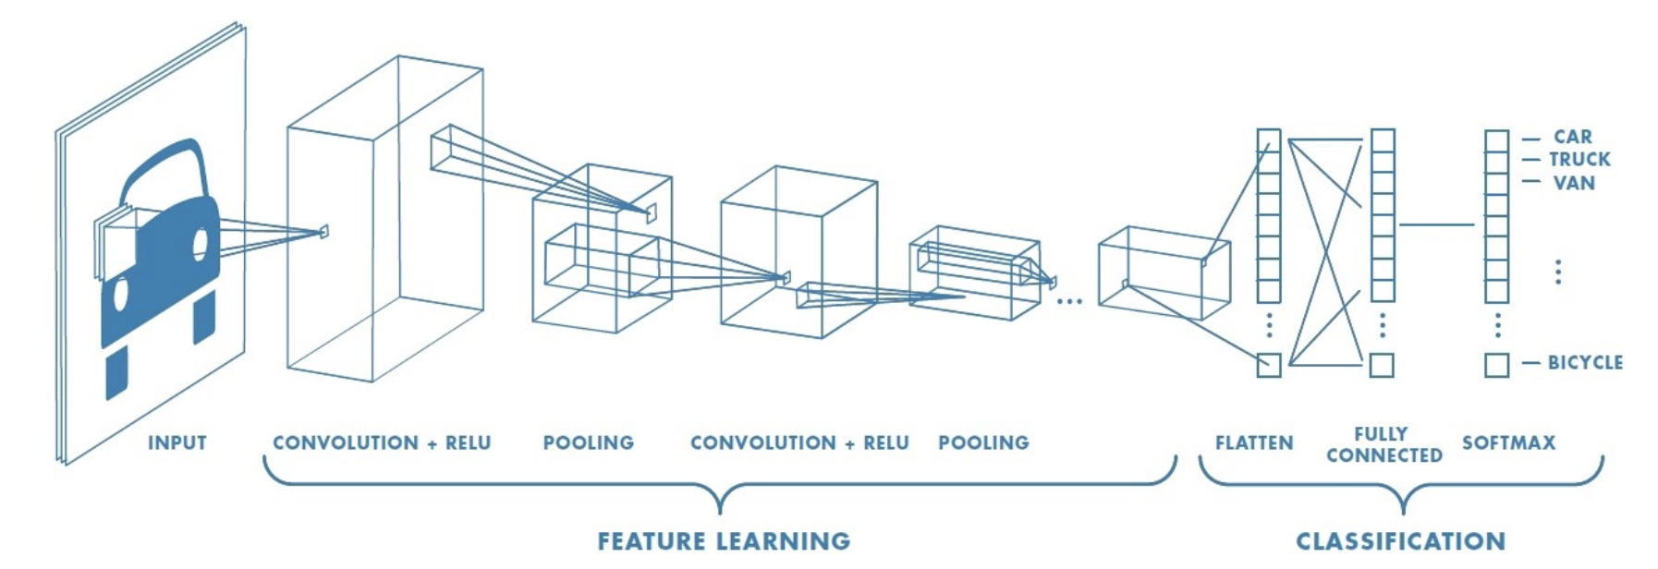

Figure 2 shows how nine pixels of an image can be convolutedAF into one element of a pooled layer. Notice how the pooled layer dimensions are much smaller than the original image.

*Figure 2: Transforming Nine Elements into One Pooled Element*

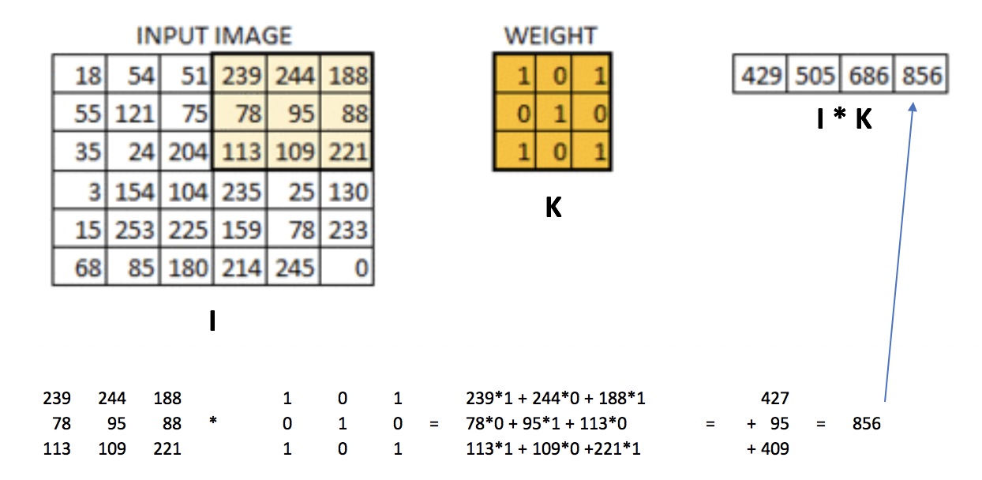

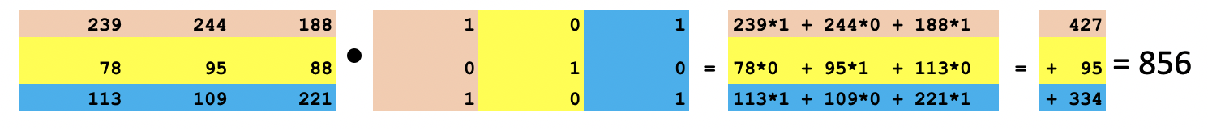

Convolving with a filter creates a feature map like the one in Figure 3.

*Figure 3: Real Image vs. Convoluted Image*

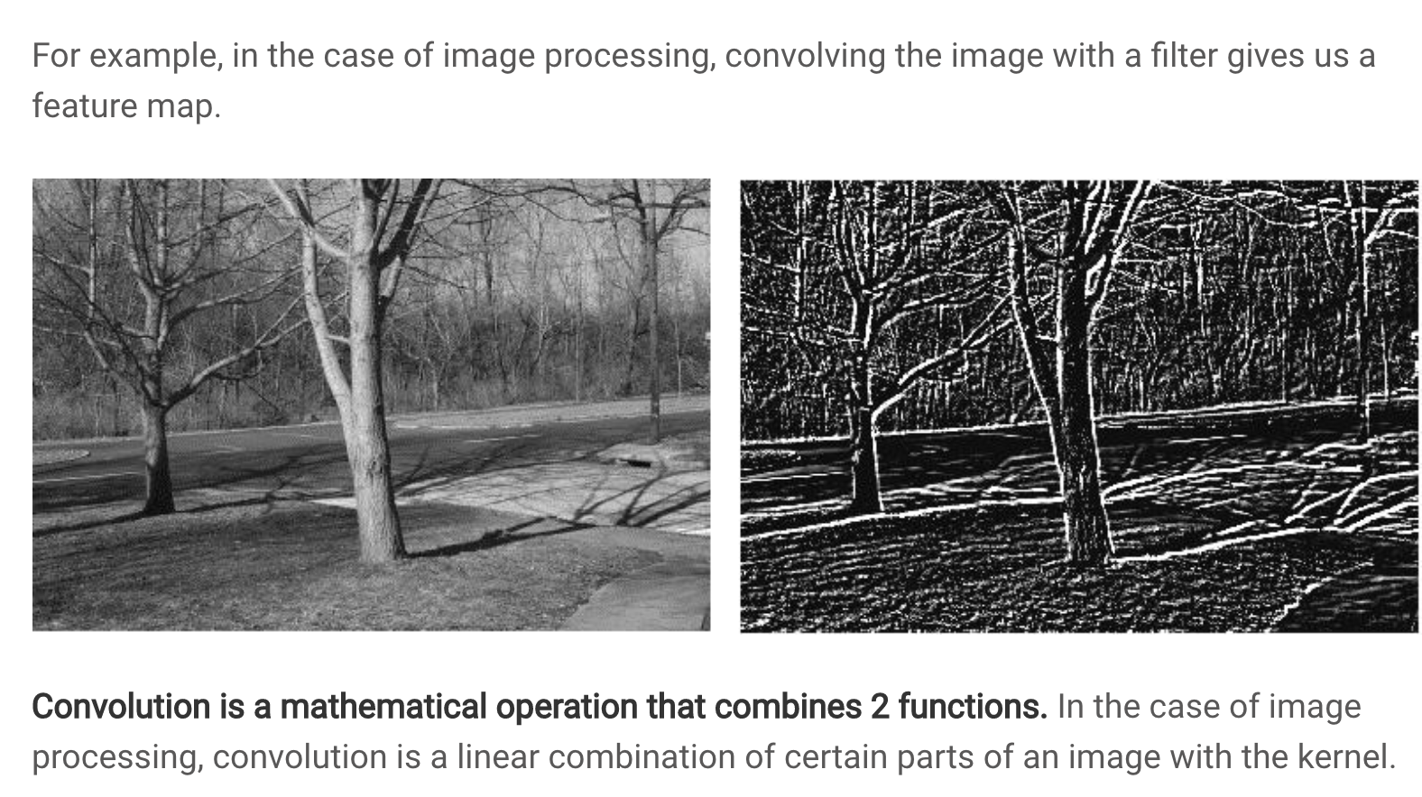

Common Filters (Kernels)

Not all filters are the same. Figure 4 highlights several filter types.

*Figure 4: Common Image Filters*

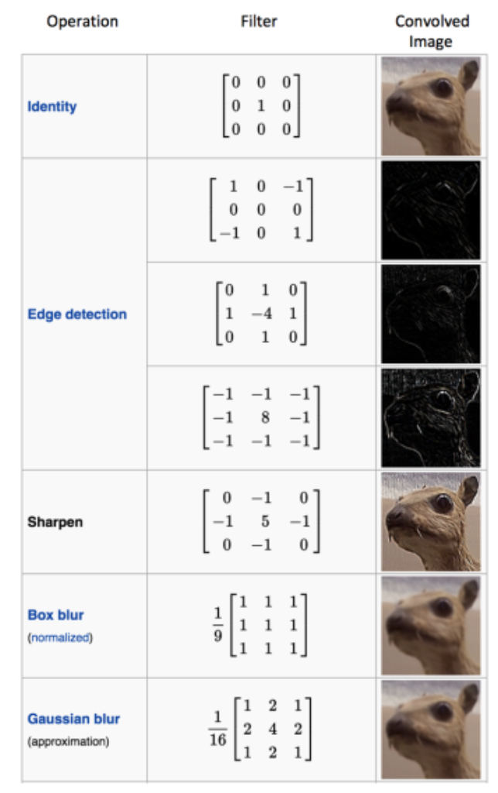

Stride

Like we saw in Figure 2 the weight matrix was applied to sub sections of the image. In the example given, the sub sections were selected by shifting horizontally across the original image one pixel at a time and then down one pixel at a time. This **stride** of 1 pixel x 1 pixel led to a convoluted image that is 4x4 pixels. A lower stride leads to a higher amount of detail in the convoluted image.

A higher stride of 2x2 leads to a smaller convoluted image. Figure 5 illustrates a how a convoluted image is created with a filter by using a 2x2 stride. The first section of the image is selected and is filtered. Then the selection is shifted two pixels across. The new selection is multiplied by the filter. Then the selection is taken from the bottom left of the original image and is multiplied by the filter. Then the selection is taken from the bottom right of the image and this section is multiplied by the filter.

*Figure 5: Creating a Convoluted Image with a 2x2 Stride*

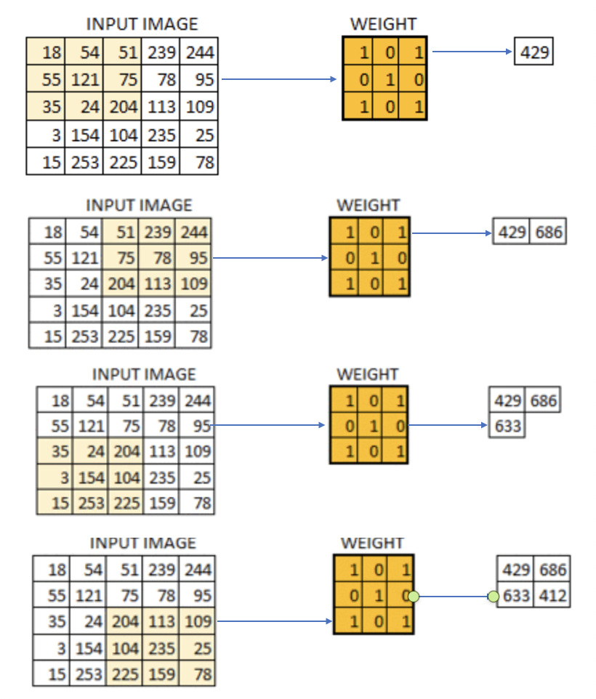

*Exercise 1 (3 marks)*

Show the calculation needed to multiply the section of the input image by the filter to generate 686. See Figure 5.

|  |
| --- |
| (51*1 + 75*0 + 204*1) + (239*0 + 78*1 + 113*0) + (244*1 + 95*0 + 109*1) = 255 + 78 + 353 = 686 |

Padding

You may have noticed that striding across the image leads to a smaller convoluted image. However, we could pad the border with zeros to retain the original size of the image. Padding also allows us to obtain more information about the borders (see Figure 6).

*Figure 6: Padding an Image*

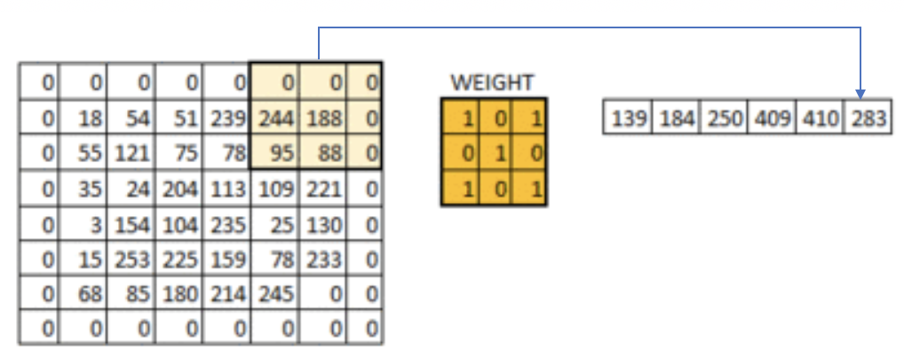

Pool Size

A pool_size attribute is used in the network to downsample the image. The calculation used for downsampling is:

output_shape = (input_shape - pool_size + 1) / strides)

Applying Multiple Filters

If we have a 32x32 image with a 3-byte color layer and we apply a stack of ten 5x5x3 filters **we** end up with a convoluted output of 28x28x3.

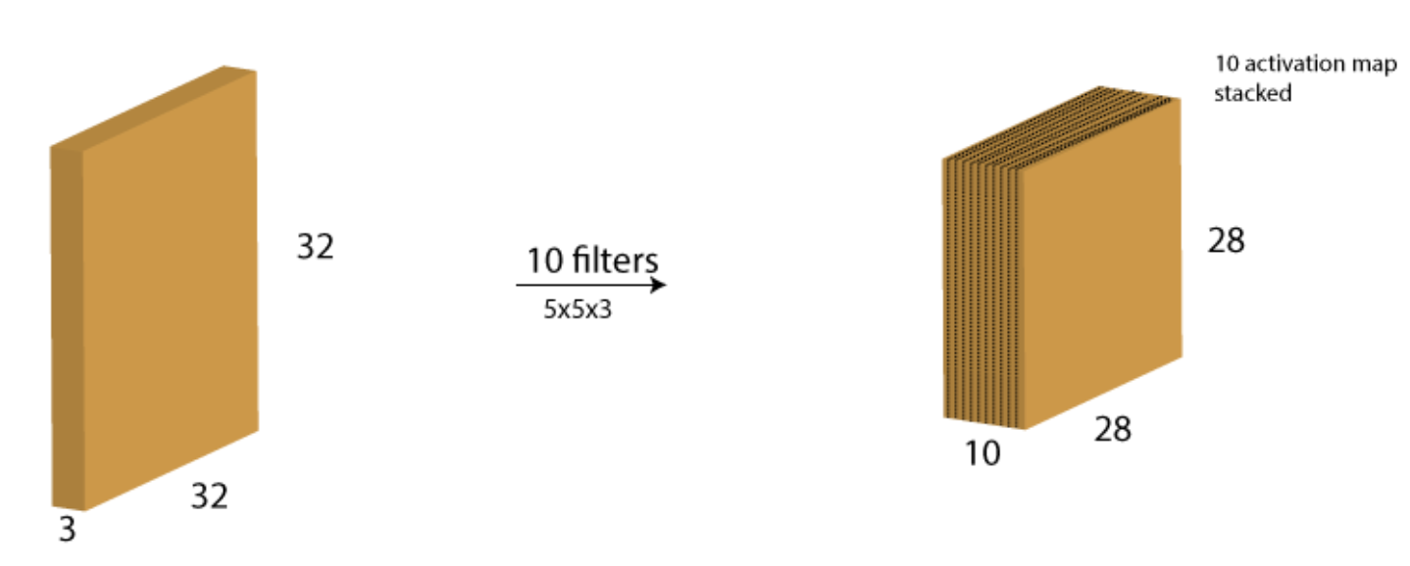

Increasing Filters in Each Consecutive Layer

In every layer filters are there to capture patterns. For example in the first layer filters capture patterns like edges, corners, dots etc. In the subsequent layers we combine those patterns to make bigger patterns. Like combine edges to make squares, circle etc.

Now as we move forward in the layers the patterns gets more complex, hence larger combinations of patterns to capture. That's why we increase filter size in the subsequent layers to capture as many combinations as possible.

<https://datascience.stackexchange.com/questions/55545/in-cnn-why-do-we-increase-the-number-of-filters-in-deeper-convolution-layers-fo>

*Example 1: Processing and Displaying Images*

This first example demonstrates how to prepare the images for modelling.

Initially the images are loaded.

img = cv2.imread(filePath)

The images are then scaled to a size of 96x96 pixels.

img = cv2.resize(img, (IMAGE_SIZE, IMAGE_SIZE))

Next, the code eliminates the 3 byte color channel.

img = cv2.cvtColor(img, cv2.COLOR_RGB2GRAY)

To understand our image data better some print statements are used to display the data attributes and contents.

print("Image Label: " + str(labels[index]))

print("Image Shape: " + str(images[index].shape))

print("Image Data: ")

print(images[index])

|  |
| --- |
| Image Label: 0  Image Shape: (96, 96)  Image Data:  [[0.06666667 0.03137255 0.01568627 ... 0.14901961 0.16470588 0.38039216]  [0.02352941 0.05098039 0.03137255 ... 0.18039216 0.21568627 0.37254902]  [0.03921569 0.03137255 0.03529412 ... 0.18823529 0.2 0.32941176]  ...  [0.30196078 0.27843137 0.29019608 ... 0.34901961 0.36470588 0.36470588]  [0.33333333 0.32156863 0.31764706 ... 0.3372549 0.33333333 0.33333333]  [0.34901961 0.31764706 0.32941176 ... 0.33333333 0.33333333 0.35294118]] |

To verify that the images are process properly, two processed test images are displayed on the screen.

plt.imshow(images[index])

plt.show()

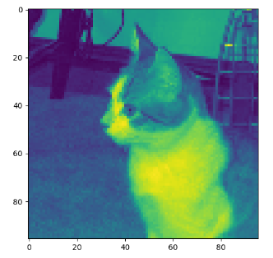 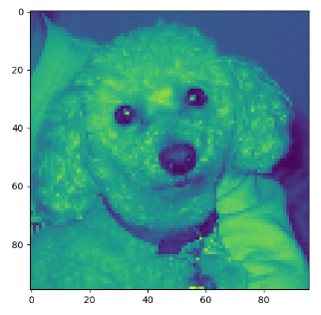

|  |
| --- |
| import matplotlib.pyplot as plt  import os  import numpy as np  import cv2  PATH = "/Users/pm/Desktop/DayDocs/data/small_cats_and_dogs/"  # Loads the image file.  def load_image(fileName, subFolder):  try:  filePath = PATH + subFolder + "/" + fileName  img = cv2.imread(filePath)  return img  except:  return np.NaN  # Extract the actual class from the image file name.  def extract_label(file_name):  return 1 if "dog" in file_name else 0  # Transforms image into scaled and squared image.  def preprocess_image(img):  IMAGE_SIZE = 96  try:  # Finds minimum of height and width.  min_side = min(img.shape[0], img.shape[1])  # Reduce image to square using minimum of width and height.  img = img[:min_side, :min_side]  # Reside to 96x96.  img = cv2.resize(img, (IMAGE_SIZE, IMAGE_SIZE))  print(img.shape)  # Eliminate three byte color channel.  img = cv2.cvtColor(img, cv2.COLOR_RGB2GRAY)  print(img.shape)  print("***")  # Scale numbers to range between 0 and 1.0  return img / 255.0  except:  return np.NaN  def getImages(dirName):  imageList = []  labelList = []  # List all items in the directory.  image_files = os.listdir(PATH + dirName + "/")  for i in range(0, len(image_files)):  image = load_image(image_files[i], dirName)  processedImage = preprocess_image(image)  # Build list of processed images and labels.  if processedImage is not np.NaN:  imageList.append(processedImage)  label = extract_label(image_files[i])  labelList.append(label)  return imageList, labelList  # Displays grayscale image and image data to ensure everything is working properly.  def verifyImage(images, labels, index):  print("Image Label: " + str(labels[index]))  print("Image Shape: " + str(images[index].shape))  print("Image Data: ")  print(images[index])  # Display the image.  plt.imshow(images[index])  plt.show()  print("*****")  # Add an extra dimension for the signle color channel.  # Changes (2000, 96, 96) to (2000, 96, 96, 1)  # Load transformed and scaled images.  X_train, y_train = getImages('train')  X_test, y_test = getImages('test')  # Verify first image in training set.  verifyImage(X_train, y_train, 0)  # Verify second image in training set.  verifyImage(X_train, y_train, 1) |

*Example 2: Convert to 3D Array*

Like other neural network examples, we need to ensure our inputs are in vertical array format. This code transforms our data into a vertical array. Here is the shape and data formatted after the transformation.

|  |  |
| --- | --- |
| **X shape: (2000, 96, 96, 1)** | **y shape: (2000,)** |
| array([[0.27058824, 0.28627451, 0.30588235, ..., 0.33333333, 0.39215686,  0.33333333],  [0.31372549, 0.30588235, 0.30588235, ..., 0.34509804, 0.38039216,  0.40784314],  [0.31372549, 0.3254902 , 0.30980392, ..., 0.36470588, 0.42745098,  0.39215686],  ...,  [0.25490196, 0.25490196, 0.24313725, ..., 0.01960784, 0.01960784,  0.01568627],  [0.28235294, 0.29803922, 0.30588235, ..., 0.01568627, 0.02352941,  0.01176471],  [0.30980392, 0.3254902 , 0.32156863, ..., 0.02352941, 0.02352941,  0.01176471]]),  array([[0.83529412, 0.85882353, 0.8627451 , ..., 0.41960784, 0.45098039,  0.43921569],  [0.79607843, 0.79215686, 0.81176471, ..., 0.41960784, 0.44705882,  0.43921569],  [0.76862745, 0.77647059, 0.78039216, ..., 0.40392157, 0.44313725,  0.4627451 ],  ...,  [0.31764706, 0.3372549 , 0.34509804, ..., 0.24705882, 0.23529412,  0.23137255],  [0.32941176, 0.3372549 , 0.36862745, ..., 0.21568627, 0.24705882,  0.22352941],  [0.34117647, 0.35294118, 0.34117647, ..., 0.22745098, 0.24705882,  0.24313725]]),  ...] | [1,  0,  0,  1,  1,  1,  1,  0,  0,  0,  0,  1,  0,  0,  1,  0,  1,  1,  1,  1,  1,  0,  0,  1,  0,  0 |

This is the code that performs the transformation. Add this code to Example 1:

|  |
| --- |
| def convertToArray(x, y):  x = np.array(x)  x = np.expand_dims(x, -1)  y = np.array(y)  print(x.shape)  print(y.shape)  print("***")  return x, y  X_train, y_train = convertToArray(X_train, y_train) X_test, y_test = convertToArray(X_test, y_test) |

*Example 3: Building and Evaluating the Model*

To help understand how the model is built here are some terms.

Kernel Size

The kernel is our sliding window which performs the convolution. Typical sizes include (1,1), (2,2),(3,3),(4,4),(5,5),(6,6),(7,7). It is rare to have more than a 7x7 kernal size.

Filters

The number of filters determines the number of ways the kernel data is transformed. The number of filters corresponds to the number of outputs that are generated during the convolution.

Strides

A stride is the horizontal and vertical step taken when shifting the convolutional window.

The model is decent - this is as good as I could make it.

|  |
| --- |
| Accuracy: 0.755  Confusion Matrix  Predicted 0 1  Actual  0 360 140  1 105 395 |

Here is the code that builds our model. Add this code to Example 2:

|  |
| --- |
| import tensorflow as tf  from tensorflow.keras import Sequential  from tensorflow.keras.layers import Dense  from tensorflow.keras.layers import Conv2D  from tensorflow.keras.layers import MaxPool2D  from tensorflow.keras.layers import Flatten  from tensorflow.keras.layers import Dropout  def create_model(X_train, y_train, X_test, y_test):  model = Sequential()  model.add(Conv2D(filters=32, kernel_size=(3, 3), activation='relu',  kernel_initializer='he_uniform',  input_shape=X_train.shape[1:]))  # Add a pooling layer to down sample height and widths by half.  # pool_size is filter size.  model.add(MaxPool2D(pool_size=(2, 2), strides=(2, 2)))  # It is common to repeat this pattern a few times by doubling the filter  # each time to offset the reduction in size from down sampling.  model.add(Conv2D(filters=64, kernel_size=(3, 3), activation='relu',  kernel_initializer='he_uniform',  input_shape=X_train.shape[1:]))  model.add(MaxPool2D(pool_size=(2, 2), strides=(2, 2)))  model.add(Conv2D(filters=128, kernel_size=(3, 3), activation='relu',  kernel_initializer='he_uniform',  input_shape=X_train.shape[1:]))  model.add(MaxPool2D(pool_size=(2, 2), strides=(2, 2)))  model.add(Conv2D(filters=256, kernel_size=(3, 3), activation='relu',  kernel_initializer='he_uniform',  input_shape=X_train.shape[1:]))  model.add(MaxPool2D(pool_size=(2, 2), strides=(2, 2)))  model.add(Conv2D(filters=512, kernel_size=(3, 3), activation='relu',  kernel_initializer='he_uniform',  input_shape=X_train.shape[1:]))  model.add(MaxPool2D(pool_size=(2, 2), strides=(2, 2)))  # flatten????  model.add(Flatten())  model.add(Dense(512, activation='relu', kernel_initializer='he_uniform'))  model.add(Dropout(0.5))  model.add(Dense(256, activation='relu', kernel_initializer='he_uniform'))  model.add(Dropout(0.5))  # Create output layer which has two classes.  model.add(Dense(units=2, activation='softmax'))  model.compile(optimizer=tf.optimizers.Adam(),  # We are using classification.  loss=tf.losses.SparseCategoricalCrossentropy(),  # Show accuracy.  metrics=['accuracy'])  history = model.fit(X_train, y_train, epochs=20, batch_size=100,  validation_data=(X_test, y_test))  model.save_weights("model.tf")  return model, history  model, history = create_model(X_train, y_train, X_test, y_test)  predictions = model.predict(X_test)  # Iterates through pairs of predictions and adds most probable option to list.  predictionList = []  for i in range(0, len(predictions)):  prediction = predictions[i]  if(prediction[0] > prediction[1]):  predictionList.append(0)  else:  predictionList.append(1)  predictionArray = np.array(predictionList)  print(predictionList)  import pandas as pd  from sklearn import metrics  # Show confusion matrix and accuracy scores.  confusion_matrix = pd.crosstab(y_test, predictionArray,  rownames=['Actual'],  colnames=['Predicted'])  print('\nAccuracy: ',metrics.accuracy_score(y_test, predictionArray))  print("\nConfusion Matrix")  print(confusion_matrix) |

*Exercise 2 (3 marks)*

Perform this calculation for one dimension only. Given that the input width is 96, the pooling filter size is 2 and the strides value is 2, prove the convoluted image that is output is approximately half the size of the original.

output_shape = (input_shape - pool_size + 1) / strides)

Show your output here:

|  |
| --- |
| output_shape = (96 - 2 + 1) / 2  = 47.5  47.5 is roughly half of the original (96) |

*Example 4: Showing the loss and accuracy*

It is helpful to visualize the validation loss and accuracy. The loss function begins to rise at epoch 16. This suggests overfitting.

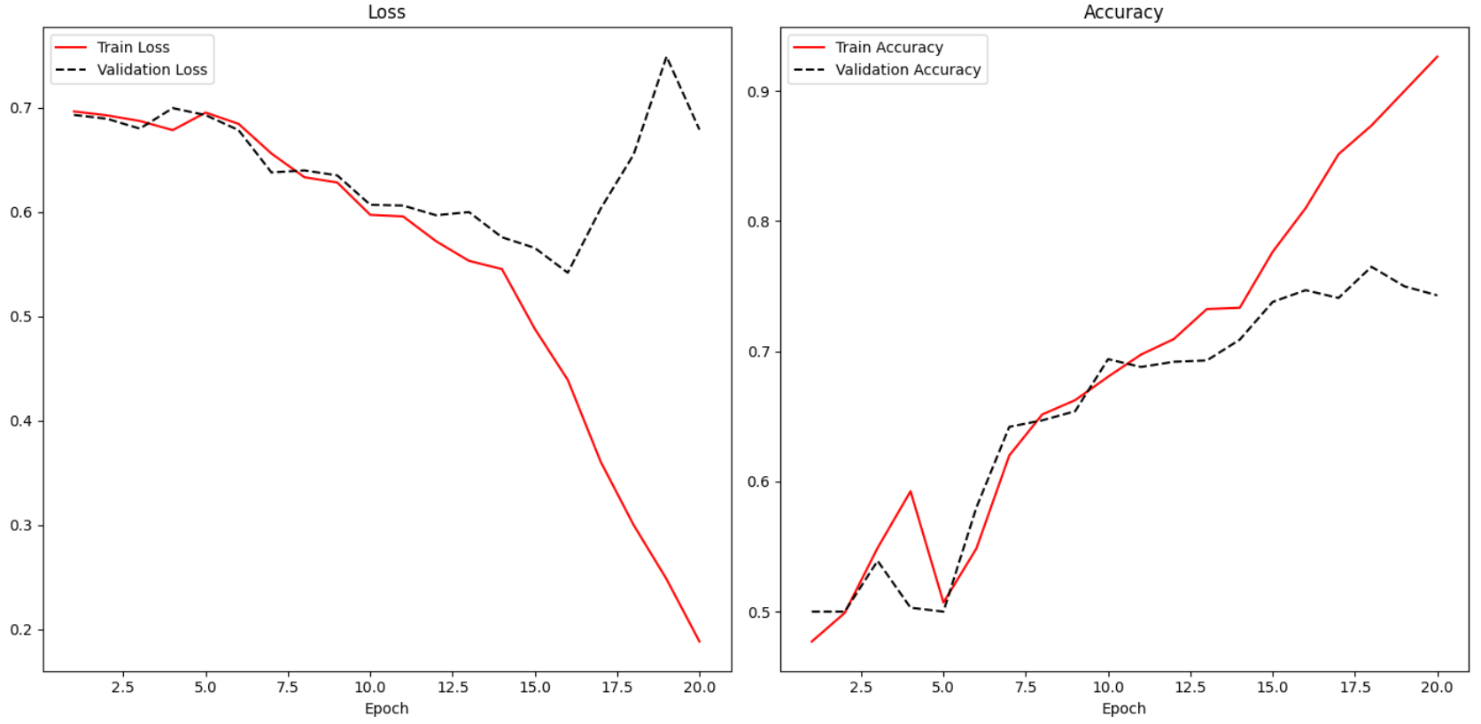

Adding the following code to Example 3 enables the reporting of loss and accuracy for classification algorithms.

|  |
| --- |
| def showLoss(history):  # Get training and test loss histories  training_loss = history.history['loss']  validation_loss = history.history['val_loss']  # Create count of the number of epochs  epoch_count = range(1, len(training_loss) + 1)  plt.subplot(1, 2, 1)  # Visualize loss history for training data.  plt.plot(epoch_count, training_loss, label='Train Loss', color='red')  # View loss on unseen data.  plt.plot(epoch_count, validation_loss, 'r--', label='Validation Loss',  color='black')  plt.xlabel('Epoch')  plt.legend(loc="best")  plt.title("Loss")  def showAccuracy(history):  # Get training and test loss histories  training_loss = history.history['accuracy']  validation_loss = history.history['val_accuracy']  # Create count of the number of epochs  epoch_count = range(1, len(training_loss) + 1)  plt.subplot(1, 2, 2)  # Visualize loss history for training data.  plt.plot(epoch_count, training_loss, label='Train Accuracy', color='red')  # View loss on unseen data.  plt.plot(epoch_count, validation_loss, 'r--',  label='Validation Accuracy', color='black')  plt.xlabel('Epoch')  plt.legend(loc="best")  plt.title('Accuracy')  plt.subplots(nrows=1, ncols=2, figsize=(14,7))  showLoss(history)  showAccuracy(history)  plt.show() |

Early Stopping and Saving the Best Model

Early stopping is a technique and saving the best model that is used in machine learning algorithms to detect overfitting. Early stopping allows you to stop training the model when the validation loss increases a specific number of times. You can control the number of times that the loss may increase with the patience level.

*Example 5: Enabling Early Stopping and Saving the Best Model*

To enable early stopping and save the best model, start with Example 4. Then place this line of code above at the start of the program. Be sure to use the big_cats_and_dogs data set for this test for best results.

|  |
| --- |
| from tensorflow.keras.callbacks import EarlyStopping  from tensorflow.keras.callbacks import ModelCheckpoint |

Next, replace the line of code where the model is fit with this instruction.

|  |
| --- |
| # configure early stopping  es = EarlyStopping(monitor='val_loss', patience=10)  mc = ModelCheckpoint('best_model.h5', monitor='val_accuracy', mode='max', verbose=1,  save_best_only=True)  history = model.fit(X_train, y_train, epochs=20, batch_size=100,  validation_data=(X_test, y_test), callbacks=[es,mc]) |

Next, replace this line of code:

predictions = model.predict(X_test)

With code that loads the binary model before making a prediction:

|  |
| --- |
| # Must match from tensorflow.keras.callbacks import ModelCheckpoint  from tensorflow.keras.models import load_model  saved_model = load_model('best_model.h5')  predictions = saved_model.predict(X_test) |

*Exercise 3 (10 marks)*

Train your model to check for dogs, cats and octopi. **Be sure to use the small_cats_and_dogs_and_octopi data set for this test.**

To enable training with the new files, drop the extracted files from octopusTest into the test folder. Drop the extract files from octopusTrain into the train folder.

After, replace extract_label() with the following code:

|  |
| --- |
| def extract_label(file_name):  if "dog" in file_name:  return 1  elif "cat" in file_name:  return 0  else:  return 2 |

The output layer needs to be set to 3 since it is classifying for dogs, cats and octopi. Replace the output layer with this version:

|  |
| --- |
| model.add(Dense(units=3, activation='softmax')) |

Next, fix the code which sets up the confusion matrix. You will want to output 0, 1 or 2 depending on the maximum element in each row of the ***predictions*** list. This is the code that needs to be fixed:

|  |
| --- |
| predictionList = []  # Iterates through pairs of predictions and adds most probable option to list.  for i in range(0, len(predictions)):  prediction = predictions[i]  if(prediction[0] > prediction[1]):  predictionList.append(0)  else:  predictionList.append(1)  predictionArray = np.array(predictionList)  print(predictionList)  import pandas as pd  from sklearn import metrics  # Show confusion matrix and accuracy scores.  confusion_matrix = pd.crosstab(y_test, predictionArray,  rownames=['Actual'],  colnames=['Predicted'])  print('\nAccuracy: ',metrics.accuracy_score(y_test, predictionArray))  print("\nConfusion Matrix")  print(confusion_matrix) |

Show your fixed code here:

|  |
| --- |
| import matplotlib.pyplot as plt import os import numpy as np import cv2   PATH = "C:\\Users\\Austin\\Desktop\\Class\\bcit\\CST\\Term 4\\COMP4948\\dataset\\small_cats_and_dogs_and_octopi\\"  # Loads the image file. def load_image(fileName, subFolder):  try:  filePath = PATH + subFolder + "/" + fileName  img = cv2.imread(filePath)  return img  except:  return np.NaN  # # Extract the actual class from the image file name. # def extract_label(file_name): # return 1 if "dog" in file_name else 0  def extract_label(file_name):  if "dog" in file_name:  return 1  elif "cat" in file_name:  return 0  else:  return 2    # Transforms image into scaled and squared image. def preprocess_image(img):  IMAGE_SIZE = 96   try:  # Finds minimum of height and width.  min_side = min(img.shape[0], img.shape[1])   # Reduce image to square using minimum of width and height.  img = img[:min_side, :min_side]   # Reside to 96x96.  img = cv2.resize(img, (IMAGE_SIZE, IMAGE_SIZE))  print(img.shape)   # Eliminate three byte color channel.  img = cv2.cvtColor(img, cv2.COLOR_RGB2GRAY)  print(img.shape)  print("***")   # Scale numbers to range between 0 and 1.0  return img / 255.0  except:  return np.NaN  def getImages(dirName):  imageList = []  labelList = []   # List all items in the directory.  image_files = os.listdir(PATH + dirName + "/")   for i in range(0, len(image_files)):  image = load_image(image_files[i], dirName)  processedImage = preprocess_image(image)   # Build list of processed images and labels.  if processedImage is not np.NaN:  imageList.append(processedImage)   label = extract_label(image_files[i])  labelList.append(label)  return imageList, labelList  # Displays grayscale image and image data to ensure everything is working properly. def verifyImage(images, labels, index):  print("Image Label: " + str(labels[index]))  print("Image Shape: " + str(images[index].shape))  print("Image Data: ")  print(images[index])   # Display the image.  plt.imshow(images[index])  plt.show()  print("*****")  # Add an extra dimension for the signle color channel. # Changes (2000, 96, 96) to (2000, 96, 96, 1)  # Load transformed and scaled images. X_train, y_train = getImages('train') X_test, y_test = getImages('test')  # Verify first image in training set. verifyImage(X_train, y_train, 0)  # Verify second image in training set. verifyImage(X_train, y_train, 1)   def convertToArray(x, y):  x = np.array(x)  x = np.expand_dims(x, -1)  y = np.array(y)  print(x.shape)  print(y.shape)  print("***")  return x, y  X_train, y_train = convertToArray(X_train, y_train) X_test, y_test = convertToArray(X_test, y_test)   import tensorflow as tf from tensorflow.keras import Sequential from tensorflow.keras.layers import Dense from tensorflow.keras.layers import Conv2D from tensorflow.keras.layers import MaxPool2D from tensorflow.keras.layers import Flatten from tensorflow.keras.layers import Dropout from tensorflow.keras.callbacks import EarlyStopping from tensorflow.keras.callbacks import ModelCheckpoint   def create_model(X_train, y_train, X_test, y_test):  model = Sequential()   model.add(Conv2D(filters=32, kernel_size=(3, 3), activation='relu',  kernel_initializer='he_uniform',  input_shape=X_train.shape[1:]))  # Add a pooling layer to down sample height and widths by half.  # pool_size is filter size.  model.add(MaxPool2D(pool_size=(2, 2), strides=(2, 2)))   # It is common to repeat this pattern a few times by doubling the filter  # each time to offset the reduction in size from down sampling.  model.add(Conv2D(filters=64, kernel_size=(3, 3), activation='relu',  kernel_initializer='he_uniform',  input_shape=X_train.shape[1:]))  model.add(MaxPool2D(pool_size=(2, 2), strides=(2, 2)))   model.add(Conv2D(filters=128, kernel_size=(3, 3), activation='relu',  kernel_initializer='he_uniform',  input_shape=X_train.shape[1:]))  model.add(MaxPool2D(pool_size=(2, 2), strides=(2, 2)))   model.add(Conv2D(filters=256, kernel_size=(3, 3), activation='relu',  kernel_initializer='he_uniform',  input_shape=X_train.shape[1:]))  model.add(MaxPool2D(pool_size=(2, 2), strides=(2, 2)))    model.add(Conv2D(filters=512, kernel_size=(3, 3), activation='relu',  kernel_initializer='he_uniform',  input_shape=X_train.shape[1:]))  model.add(MaxPool2D(pool_size=(2, 2), strides=(2, 2)))   # flatten????  model.add(Flatten())   model.add(Dense(512, activation='relu', kernel_initializer='he_uniform'))  model.add(Dropout(0.5))  model.add(Dense(256, activation='relu', kernel_initializer='he_uniform'))  model.add(Dropout(0.5))   # # Create output layer which has two classes.  # model.add(Dense(units=2, activation='softmax'))   model.add(Dense(units=3, activation='softmax'))   model.compile(optimizer=tf.optimizers.Adam(),  # We are using classification.  loss=tf.losses.SparseCategoricalCrossentropy(),  # Show accuracy.  metrics=['accuracy'])   ############  # history = model.fit(X_train, y_train, epochs=20, batch_size=100,  # validation_data=(X_test, y_test))   # configure early stopping  es = EarlyStopping(monitor='val_loss', patience=10)  mc = ModelCheckpoint('best_model.h5', monitor='val_accuracy', mode='max', verbose=1,  save_best_only=True)   history = model.fit(X_train, y_train, epochs=20, batch_size=100,  validation_data=(X_test, y_test), callbacks=[es, mc])   ############  model.save_weights("model.tf")  return model, history  model, history = create_model(X_train, y_train, X_test, y_test)   # predictions = model.predict(X_test)  # Must match from tensorflow.keras.callbacks import ModelCheckpoint from tensorflow.keras.models import load_model saved_model = load_model('best_model.h5') predictions = saved_model.predict(X_test)   # Iterates through pairs of predictions and adds most probable option to list. predictionList = [] print("PREDICTIONS******************************************") print(predictions) for i in range(0, len(predictions)):  prediction = predictions[i]  max_val = prediction[0]  max_index = 0  for j in range(1,len(prediction)):  if prediction[j] > max_val:  max_val = prediction[j]  max_index = j  predictionList.append(max_index)  predictionArray = np.array(predictionList)  print(predictionList) import pandas as pd from sklearn import metrics  # Show confusion matrix and accuracy scores. confusion_matrix = pd.crosstab(y_test, predictionArray,  rownames=['Actual'],  colnames=['Predicted'])  print('\nAccuracy: ',metrics.accuracy_score(y_test, predictionArray)) print("\nConfusion Matrix") print(confusion_matrix)   def showLoss(history):  # Get training and test loss histories  training_loss = history.history['loss']  validation_loss = history.history['val_loss']   # Create count of the number of epochs  epoch_count = range(1, len(training_loss) + 1)  plt.subplot(1, 2, 1)  # Visualize loss history for training data.  plt.plot(epoch_count, training_loss, label='Train Loss', color='red')   # View loss on unseen data.  plt.plot(epoch_count, validation_loss, 'r--', label='Validation Loss',  color='black')   plt.xlabel('Epoch')  plt.legend(loc="best")  plt.title("Loss")  def showAccuracy(history):  # Get training and test loss histories  training_loss = history.history['accuracy']  validation_loss = history.history['val_accuracy']   # Create count of the number of epochs  epoch_count = range(1, len(training_loss) + 1)  plt.subplot(1, 2, 2)  # Visualize loss history for training data.  plt.plot(epoch_count, training_loss, label='Train Accuracy', color='red')   # View loss on unseen data.  plt.plot(epoch_count, validation_loss, 'r--',  label='Validation Accuracy', color='black')  plt.xlabel('Epoch')  plt.legend(loc="best")  plt.title('Accuracy')  plt.subplots(nrows=1, ncols=2, figsize=(14,7)) showLoss(history) showAccuracy(history) plt.show() |

Show your new confusion matrix here:

|  |
| --- |
|  |